AP European History
September 28 – October 2 2026

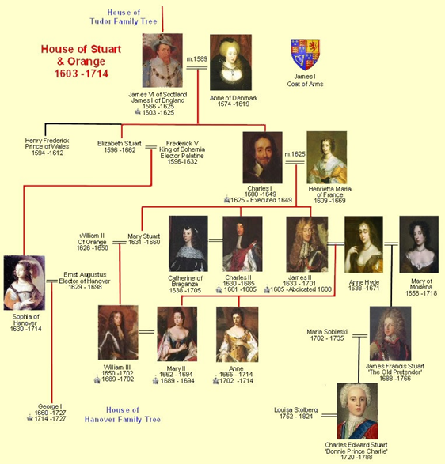
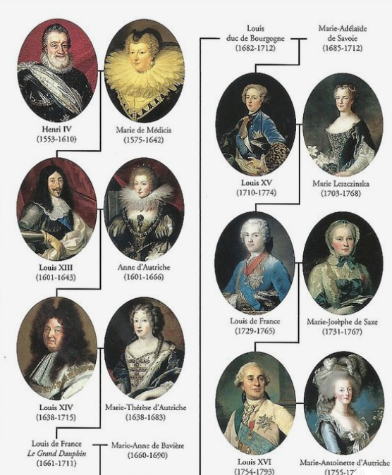
- Hopefully you worked on the DBQ over the weekend though it is not due until Tuesday. I am totally sure some of you procrastinated. I am sorry that this week is so jacked up and the adults running the state and district cannot make better plans but, here we are. We are starting a new unit this week, and it is a long one. We will be looking at the political battle between constitutionalism vs. absolutism. This is sort of the battle of the past vs. the future.
- This unit will start with an almost 100 years of the Stuart dynasty of the UK culminating in its constitutional monarchy. We will then look at the idea of absolutism with France under Louis XIV, Russia under Peter the Great. While it is sometimes forgotten the absolutist of all the Ottoman Empire will also be addressed.
- So, the schedule this week looks like we will be together Monday and Tuesday, maybe on Thursday and again of Friday.
- Other than completing the DBQ for the Unit Test the only homework is on the weekend due on October 5th. But it is open now and not dependent on class discussion and notes. Scan to the bottom and find the links. These will be answered on AP classroom.

MONDAY and TUESDAY (Recap questions today) (DBQ is due on AP Classroom)
- SWBAT explain the historical context of key events during the reign of King James I Stuart IOT answer questions tomorrow (r. 1603-1625) (OS-9)(SP-2)
- SWBAT analyze primary source readings on King James I and the Stuart Dynasty IOT answer guided questions(OS-9)(SP-2)

Materials Strategy/Format
ppt/video/sources Lecture-discussion(SL.CCR.1)

Introduction
- How about a little review activity on the Tudor Dynasty?
- One of the key important themes of European History of the 17th and 18th century is the growing split between two political systems. Last unit our focus was on absolutism and its hot, good looking cousin, Enlightened Despotism. Now we will transition toward the other trend: constitutionalism or republicanism. for this discussion, our models will be events in England (soon to be called Britain) and Holland. Also, we will be backtracking historically to events of the 17th century. This will involve something of a mini-unit on the English Stuart Dynasty.
- While it now seems like years ago we discussed the demise of the Tudor Dynasty and its fall was, as fate would have it, for exactly the same reason as Henry VIII always feared, the want of a male heir. Of course, in this case it was the lack of any actual heir. I mean let's face old Henry, you had to pull many immoral and suspect strings simply to have a male heir so it was perhaps in the cards that female Tudors would be every bit as crucial as the men. In fact, is it so far from reality to say that Queen Elizabeth was far superior in her good for England than was Henry VIII?
- And in keeping with the bitter irony, Elizabeth I hesitantly had Mary Queen of Scots executed only to know perhaps in her dying breath that Mary's son, James VI of Scotland would soon be James I of England, thus creating the United Kingdom (along with Wales).
- With the arrival of the first foreign king of England since 1066 (William of Normandy) the UK was in for some rough seas (though not so much under James I as his son Charles I), for England was a very different place from Scotland. First, there was that pesky Parliament to deal with. Oh, to be sure, Scotland had its rebellious nobles but in England by the 17th century there was a growing number of pesky middle class too. In fact, since the 14th century Wat Tyler Rebellion even peasants had come to expect rights under common law, something that a Scotsman could only see in a dream.
- Another issue for James I would be, not surprisingly, religion. As the sovereign of England, he was head of the Anglican Church and no Anglican or Catholic could question that. None that is except of course the growingly radical sect of the Church, the Puritans. James I was not unfamiliar with such a lot. He was, after all also the sovereign of Scotland many of whose population had accepted the radical teachings of John Knox. As we have discussed, Mary Stuart had attempted to bridge the gap between her own Catholicism and her Presbyterian (Calvinist) subjects though the effort was largely a failure. Internecine conflict in fact helped seal her fate as noblemen drew alliances for or against Presbyterianism. James would also have to deal with these same problems as he ascended the throne.

Hallmarks of Constitutionalism
- When we discuss these origins, we have to understand there is a most definite "change over time" at work. The story of this growth is predicated on royal vs. some form of legislative branch. While it is true that parliaments, diets, and assemblies did exist in absolutist countries their power ebbed and flowed vs. the monarchy. Weak monarchs=stronger assemblies because more often than not nobles dominated them. It was only as of the late 17th century that a definable middle class started to grow and demand some voice in these assembles.
- Another hallmark of constitutionalism is the presence of a unified law code that protects civil and political rights on some level. Initially these codes defined the rights of nobles (such as the 1215 Magna Carta). As the influence of mercantile and capitalist policies formed by the early 18th century the rights of the middle class strengthen (especially related to property rights). It will be 200 years nearly before any serious thought is given to peasants and not surprisingly England and Holland will lead the way on this front.
- Religious toleration is also a key tenet of constitutionalism and, as we have seen even absolutists did not want to return to the bad old days of the 16th and early 17th centuries of holy wars. Even war against the Ottoman Empire slowed except for skirmishes between them and Russia/Habsburgs. To be sure, state religions were still the norm.
- Over time more traits would be added as we flesh out what was meant by liberalism because at this point there was little differences between this ideology and conservative values. But you can clearly see that from the late 17th century through the 18th century the Enlightened idea of "natural, inalienable rights will become a hallmark (think 1st Amendment of the Bill of Rights).
- Most Americans think of the origins of all of the above as being English. Yet, the coming of these ideas for England (and Americans by consequence) was a painful process.

The Man Who Became King
- Though many member of the court were shocked by James I manners (he could be rather rough-hewn) he was a learned man. In fact, he was the author of several books and essays on various topics. The majority of James's written works are concerned with theology and the justification of the theory of Divine Right, and for those reasons he must be considered as a major writer of political philosophy. In lively style and with considerable learning he defended the Oath of Allegiance which Catholics were required to take. A famous political tract he penned, The True Law of Free Monarchies, was a simple explanation of his theories for the general literate public. He also wrote the Book of Sports, formally Declaration of Sports, order issued by King James I of England for use in Lancashire to resolve a conflict, on the subject of Sunday recreations, between the Puritans and the gentry, many of whom were Roman Catholics. Permission was given for dancing, archery, leaping and vaulting, and for “having of May games. There were other sports (blood sports) that were not allowed. Perhaps one of the most interesting was his essay A Counterblast on Tobacco (1604), one of the first, attacks on smoking ever written. He wrote "Smoking is a custom loathsome to the eye, hateful to the nose, harmful to the brain, dangerous to the lungs."
- One area of the life of King James that for many years remained clouded in controversy was allegations that James was homosexual. As James did father several children by Anne of Denmark, it is actually more accurate to say that he was allegedly a bi-sexual. While his close relationships with a number of men were noted, (especially the Duke of Buckingham). While it would not be entirely surprising if he were, the main issue would be how churchmen and especially the Puritans would view him.
- Despite the relative ease of the succession, not everyone was excited to have James I around.

The Gunpowder Plot
- So, if you've ever seen the movie V for Vendetta then you heard the main character several times reference this famous event. In November 1605, the infamous Gunpowder Plot took place in which some Catholics, most famous Guy Fawkes plotted to blow up James I, the first of the Stuart kings of England. The story is remembered each November 5th when ‘Guys’ are burned in a celebration known as "Bonfire Night"
- Catholics in England had expected James to be more tolerant of them. In fact, he had proved to be the opposite and had ordered all Catholic priests to leave England. This so angered some Catholics that they decided to kill James and put his daughter Elizabeth on the throne ensuring that she was a Catholic. This led to a plot to kill not only the king of England, James, but also everyone sitting in the Houses of Parliament at the same time as James was there when he opened Parliament on November 5th, 1605.
- Guy Fawkes and his fellow conspirators, having rented out a house right by the Houses of Parliament, managed to get 36 barrels of gunpowder into a cellar of the House of Lords. The plot was foiled and the leaders were drawn and quartered.
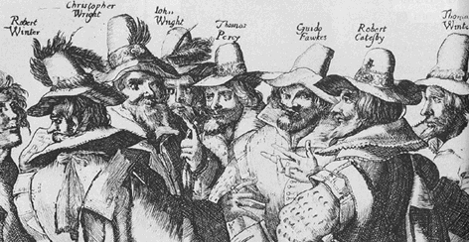

The Reign of James I Key Political Issues
- Despite his long reign, James I really was responsible for little legislation. This is partly because of his view of his role and the general inactivity of Parliament. His relationship with Parliament was contentious and would lay the ground work for the English Civil War as his son Charles I seems to have blamed that body for his demise. The main bone of contention was finances. James I was not free to frivolously spend as did his mainland counterparts and was in effect placed on a budgetary allowance. There was an attempt to negotiate a deal whereby the king would receive more income to pay his debts (read here "live like a king"). However, what came to be called the Great Contract failed to gain passage. In 1614 King James I got so angry that he dissolved Parliament after only a few weeks and deemed it the "Addled Parliament." He ruled without Parliament until 1622.
- A foreign policy issue with domestic overtones was known as the Spanish Match. The King rightly argued that continued aggressions with Spain was draining the treasury. The Duke of Buckingham tried to broker a deal ending hostilities in exchange for a personal loan. When most Parliamentarians smelled a "catholic plot" they refused to accept it and James I (you guessed it) dissolved Parliament again. The future king Charles I and the Duke of Buckingham then tried the same scheme with France and some say a secret deal may have been discussed to return England to Catholicism in exchange for a loan (This was later known as the 1670 Treaty of Dover when it came up under King Charles II).

King James and Religious Issues
- Not surprisingly James I hoped to rule England minus the usual controversy. As stated above Catholics were required to take an oath to support the monarchy. The practice existed from the time of Elizabeth I (the recusants) but was formalized by Parliament. Catholics who took the oath were allowed positions in the government and James I basically ignored those who did not take the oath. He wrote that on the issue of Catholicism "any that will be quiet and give but an outward obedience to the law."
- It was the Puritans that caused the main issue early in his reign. The 1603 Millenary Petition was a list of requests given to James I by Puritans in 1603 when he was travelling to London in order to claim the English throne. The petition asked James I to support their efforts to strip the power of Catholicism from Anglicanism. While the Puritans professed loyalty to their new king it also disavowed certain practices that the new king had accepted in written support while still in Scotland. The Millenary Petition clearly stated what the signatories objected to. These included the signing of the cross during baptism, the use of women during the administration of baptism, bowing at the name of Jesus, the use of the words ‘priest’ and ‘absolution’, the wearing of the square cap and the surplice – both of which were deemed to be ‘popish’. The signatories also wanted the Sabbath to be better observed and the quality of the clergy in England and Wales to be improved.
- In 1604 a religious convocation was held at Hampton Court leading to the creation of the Authorized Bible. as you have previously seen this was an important example of the prose of the period and was written to make the Bible more readable and was carried around the globe after its completion in 1611.

Conclusion
IN 1625 James I passed quietly away. He probably left England no better or worse than he found it and maybe that was his greatest contribution. England remained relatively stable though challenges to his reign did erupt in Scotland. He avoided the two greatest potential problems in his reign: open warfare with Parliament and religious strife. His son Charles I will do the exact opposite with dreadful effect.

Homework
Complete the DBQ essay!!!!!!!!!!!!!!

WEDNESAY - FRIDAY
- SWBAT Examine causation of the English Civil War IOT complete primary sources (OS-9)(SP-2)

Materials Strategy/Format
PPT and video Lecture-discussion(SL.CCR.1)

Student Skills
Contextualization Causation Comparison

Introduction
- Charles I was never meant to be King (you will recall a similar situation with young Henry VIII). He was overshadowed by his brilliant elder brother Prince Henry, to whom he was devoted, but Henry died of typhoid when Charles was eleven years old. With Henry's death, Charles became heir to the throne of the Three Kingdoms: England, Scotland and Ireland.
- The death of Prince Henry prompted a succession crisis. King James and Queen Anne were too old to have more children and the sickly Charles was not expected to survive to adulthood. A proposal was made that in the event of Charles' death, the succession would pass to James' daughter Princess Elizabeth and her husband the Elector Palatine Frederick V, which would mean the Wittelsbach dynasty acceding to the throne of the Three Kingdoms. However, by strength of will, Charles worked to overcome his physical weaknesses. He followed a self-imposed regimen of hard physical exercises that led to rapid improvements in his health and physique.
- Charles came to the throne amid pressure from English Protestants for intervention against Spain and the Catholic powers in the religious wars raging in Europe (the Thirty Years War, 1618-48). He allowed England's foreign policy to be directed by the unpopular Duke of Buckingham, who masterminded a series of disastrous military expeditions against Spain and France intended to indirectly assist the Palatinate. Like his father, Charles dissolved his first two parliaments when they tried to impeach Buckingham but he was forced to call a third because he needed funds to crush a rebellion in Scotland against Presbyterian nobles (it had actually started while James was still alive an was known as the Jacobite Rebellion). In 1628, England nobles knew they had Charles in a position to weaken his power. Charles' opponents formulated the Petition of Right as a defense against the King's arbitrary use of his powers. Charles grudgingly accepted the Petition in the hope that Parliament would grant him subsidies, but in practice he ignored its provisions.

The Death of Buckingham
- This seemed to be a turning point in the mind of the king. Following the assassination of Buckingham in 1628, critics in Parliament turned their attention to Charles' religious policy. Growing increasingly resentful of parliamentary interference in matters which he believed were his concern alone, Charles angrily dismissed his third Parliament in 1629. Furthermore, he imprisoned several of his leading opponents, and declared his intention of ruling alone. The eleven-year period of the King's despotic personal rule was also described as the "Eleven Year Tyranny". It was initially successful and during the turmoil of the civil wars, many people looked back upon it as a golden age of peace and prosperity. Charles I helped create this prosperity by ending the wars with France and Spain. However some viewed this as nothing more than a Catholic plot.
- Another issue troubling the nobles was he reinstitution of a bad memory. Charles and his advisers made extensive use of the Court of Star Chamber to prosecute opponents. Dating back to the 15th century, Star Chamber had originally been a court of appeal. Under the early Stuarts, it came to be used to examine cases of sedition, which in practice meant that the court could be used to suppress opposition to royal policies. Star Chamber sessions were held in secret, with no indictments, no right of appeal, no juries, and no witnesses. It became synonymous with the King's misuse of his power

The Spark of the Civil War to Come: Ship Money
  - In former times coastal towns built and maintained ships for royal use in wars
  - But without Parliament to grant legal taxes, Charles was obliged to raise income by obscure and highly unpopular means including forced loans, the sale of commercial monopolies and, most notoriously of all, "ship-money"
  - Eventually ship building was more centralized and many coastal towns simply paid a tax. The King decided that this was the duty of the whole kingdom and wanted to centralize tax collection. Was this a good idea for the good of the nation-state? Why would some resist? Neither side would give in (sounds a bit like Congress vs. The President, huh?!)

A New Wave of Religious Violence Begins to Erupt: Scotland 1637
- Much as we saw with Elizabeth I and James I king Charles had mixed religious views. Charles favored the elaborate and ritualistic High Anglican form of worship. He appointed William Laud Archbishop of Canterbury in 1633. Laud insisted upon strict compliance to the established tenets of the Church and vigorously supported the King's claim to divine right. Laud also made extensive use of Star Chamber and the ecclesiastical court of High Commission to suppress opposition from Puritans who regarded his high church liturgy as dangerously close to Roman Catholicism.
- The King's marriage to the French Catholic princess Henrietta Maria also caused consternation amongst English Protestants, particularly as she was allowed to practice her religion openly and freely. In some quarters, Henrietta Maria's influence over the King and the royal children was regarded as part of an international "popish plot" against the Protestant faith.
- Although Charles himself was high-minded and devout, his religious policies were deeply divisive. In collaboration with Archbishop Laud, he insisted upon religious conformity across the Three Kingdoms. This went disastrously wrong when the Anglican episcope and the Book of Common Prayer Book were forced upon the Scottish Kirk in 1637, resulting in the creation of the Scottish National Covenant against interference in religion, and the Bishops' Wars between the two nations. In order to finance war against the Scots, Charles was obliged to recall Parliament in 1640, bringing his eleven-year personal rule to an end.

Tensions Building Against the King
- In the House of Commons an opposition movement started under John Pym who received support from several Puritan members of the Lords. The Earl of Stafford and William Laud were both arrested and executed without Charles I lifting a finger.
- In 1641, news of the Irish Uprising reached London, provoking a crisis over whether King or Parliament should control the army that was needed to quell the rebellion. Against a background of riots and civil unrest, the King and royal family were forced to flee from London. By January 1642 following Charles' disastrous attempt to arrest members regarded as his leading opponents in Parliament. During the spring and summer of 1642, as King and Parliament appealed for the support of the nation and maneuvered to gain control of the armed forces, a violent confrontation became inevitable. King Charles raised his battle standard at Nottingham Castle on 22 August 1642, which was his call-to-arms and the beginning of the English Civil War. His supporters came to be known as the Cavaliers. Ironically, the navy that Charles had built on the proceeds of ship-money declared for Parliament. Having lost London to the Parliamentarians, Charles set up his court and military headquarters at Oxford. The Cavaliers drew most of their support from northern and western areas.
- The Parliamentary army became known as the Roundheads and Puritan noble Oliver Cromwell was given command of what came to be called the New Model Army.

The Fighting and Why the Roundheads won?
Who will have an advantage here?
Battle of Marston Moor in 1644 was the largest battle
- The Solemn League and Covenant (alliance with Scotland and a future with a Presbyterian system in both countries) This is actually the beginning of what came to called Great Britain
- The leadership of Cromwell and the New Model Army (why better?)
3. Battle of Naseby in 1645 was the kings final defeat!

Why did the King Have to Die?
- After Charles I agreed to new elections, an overwhelming number of Puritans won seats. In a final bid to control Parliament, the king dispersed the House of Commons with an armed invasion known as Pride’s Purge. The parliamentarians re-convened in another location and placed Charles I on trial for treason, this came to be known as the Rump Parliament.
- At this session, the Rump Parliament called for the abolishment of Anglicanism, House of Lords, and death for Charles I

Conclusion
The expulsion of the monarchy and the establishment of the Republic and then Protectorate is a classic example of “be careful what you wish for because you just might get it.” The dictatorship of the Puritans under Cromwell was not a happy time in England. The period of Elizabethan culture was quashed. The next phase of British History will restore the monarchy (The Restoration)

Weekend Homework
Due on Monday we will write 2 SAQs and each will be a separate grade
Protestants in the House of Commons against Stuart Catholic policies.
https://apclassroom.collegeboard.org/15/assessments/assignments/81059724

Women in the 17th century
https://apclassroom.collegeboard.org/15/assessments/assignments/81059729

