AP European History
September 14 – 18 2026

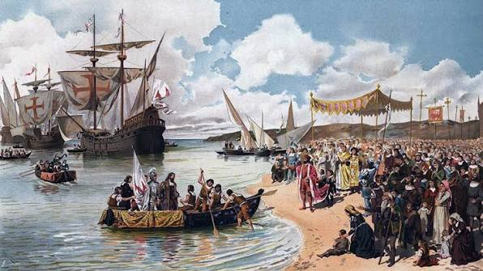
- The assessment for the Reformation Unit Test will be on Today, Monday September 14 with the SAQ due on Wednesday in class (remember that this can be handwritten or typed. Soon we will be doing most of our FRQs on the AP Classroom platform.
- We will start our new sub-Unit on the Age of Exploration Tuesday (which on AP classroom was part of Unit 1). I believe much of this unit will be familiar to many of you so after the craziness of the Reformation that should at least be a relief.
- We will return this week to quite a few primary sources this week and next week. Compared to the Reformation Unit this one will be quite short.

MONDAY
- SWBAT analyze sources (IOT) complete the unit test on the Reformation

Materials Strategy/Format
Any notes that you made. Assessment and Review

Student Skills
Analysis Causation CCOT

Instructions
Unit Test
- The Reformation before Luther
- Luther’s theology
- Zwingli and the Swiss Civil War
- The Schmalkaldic War
- Calvinism
- The Age of Religious Wars (France, England, Thirty Years War)

Homework
Work on your SAQ due on Wednesday and don’t forget to use the ACE format

TUESDAY (Begin New Unit) and WEDNESDAY (SAQs are due)

- SWBAT Explain key factors defining the Age of Exploration commencing in the 16th century (INT-1,2,3,4) (OS-3,4,6) (SP-3)
- SWBAT analyze primary sources on the rise and fall of Spain under Philip II (SP-2,3)

Materials Format/Strategy
PPT &Primary sources lecture/discussion/Doc Analysis

Introduction
- This Unit will detail the beginnings of the so-called Age of Exploration (though it clearly spanned into the next historical period. The first step in the process involved the development of naval improvements and new techniques in sailing. Though the first steps were really taken by the Portuguese, they quickly fell under pressure of the Spanish. Today we will spend most of our time looking the rise of Spain and the implications that it's rise had on the Age of Exploration.
- In the mid 1500s Spain was a superpower under HRE Charles V (1517 – 1576). But. this was really its zenith. After this period it was in slow decline and following the 30 Years War was no longer truly powerful. The empire literally existed on all of the major continents. It was hugely diverse? Can there be a problem here? Think of our own military.
- The Spanish military was unchallenged. Its infantry was the best, its cavalry commanded by Castellan nobles was well trained, and its navy plied the seas unchallenged by any power (except for some occasional English privateers called Sea Dogs)
- But there were cracks beneath the surface.
- Charles V was constantly at war:
a. In Italy vs. France and sometimes the papacy and allied city-states
b In SE Europe against the Turks
c. In Germany vs. Lutherans
d. In the Americans vs. resistant peoples

- These wars were largely fought with Spanish silver but Spain itself was not really involved. Spain is only paying the bill and reaping no benefit
- Charles V is tired and so he divided the empire: Ferdinand I gets HRE (brother) and Philip II (son) gets the biggest part

Philip II (Habsburg)
- A True defender of the Faith. He was a devout Catholic who had as his goal no less than the return of Catholic power to all of Europe
- He took up where Dad left off and became involved in wars that normally would have only been civil conflicts
  - In England (his undoing )
  - In France (stop Huguenot power)
  - In Holland (more on this later)

Weaknesses of the Empire (you may already know that the defeat of the Spanish Armada in 1588 will be a pivotal point in world history)
However, there were cracks. So, let’s look at some problems that Spain already had.
- A Huge Bureaucracy
  - You need it for centralization but if it gets too big then it is counter-productive
  - Philip II was a micro-manager (The Escorial was emblematic). But the empire was just too big w/o delegation
  - Staffed with Castellan Bureaucrats (In Spain the highest tax payer got the most civil jobs). So, lot’s of noble bureaucrats but soon competency meant nothing. Plus, jealousy was growing among other Spanish. Would you work together w/ an elitist?
- This was also true of the Spanish army
  - You have the largest and most advanced army but
  - It is staffed by Castellans
  - It was huge and costly
  - Billeting troops in peacetime homes reduced morale among the citizens (Think about American fears over the Quartering act! People were not really compensated and complaints were common. Therefore, resentment at home and abroad (Think about the American experience in Vietnam)

- Religion as the Bedrock
  - Catholicism is the true religion
  - The Inquisition was also political for Spain’s monarchy. A heretic is also seditious and treasonous.
  - To some extent this did work. Spain, unlike others (France) had no real religious resistance.

- Economics
  - The Treasure Fleets and Cash crops from the colonies in New Spain didn’t really supply Spanish people’s desire for wealth. (The encomienda system)
  - There was a huge gulf between classes w/ upper class keeping most money (sound familiar)
  - Foreign bankers had gotten most of this (Philip II went bankrupt 3 times)

- The Dwindling of Spain: Troubles at Home and Abroad Late 16th and early 17th centuries)
  - The Black Plague strikes the Potosi mines and elsewhere, silver goes down but bills don’t
  - Instant Karma: Castille the biggest tax payers end up w/ the Plague. Results?
  - A Dutch Revolt erupted and this was the wealthiest part of the empire (over a new tax called “The Tenth Penny”) The Duke of Alba (no relationship to Jessica Alba) is sent to crush the result and this was called the “Spanish Fury.” This drags on even after Philip II death.

- A New Foreign policy problem: The English
  - Philip II had hoped to wed the new queen, Elizabeth I (Tudor) but was rejected.
  - He then married Mary Stuart, Queen of Scotland and hoped that through her, he might take over England. This failed and Mary was executed by order of Queen Elizabeth I
  - There were two failed assassination attempts (Mendoza and Babington plots) that were uncovered and foiled. These both led to Philip II.
  - Meanwhile Queen Elizabeth I under the influence of one of her favorites, Sir Walter Raleigh has convinced her that the English need an empire and the Spanish are in the way. She orders acts of state-sponsored piracy against Spanish ships (Side Note: The first English attempt at colony in North America, Roanoke, was in part designed to be a base of operations against Spain in the western Atlantic.).
  - Perhaps more importantly, English mercenaries (called Sea Beggars) aided fellow Dutch Protestants in their revolt against Spain.

Conclusion
In 1588 Philip II decided that he’d had enough and launched the largest invasion fleet in the world to that point. Due to superior tactics of the English fleet and bad luck (gale force winds that scattered the larger Spanish fleet) Spain was defeated. Though the fleet was rebuilt and improved, it was at great expense further hampering Spain’s treasury. In 1598 Philip II died and his two successors were both weak and the empire declined. So, in the reign of a single leader Spain reaches its apogee. The final embarrassment was Spain’s attempt to extract tax money from others (Portugal). A revolt occurs that cannot be crushed. Spain’s status dwindles from super-power to minor player.

Homework
Complete the SAQ if needed

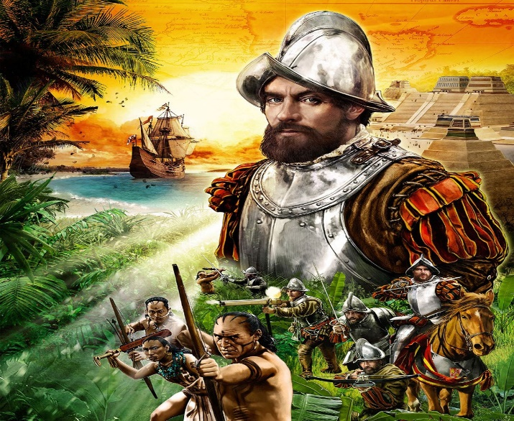
THURSDAY
- Examine the rise and decline of Spanish power in the 17th century (INT-1,2,3,4) (OS-3,4,6) (SP-3)

Materials Format/Strategy
PPT lecture/discussion

Introduction
- This Unit will detail the beginnings of the so-called Age of Exploration (though it clearly spanned into the next historical period. The first step in the process involved the development of naval improvements and new techniques in sailing. Though the first steps were really taken by the Portuguese, they quickly fell under pressure of the Spanish. Today we will spend most of our time looking the rise of Spain and the implications that it's rise had on the Age of Exploration.
- In the mid -500s Spain was a superpower under HRE Charles V (1517 – 1576). But. this was really its zenith. After this period, it was in slow decline and following the 30 Years War was no longer truly powerful. The empire literally existed on all of the major continents. It was hugely diverse? Can there be a problem here? Think of our own military.
- The Spanish military was unchallenged. Its infantry was the best, its cavalry commanded by Castellan nobles was well trained, and its navy plied the seas unchallenged by any power (except for some occasional English privateers called Sea Dogs)
- But there were cracks beneath the surface.
- Charles V was constantly at war:
a. In Italy vs. France and sometimes the papacy and allied city-states
b In SE Europe against the Turks
c. In Germany vs. Lutherans
d. In the Americans vs. resistant peoples

- These wars were largely fought with Spanish silver but Spain itself was not really involved. Spain is only paying the bill and reaping no benefit
- Charles V is tired and so he divided the empire: Ferdinand I gets HRE (brother) and Philip II (son) gets the biggest part

Philip II (Habsburg)
- A True defender of the Faith. He was a devout Catholic who had as his goal no less than the return of Catholic power to all of Europe
- He took up where Dad left off and became involved in wars that normally would have only been civil conflicts
  - In England (his undoing )
  - In France (stop Huguenot power)
  - In Holland (more on this later)

Weaknesses of the Empire (you may already know that the defeat of the Spanish Armada in 1588 will be a pivotal point in world history)
However, there were cracks. So, let’s look at some problems that Spain already had.
- A Huge Bureaucracy
  - You need it for centralization but if it gets too big then it is counter-productive
  - Philip II was a micro-manager (The Escorial was emblematic). But the empire was just too big w/o delegation
  - Staffed with Castellan Bureaucrats (In Spain the highest tax payer got the most civil jobs). So, lot’s of noble bureaucrats but soon competency meant nothing. Plus, jealousy was growing among other Spanish. Would you work together w/ an elitist?
- This was also true of the Spanish army
  - You have the largest and most advanced army but
  - It is staffed by Castellans
  - It was huge and costly
  - Billeting troops in peacetime homes reduced morale among the citizens (Think about American fears over the Quartering act! People were not really compensated and complaints were common. Therefore, resentment at home and abroad (Think about the American experience in Vietnam)

- Religion as the Bedrock
  - Catholicism is the true religion
  - The Inquisition was also political for Spain’s monarchy. A heretic is also seditious and treasonous.
  - To some extent this did work. Spain, unlike others (France) had no real religious resistance.

- Economics
  - The Treasure Fleets and Cash crops from the colonies in New Spain didn’t really supply Spanish people’s desire for wealth. (The encomienda system)
  - There was a huge gulf between classes w/ upper class keeping most money (sound familiar)
  - Foreign bankers had gotten most of this (Philip II went bankrupt 3 times)

- The Dwindling of Spain: Troubles at Home and Abroad Late 16th and early 17th centuries)
  - The Black Plague strikes the Potosi mines and elsewhere, silver goes down but bills don’t
  - Instant Karma: Castille the biggest tax payers end up w/ the Plague. Results?
  - A Dutch Revolt erupted and this was the wealthiest part of the empire (over a new tax called “The Tenth Penny”) The Duke of Alba (no relationship to Jessica Alba) is sent to crush the result and this was called the “Spanish Fury.” This drags on even after Philip II death.

- A New Foreign policy problem: The English
  - Philip II had hoped to wed the new queen, Elizabeth I (Tudor) but was rejected.
  - He then married Mary Stuart, Queen of Scotland and hoped that through her, he might take over England. This failed and Mary was executed by order of Queen Elizabeth I
  - There were two failed assassination attempts (Mendoza and Babington plots) that were uncovered and foiled. These both led to Philip II.
  - Meanwhile Queen Elizabeth I under the influence of one of her favorites, Sir Walter Raleigh has convinced her that the English need an empire and the Spanish are in the way. She orders acts of state-sponsored piracy against Spanish ships (Side Note: The first English attempt at colony in North America, Roanoke, was in part designed to be a base of operations against Spain in the western Atlantic.).
  - Perhaps more importantly, English mercenaries (called Sea Beggars) aided fellow Dutch Protestants in their revolt against Spain.

Conclusion
In 1588 Philip II decided that he’d had enough and launched the largest invasion fleet in the world to that point. Due to superior tactics of the English fleet and bad luck (gale force winds that scattered the larger Spanish fleet) Spain was defeated. Though the fleet was rebuilt and improved, it was at great expense further hampering Spain’s treasury. In 1598 Philip II died and his two successors were both weak and the empire declined. So, in the reign of a single leader Spain reaches its apogee. The final embarrassment was Spain’s attempt to extract tax money from others (Portugal). A revolt occurs that cannot be crushed. Spain’s status dwindles from super-power to minor player.

FRIDAY
- SWBAT analyze primary sources on mercantilism and the nature of transatlantic slavery (IOT) complete reading questions.

Materials Strategy/Format
Doc. Reader Close text reading and analysis

Instructions
- Today using the document reader from AP European but also a section from the AP US book we will look at the impact of Spanish imperialism on both Native and Africans.
- One of the most famous exchanges about the treatment of Natives was made between two Catholic priests Bartholomew de las Casas and Juan Ginés de Sepúlveda. You will be using the APUS text for this one and our usual document reader for the nature-impact on African Americans. There is a possibility that you will not complete this in class today.

Homework (Due Monday)
Using your textbook complete the following sections:
Mapping the Past page 436 Answer Analysis and Connections
Primary Source 14.1 page 437 Answer Evaluate the Evidence
Primary Source 14.2 page 438-439 Answer Evaluate the Evidence

