AP European History
August 31st -September – 4 2026

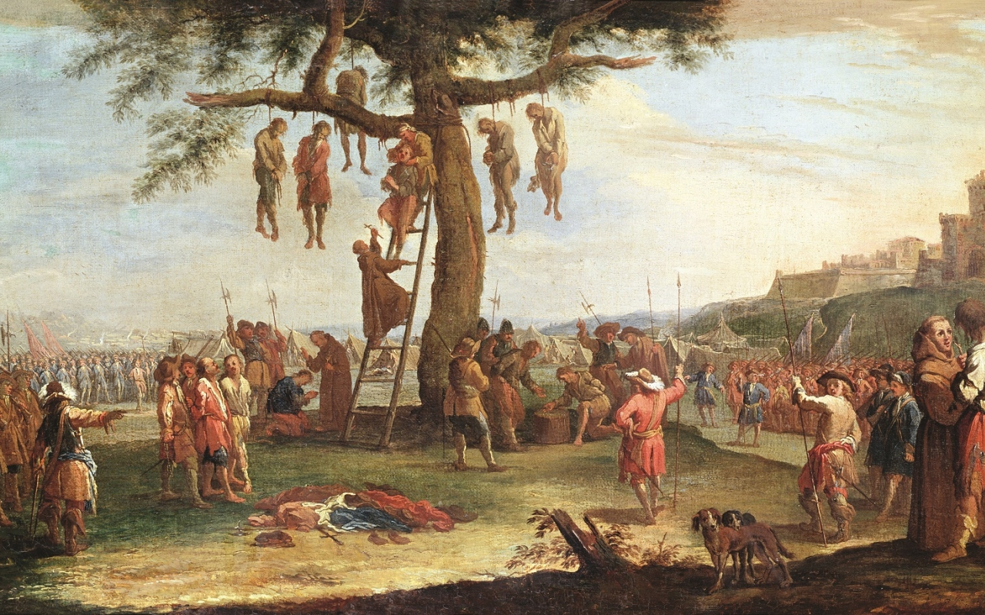
The Hanging Tree, Jacques Callot, 1633

- Hope you enjoyed the weekend and finished the quia.com review on the Early Reformation. Now we will be moving into a terrible phase of European History with the Age of Religious Wars and the second half of the Reformation Unit (The Political Impact of the Reformation)
- Your assignments this week. Wednesday a section of primary source questions will be due in class (see lesson plan below for the docs and questions. A weekend Quia quiz on the Age of Religious Wars (Due Tuesday the September 8th), also a text reading in class on Friday about the Catholic or Counter-Reformation.
- The Unit Test for this material will be around 9/10 – 9/11. SAQ and MCQ This will be an MCQ (50 questions) and another SAQ to be completed at home in blue-black ink or typed but no emails.

MONDAY and TUESDAY
- Examine the causes and effects of the French Religious War (IOT) complete doc. Questions (OS-2,11) (SP-2,3,11, IS-10)

Materials Format
PPT Primary source book Lecture/Discussion/Documents

Intro
- As we say last week, the Reformation while certainly a religious movement swiftly adopted Political overtones. The German princes saw Luther as a rallying point for their designs against both the Catholic Church and the HRE Charles V.
- In Switzerland, civil wars erupted claiming thousands of lives including Ulrich Zwingli. Not only were regions and kingdoms dividing over religion.
- In England, the protest against Catholicism took on dynastic overtones as Henry VIII broke from the Church and created Anglicanism. His son Edward VI under the influence of John Knox and John Calvin allied with the Puritans only to have some of this alliance undone when Mary I briefly returned England to Catholicism. England will be left swinging between Anglicanism and the more radical offshoot Puritanism. It will be left to Queen Elizabeth I to create something of a balance. But generally speaking, religious turmoil in England will be far less grave.
- Europe was quickly developing a bipolarity not unlike we will see in the Post-WWII Cold War.
- Today we will examine how the reformation developed in France. Not surprisingly the same trends will be recognizable. Here papal support was in the hands of one dynasty while another supported the teachings of John Calvin (Huguenots). In the middle was the ruling dynasty in the hands of a female regent.
Procedure
I Preconditions of Instability
The Early Reformation in France
a. The Huguenots of France and the Catholic Majority were often at odds.
b. The suppression of Huguenots by King Francis I to appease Charles V in 1525
c. King Henry II of France commanded that Huguenots be subject to potential torture
d. A Pivotal Moment: The death of Henry II in a jousting match creates a succession issue.
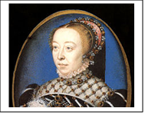e. A familiar trend in France is set up: regency

II The Regency of Catherine de Medicis (Valois)
- King Francis II (Valois) is only a child (see caption)
- A three-way power struggle ensues: The Guises, the Bourbons, and Montmorency-Chatillions
- Each of these had bases of strength and support both regionally and religiously
- The Guise were Ultra-Catholics, the Montmorency-Chatillions were Huguenots and finally the Bourbon were Huguenot but not staunchly so.
- 
Catherine and her son represented the Valois Dynasty and her main objective was to hold on to power for her son

III The Impact of Calvinism
- Huguenots were a branch of Calvinism but aristocrats (about 1/3 were Huguenots) were at
Attracted for political reasons: Guise were Catholic and nearest the throne and they were
attempting to centralize power hoping to be in position if the Valois stumbled.
- The Huguenot princes hoped to decentralize and control their own realms w/ total authority
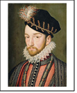
IV The Plot Thickens
- Francis II died in 1560 already a sickly child leaving Charles IX as king. But it’s the same old
problem: he too is young and now all sides are growing more tense.
Catherine, fearing the growing influence of the Guise makes allegiances among the Huguenots.
- The January Edict 1562 allowed Huguenots to worship in private.
- The Guise attacked and killed Huguenots at a service and the Huguenots basically did nothing, a move which could only embolden the Guise.
- The Effects: open warfare starts and the two Huguenots join forces along w/ troops from parts of the HRE that had adopted Protestant views. At end of this phase the Huguenots were victories and were granted more freedoms. Now Catherine is worried about what the Huguenots might try to pull.
V Catherine’s Secret Plan
a. Catherine feared the Bourbons now just as much as the Guise. Admiral Coligny had the ear of young Charles IX and he was planning an invasion of the Netherlands to aid Protestant forces there
b. Catherine knew this would be a disaster as France would be surrounded on all sides by Catholic
forces (Spain controlled Holland and was Ultra-Catholic).
- The assassination plot against Coligny failed and Catherine was afraid that Colginy would
know that she was behind it!
- The St. Bartholomew Day Massacre 20,000 Huguenots murdered in Paris 1572
- International implications: Pope and Philip II rejoiced but Beza began a campaign to
Not only overthrow Catholic power in France but the right of all people to overthrow a sovereign who harms his people!!!!
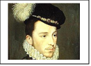

VI Religious Toleration for Protestants
- King Henry III now is on the throne and he fears the development of the new Catholic League
and the inherent threat to his power.
- Factions square off with a twist. A new player entered the game: Henry of Navarre who had
married into the Valois line and had a claim to the throne
- Henry III and Henry of Navarre make an alliance and attack the Catholics.
- Henry of Navarre becomes King Henry IV after an assassin killed Henry III (ending the
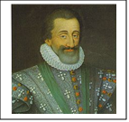
Valois line and inaugurating the Bourbon)

Conclusion
Henry IV stuck a bargain. He became a Catholic to pacify the Guise sympathizers
but the then issued the important Edict of Nantes in 1598 making
Huguenots protected. Henry IV will be assassinated as a result by an Ultra-Catholic Monk

Homework
Complete the following Primary Source questions (due in class Friday) You can handwrite or type these questions.
Radical Reformation Primary Sources
Document 1
“I come now, as I proposed, to consider the remedies which we have employed for the correction of these evils, not here intending to describe the manner in which we proceeded (that will afterwards be seen), but only to make it manifest that we have had no other end in view than to ameliorate in some degree the very miserable condition of the church. Our doctrine has been assailed, and still is every day, by many atrocious calumnies. Some declaim loudly against it in their sermons; others attack and traduce it in their writings. Both rake together everything by which they hope to bring it into disrepute among the ignorant. But the confession of our faith, which we presented to your imperial majesty, is before the world, and clearly testifies how undeservedly we are harassed by so many odious accusations. And we have always been ready in times past, as we are at the present day, to render an account of our doctrine. In a word, there is no doctrine preached in our churches but that which we openly profess….”
John Calvin, The Necessity of Reforming the Church (1543)
Questions
- When Calvin writes about people assailing our doctrine, what cornerstone belief of Calvinism is most likely being attacked? In what way is this doctrine a disavowal of the Renaissance?

- In the following line, “But the confession of our faith, which we presented to your imperial majesty, is before the world, and clearly testifies how undeservedly we are harassed by so many odious accusations” who is most likely the imperial majesty that he is addressing?

- What book did Calvin write in part to sooth the fears of this and other kings?

- Followers of Calvin in his native France came to be called by what name?

Document 2
“From Germany arrived the first Anabaptists; they believed that infant baptism is not New Testament baptism, and that they were the true elect of God who did not require any external authority. All goods (including wives) should be held in common, in preparation for an imminent Second Coming. In a proclamation of November 1538, they were ordered by the king to leave the realm; those who remained were persecuted and burned.”

The Anabaptists... were people who kept their hats on before magistrates and superior officials, refused to swear oaths, whose pacifism made them reject military service, and who were familiar with the gaols (jails for we Americans) of every country in the land.”
Peter Ackroyd, The Tudors (2012)

5. Why was the refusal of infant baptism so troubling to most Protestants and Catholics?
6. In what way does the line, “All goods (including wives) should be held in common, in preparation for an imminent Second Coming,” reveal both the apocalyptic and communal nature of Anabaptism?
7. Based upon the passage, what choice did the king (Henry VIII in this case) give to the followers of Anabaptism?
8. Based on the second part of the passage, for what reason would most political leaders have mistrusted Anabaptists?

Document 3
IV. We are agreed (as follows) on separation: A separation shall be made from the evil and from the wickedness which the devil planted in the world; in this manner, simply that we shall not have fellowship with them (the wicked) and not run with them in the multitude of their abominations. This is the way it is: Since all who do not walk in the obedience of faith, and have not united themselves with God so that they wish to do His will, are a great abomination before God, it is not possible for anything to grow or issue from them except abominable things. For truly all creatures are in but two classes, good and bad, believing and unbelieving, darkness and light, the world and those who (have come) out of the world, God's temple and idols, Christ and Belial; and none can have part with the other.
The Schleitheim Confession, 1527

Questions
9. The Anabaptists were noteworthy for separating themselves from the world and creating communal enclaves. What evidence reveals this in the passage?

10. Based on the passage and your knowledge of Anabaptism give ONE example of how the Branch Davidians in Waco Texas (led by David Koresh) resembled 16th century Anabaptism. And, give ONE example of how they rejected Anabaptism.

Document 4
“Remember, that time is money. He that can earn ten shillings a day by his labor, and goes abroad, or sits idle, one half of that day, though he spends but sixpence during his diversion or idleness, ought not to reckon that the only expense; he has really spent, or rather thrown away, five shillings besides. [...] Remember, that money is the prolific, generating nature. Money can beget money, and its offspring can beget more, and so on. Five shillings turned is six, turned again is seven and three-pence, and so on, till it becomes a hundred pounds. The more there is of it, the more it produces every turning, so that the profits rise quicker and quicker. He that kills a breeding-sow, destroys all her offspring to the thousandth generation. He that murders a crown (a unit of currency), destroys all that it might have produced, even scores of pounds.”
Max Weber quoting Ben Franklin, The Protestant Ethic and the
Spirit of Capitalism, 1930

Questions
11. How does the advice given by Benjamin Franklin also reflect the views of Calvinism during the 16th century?

12. In 1930 Max Weber associated the growth of capitalism with the expansion of Protestantism and in particular Calvinism. Though most historians believe that this is an over-simplification, what evidence might be used to support his thesis?

13. Why did nobles in countries such as France, Holland, and Scotland also support Calvinism though it had little to do with capitalism?

WEDNESDAY (Text questions are due today) and THURSDAY
- Examine the impact of religion on the reigns of Henry VIII, Edward VI, Mary I, and Elizabeth I (IOT) complete quia (OS-2,11) (SP-2,3,11, IS-10)

Materials Strategy/Format
PPT, Review Lecture-discussion (open group review)

Instructions
- One of our most important topics in the Age of Religious Wars was England’s break with the Catholic Church. This has important implications for both European and American History. Though early signs of anticlericalism had surfaced in England with Wycliffe’s challenges by the 1520s, Catholicism still enjoyed widespread popular support. As for Henry VIII, he had no wish and no need to break with the church. In fact, he wrote political-religious tracts against Martin Luther earning him the moniker “Defender of the Faith” from the Pope. Yet, in just months Henry VIII was ready to send England down the road to reformation.
- Flash back to the reign to Henry VII who had made a marriage alliance with Spain for his son Arthur to wed the infanta (princess) Catherine of Aragon. However, Arthur fell ill and died leaving Catherine a widow and the Tudor Dynasty in jeopardy as no male heir had resulted, So, Henry VII ever the Machiavellian made a bold move. He sent a representative to the Pope explaining his political problem and the Pontiff granted a dispensation. Now, the Catholic Church cleaved normally would not think of what Henry VIII was proposing; a marriage of Henry VIII (soon to be) with Catherine, the widow of Arthur. And there was Biblical sanction for the Pope to say no.
- Leviticus 18:16 "Thou shalt not uncover the nakedness of thy brother's wife: it is thy brother's nakedness."
- Leviticus 20:21 "If a man shall take his brother's wife, it is an unclean thing...they shall be childless."
- One must wonder why the Pope would defy the scriptures and grant a pass. Well, I’m sure it involved a cash payout. But this cleared the way for an royal nuptial. Now what we have to also consider is whether Henry (or Catherine) for that matter would welcome this “proposal.” It was not exactly a match made in heaven. Catherine was very devout, and Henry was a party boy who never expected to be king.
- When King Daddy breathed his last royal breath, he must have thought that he saved the dynasty at least. But going forward a few years and Catherine, as Henry would tell it, has not done her duty and bore a child. After several miscarriages. she did have Mary (very important to the story). But that is not a boy and Henry was willing to be bold like daddy would have been. There was this girl, a commoner that he had met in France named Anne Boleyn. However, you can’t really have a baby with her as it would not be a legitimate heir. So, after counseling with some advisers, Henry decided to get a divorce. But wait, the Catholic Church (who Henry defended) was against divorce. Well, you guessed it, Henry decided to ask the Pope for another dispensation. However, new Pope and a new problem b/c kicking Catherine to the curb was a real issue. Catherine was a Habsburg, The HRE Charles V (you know him) was also a Habsburg. So, fatefully the Pope, under considerable pressure said no. Well now what?
- It was the clergyman Thomas Cranmer and the king’s influential adviser Thomas Cromwell—both Protestants—who built a convincing case that England’s king should not be subject to the pope’s jurisdiction. Eager to marry Anne, Henry appointed Cranmer as the Archbishop of Canterbury, after which Cranmer quickly granted Henry’s divorce from Catherine. In June 1533, the heavily pregnant Anne Boleyn was crowned queen of England in a lavish ceremony. Wait, you can do the math here…Anne was preggers and Henry was still married.
- Parliament’s passage of the Act of Supremacy in 1534 solidified the break from the Catholic Church and made the king the Supreme Head of the Church of England. To this day the monarch is also the head of the church and for his part the King agreed to never attempt to alter the religion without first consulting Parliament. Cranmer and Cromwell were placed in positions of power, and a Protestant queen by Henry’s side. Maybe you noticed that Henry was now similar to a Pope. This will cause problems innumerable going forward. Some, you know them as Puritans will begin to question the idea of this so-called Episcopal system with one person at the head of the church preferring independently run churches, known as a Presbyterian system.

The New Anglican Church
- One of the first moves that the new church made was to create an English Bible. The Crown also moved to dissolve England’s monasteries and take control of the Church’s vast property holdings from 1536-40. Few people seemed to have an issue with this. Henry VIII initially seemed to want to keep many of the rituals of Catholicism but accepted most of old Luther’s ideas on the sacraments.
- Well, mission accomplished right, we have our own state church. But what about that male heir? Anne Boleyn, of course, would fail to produce the desired son (although she gave birth to a daughter who would become Elizabeth I), and by 1536, Henry had fallen for another lady-in-waiting, Jane Seymour who finally bore him a male heir, the future Edward VI Imagine Parliament each time being convened to pass an Act of Succession naming the offspring of the King with that woman as the legitimate heir to the throne. That May, after her former ally Cromwell helped engineer her conviction of adultery, incest and conspiracy against the king. She was executed!
- Henry VIII seemed to have a thing for Catherine’s because he then wed Anne of Cleves sight unseen (he said that she had the face of a horse) finally setting on Catherine Parr, who somehow outlived the old king.
The Short Reign of Edward VI (I know, he looks like a girl)
- When Henry VIII died, he did, at long last have a male heir by Jane Seymour but he
was far too young to rule. So, a regency was established under the Duke of Somerset
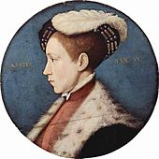
and the Duke of Northumberland These men, along with an executive council ran
the kingdom.
- One of the most important aspects of Edward’s reign was the growing unrest in the
Anglican Church between the Puritans and Anglicans.
- The Puritans wanted to reorder the Anglican Church along the lines of Calvinism and
Remove any vestige of Catholicism (which they would of course identify). Their main argument was what the called the popish idea of a pope-like figure running the church. You know them as Puritans.
- By 1553 Edward VI was dying and a succession crisis was brewing because there was
no male heir and thus a new Tudor had to be found.
- The Duke of Northumberland supported Lady Jane Gray as did many in the Parliament. Meanwhile Mary Tudor was supported by Tudor nobles. The problem here was that Mary I was unabashedly Catholic and people wondered that especially once she we Philip II of Spain whether England would be retuned to Catholicism. After nine days, the privy council of Parliament reversed itself and proclaimed Mary Tudor queen. The 9-day reign of Lady Jane Gray was over.
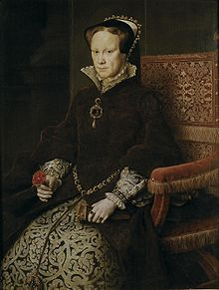
The Reign of Mary Tudor
- Mary Tudor attempted to return Catholicism in England and undo the more Calvinist reforms of her successor. At the behest of Charles V HRE she wed Philip II of Spain and together they traveled to see the Pope.
- This angered Englishmen on two accounts: first the return of Catholicism angered Puritans and non-Puritans and the combination of the throne made many believe that Spain was now in charge of the destiny of England
- Several hundred English Anglicans and Puritans were executed and many were exiled. Many of these leading Puritans went to Geneva. These “Marian exiles” returned even more radical than before after Mary’s death.

Conclusion
So, Henry VIII broke with the Catholic Church going from defender of the faith to destroyer of it in England. This will start a virtual rollercoaster ride of religion in England. The only son of Henry VIII was Edward VI (Jane Seymour’s son). He will move England far more into line with Calvinism and the Anglican Church will finally only recognize 2 sacraments. Following a brief return to Catholicism under Mary Tudor, Queen Elizabeth will be named queen. We will return to her in a later unit

Homework
None or work ahead

FRIDAY
- SWBAT analyze primary-secondary text sources on the Counter-Reformation (IOT) complete guided reading questions

Materials Strategy/Format
AP Textbook Close Text Reading/Map Skills

Instructions
- Today using your textbook (which I am assigning today) you will answer the following questions. The question generally go in order and should be finished in class.
- Take your textbook home and you will not have to bring it to class very often and I will always note on the lesson plan.

Weekend
You can take a break or complete the quia.com review Age of Religious Wars (due on Tuesday September 8th)
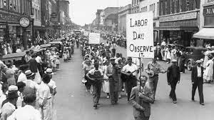
The First Labor Day, Sept. 5^{th,} 1882

