European History
October 5 – 9 2026
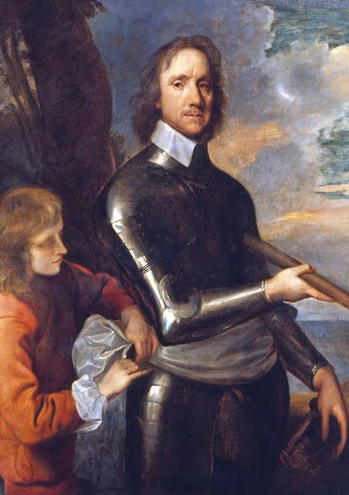
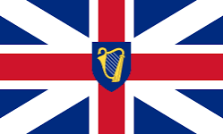
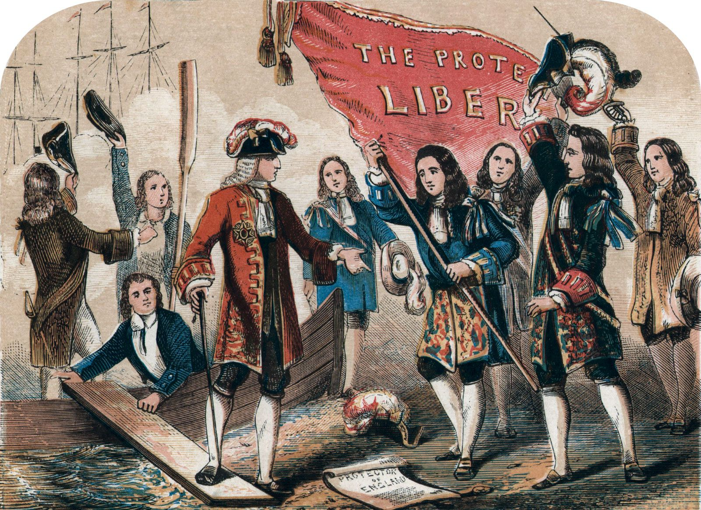
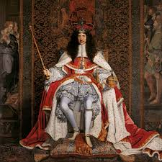

- Hopefully you remembered to complete to the 2 practice SAQs Protestants in the House of Commons against Stuart Catholic policies.
https://apclassroom.collegeboard.org/15/assessments/assignments/81059724
Women in the 17th century
https://apclassroom.collegeboard.org/15/assessments/assignments/81059729
- This is the last week of the quarter and, in hopes of helping your average you will have a take home quiz on quia related to the Stuart Dynasty. See the link below. Now this time I am suggesting that you not take ot too early since we have much to cover that will be on the quiz. Other than the quiz that will be the only work outside of class. We will start the second part of our Unit after fall break.
- I plan to do grades over the break and so do not come at me this week with “extra credit” or “make up” work which is actually a zero b/c you didn’t do the work.

MONDAY (Practice SAQs are due)
- SWBAT Examine the development of the Commonwealth and the Protectorate Period 1649-1660) (OS-9)(SP-2)

Materials Strategy/Format
PPT Lecture-discussion((OS-9)(SP-2)SL.CCR.1)

Introduction
- Last week we saw that the serious issues that evolved throughout the reigns of the James I and Charles I led to Civil War. The war (1642 – 1651) was terrible and impacted all aspects of life in England and the death toll probably neared 200,000. After the death of Charles, I the Parliament outlawed Anglicanism and replaced it with Calvinism. With it came alteration in society and culture. The House of Lords was completely abolished and titles of nobility were also under assault. As the dates imply, the fighting of the civil war continued even after the death of the king.
- The development of England’s first and only period of life without the monarchy was controversial

The Commonwealth Period
- In 1649, The Rump of the Long Parliament declared that England "shall henceforth be governed as a Commonwealth and Free State by the supreme authority of this nation, the representatives of the People in Parliament … and that without any King or House of Lords." The government was basically run by an appointed Council of State (largely composed of its own Members) to act as the executive branch of government. Further, in 1650, every adult male was required to take the "Engagement," a sort of loyalty oath. It said "I do declare and promise, that I will be true and faithful to the Commonwealth of England, as it is now established, without a King or House of Lords". Not surprisingly many were unwilling to subscribe; the Rump was widely regarded as illegitimate and survived only because of Army support.
- So right from the beginning many people, even those who had supported the Parliament began to have doubts. It was apparent to many that they had simply exchanged one divine right ruler for another.

The Invasion of Ireland
- Given the history of trouble between Protestant England and Catholic Ireland, it is probably not surprising that Cromwell might be interested in striking there. The situation in Ireland was complex and when the Civil War erupted the Irish generally supported Charles I as he had given a general pledge of toleration for Catholics.
- Charles I's execution, his son Charles was proclaimed King in Ireland by an alliance of Royalist Protestants and Anglo-Irish Catholics hoping for toleration. By August 1649, Oliver Cromwell arrived with an army of 12,000 troops. During the next ten months, Cromwell subdued Ireland entirely in a bloody and successful campaign. Cromwell's men stormed Drogheda Castle and massacred over 2,000 defenders. Cromwell said, "I am persuaded that this is a righteous judgment of God upon these barbarous wretches who have imbued their hands in so much innocent blood, and that it will tend to prevent the effusion of blood for the future, which are the satisfactory grounds to such actions, which otherwise cannot but work remorse and regret."
- Over the course of the next three years’ Irish resistance was crushed. he Act for the Settlement of Ireland authorized the expropriation of land on a grand scale - eleven million acres of land (out of Ireland's roughly twenty million) were confiscated. Much was given to English soldiers in lieu of wages, who in turn sold it to Protestant settlers. By 1656, four-fifths of Irish land was owned by Protestants. This is the origins of a history of violence and bloodshed between Irish Catholics and Irish Protestants who were loyal to England that even now occasionally erupts.

Meanwhile In Scotland
- Of course the Scots had invaded to support the Parliament forces but did not agree to the execution of their king and immediately declared Charles II as their king (eventually he'll be the king of England as well). While like his precedents Charles II had no taste for Presbyterianism he thought that Scotland was worth the Covenant. Charles went to Scotland and subscribed to the Solemn League and Covenant, 23 June 1650. (His coronation was at Scone, 1 January 1651, the last King crowned in Scotland.
- After Cromwell's forces invaded Scotland they were nearly defeated. But at the battle of Dunbar, the tide turned. Charles II who at one point had to climb up in a tree and hide, was soon spirited away to France. The surviving Scots from the battle surviving Scots soldiers were transported to the West Indies, as "indentured servants."
- By 1652 campaign, Scotland (like Ireland) was reduced to an English province. The term Great Britain was now commonly used.

War with the Dutch
- More proof that religion was no longer a source of unity is revealed by the war between the two now Calvinist nations, Britain and Holland. As you know by 1648, the Dutch had achieved complete independence from Spain. After 1650, both England and the Netherlands were Protestant republics.
Until 1650 Charles I's son-in-law, William II of Orange was Stadholder of the Netherlands and had wielded great influence. But in 1650, he died two weeks before the birth of his heir - son of Mary Stuart, and grandson of Charles I. The office of Stadholder was abolished, and Holland's merchants gained more power.
- The two countries had political interests in common, they were rivals in trade and commerce.
In 1623, the Dutch had killed a number of English merchants in the East Indies.
There was also long-standing competition over the carrying trade. In 1650, the Council of State made overtures to settle the problem by compromise. The Dutch saw this "compromise" as an attempt to undermine their sovereignty, and rejected it. So, Parliament passed another series of the Navigation Acts 1651.
- The fighting was all naval in nature and despite some stunning victories, the English won a series of engagements in 1653. The English captured or destroyed four times as many ships as the Dutch. By 1654, England made peace with the Netherlands, giving them generous terms in the Treaty of Westminster. The English hoped to promote good relations with fellow Protestants and to avoid the return to power of the Orange family. As it turns out, this was a fateful turn of events.

The End of the Commonwealth
- The Commonwealth was growing more unstable. They began planning to reduce the size of the Army, and to organize elections. Cromwell and the Army alleged that the House intended not to hold elections for a wholly new Parliament, but simply to make up their numbers - i.e. so that the existing c. 150 MPs would automatically retain their seats. In 1650 Cromwell assembled forces and surrounded the Parliament.
- Cromwell rose in Parliament and essentially told the group that they had outlived their usefulness. e dissolution of the Rump effectively ended England's brief experiment with republican government: it was replaced by a military dictatorship until (after a brief period of virtual anarchy) monarchy was restored in 1660. What followed was durect rule by Cromwell. After dissolving the Rump, Cromwell did not organize elections; instead he nominates 144 "godly" men. This "Nominated Parliament" was often called "Barebones." This is also sometimes known as the "Rule of the 36" after the 36 military districts that were created. In 1653, Cromwell assumed the office of Lord Protector of England, Scotland and Ireland.
- Not surprisingly people challenged Cromwell's right to rule and rebellions started to breakout with sometimes former enemies joining forces.

Conclusion
In 1658 Cromwell died but already moves had been made to restore the monarchy under Charles II who was in France. There was an attempt to elevate Cromwell's son to Protector status but this came to nothing. A delegation of nobles and Clergy was sent to France to ask Charles II to return Stuart Rule to England, and of course, he had to agree to rule with Parliament.

Homework
Review your notes
TUESDAY and WEDNESDAY
- Examine the causes and events of the Restoration and the Glorious Revolution (OS-9)(SP-2)
- Analyze primary source on John Locke

Materials Strategy/Format
PPT and video? Lecture-discussion
and assessment (SL.CCR.1)

Introduction
- So, last night you read and one would assume made a few notes on the Restoration Period of British History. The arrival of Charles II was greeted with happiness and relief by all except of course the Puritans who had toppled his father. For some of these leaders it was the death sentence but for others, it was simply clear that the decades old power struggle within the Anglican Church was effectively over.
- The 1660 Act of Conciliation and Oblivion was given the royal assent in August 1660. Most of those who had supported the Commonwealth and Protectorate régimes were granted a free pardon but a number of individuals were excepted. Some sixty were named for capital punishment as various drafts of the bill passed between the Lords and Commons during the summer of 1660. However 39 of the so-called "regicides" were brutally dispatched.
- The Restoration (sometimes called the Cavalier) Parliament also disbanded the New Model Army but actually raised a poll tax to pay their salaries and the King was allowed to maintain a 3,500 man standing army. Militia Act of 1661 confirmed that the monarch, as head of state, was supreme commander of the army and navy. This settled one of the most important questions over which the English Civil War had been fought. Although the prerogative courts that had enabled Charles I's autocratic personal rule during the 1630s were not revived, the Cavalier Parliament did not question the monarch's right to appoint ministers and state officials or to direct foreign policy.

Signs of Trouble
- Very soon it was becoming apparent that Charles II was going to resist Parliamentary control. The Crown remained dependent upon Parliament for revenue, but it was found that the annual sum granted by the Convention was insufficient to meet Charles II's expenses. In 1662, the Cavalier Parliament imposed the Hearth Tax ,a type of property tax as a supplemental tax to make up the shortfall. This caused great resentment because collectors and constables were given authority to enter households to inspect the number of hearths for taxation. Even with the tax Charles II soon outspent his allotment and MPs were getting a little sick of the king's lifestyle.
- The Act of Uniformity of 1662 brought all ordained clergymen under the doctrines and liturgy of the established Church. Candidates for the ministry had to be ordained by a bishop according to the rites of the Church of England. They were required to renounce the Solemn League and Covenant and to declare their acceptance of the revised Book of Common Prayer and all doctrinal articles sanctioned by the Church. Hundreds of Presbyterian and non-conformist clergymen were ejected from their livings on St Bartholomew's Day 1662 (obviously a symbolic date) for refusing to comply with the Act of Uniformity.
- MPs were also a bit concerned when the King started surrounding himself with Catholic ministers. To counter this trend Parliament passed the Clarendon Code (and later the Test Act) asserting that all high ranking members of the military, government, and even education must swear allegiance to the Anglican Church (they reasoned that a true Catholic could never do this).
- The 1670Treaty of Dover was a secret negotiation between Charles II and Louis XIV that would have granted the Stuart king a sum of money in exchange for working toward a Catholic England. In a weird turn of events one Titus Oates claimed to have evidence that the King was trying to return Catholicism. Through a Jesuit plot Charles II would name his brother the Duke of York heir, a know devout Catholic. Even though Oates couldn't prove anything, enough people believed him to cause great concern.

The Formation of the Whigs and Tories
- An important byproduct of the growing tensions over Charles II actions was the creation of the UK's first political parties. The Tories (earlier known as the Court Party for their support of the King) were the more conservative and pro-royalty faction. However, a powerful opposition group formed known as the Whigs (the Country Party) largely due to the King's actions. In three successive Parliamentary elections Whigs won many seats in the Commons. This is important because tougher legislation was passed constraining the king's actions.
- The 1679 Habeas Corpus Act a new Exclusion Bill was introduced and passed by the House of Commons; James The Duke of York was declared incapable of succeeding to the Crown, which, in the event of the king dying without male issue, was to pass to the nearest Protestant heir. Charles was determined not to allow the exclusion of his brother, and he prorogued the parliament, but not till it had passed, almost if not quite by accident, the Habeas Corpus Act. Theoretically an accused person could procure a writ of Habeas Corpus which required that he be either brought up for trial or set at liberty. But the lawyers had discovered devices enough by which the issuing of the writs could be deferred almost indefinitely. The new Act required that trial or release should take place within a definite time after application for the writ. This was important civil rights measure in the future but for now, it was likely a ploy to protect Whig dissenters.

Synthesis Point: Impact on American History
The Restoration Colonies were the largest wave of colony building during the colonial period. Check out the link and see how these colonies came together
https://www.cliffsnotes.com/study-guides/history/us-history-i/seventeenth-century-colonial-settlements/restoration-colonies

The Rise of James II and the Glorious Revolution
- So, unlike the usual succession issue here there were too many male claimants to the throne. As a result the Duke of York became king in 1681 and the tensions immediately escalated. James II immediately defied Parliament by naming Catholic officials but the real final straw with the birth of a male heir baptized as a Catholic. A delegation offered the crown to William, the Dutch stadholder whose wife Mary was a Stuart.
- The Glorious Revolution of 1688-1689 replaced the reigning king, James II, with the joint monarchy of his protestant daughter Mary and her Dutch husband, William of Orange. It was the keystone of the Whig (those opposed to a Catholic succession) history of Britain. According to the Whig account, the events of the revolution were bloodless and the revolution settlement established the supremacy of Parliament over the crown, setting Britain on the path towards constitutional monarchy and parliamentary democracy.
- But it ignores the extent to which the events of 1688 constituted a foreign invasion of England by another European power, the Dutch Republic. Although bloodshed in England was limited, the revolution was only secured in Ireland and Scotland by force and with much loss of life.
William and Mary take the throne
Popular rights were further definitely asserted; the right of presenting petitions to the- king, violated by the treatment of the seven bishops; the right of free election and free debate in parliament; and the right to the frequent assembly of parliament. The crown was offered to William and Mary conditionally on their acceptance of this latest charter of national liberties. Their acceptance was accompanied by the Act of Settlement fixing the succession on the lines laid down; and William and Mary were proclaimed king and queen of England and Ireland on February 13, 1689. Thus was the Glorious Revolution of Whig tradition carried to completion; and since the official New Year was still dated not from the January 1 but from March 25, 1688 remained the titular date year of the new order.

Homework
look over your notes about the Commonwealth, Protectorate, Restoration, and Glorious Revolution for recap questions at the end of class on Wednesday.
Homework for Thursday Night
Stuart England
https://www.quia.com/quiz/8093301.html

THURSDAY and FRIDAY
- SWBAT analyze primary sources on Stuart England (IOT) answer reading questions
- SWBAT analyze primary sources on 1st quarter materials (IOT) complete MCQ review

Materials Strategy/Format
Document sets and device for Friday Close text reading and review

Instructions
- Today and tomorrow, we will round out the 1st quarter with primary source readings on the Stuarts using the Sources on the West book. This will be your last classwork grade of the quarter.
- On Friday your quia review should be completed by 8:00 AM and you will be bringing your device for a partner review of 1st quarter materials. You are NOT required to work with a partner. You can use any materials (besides me) that you need to answer your questions. This is also on the quia.com website.

Homework


