AP US History
September 7 - 11 2026

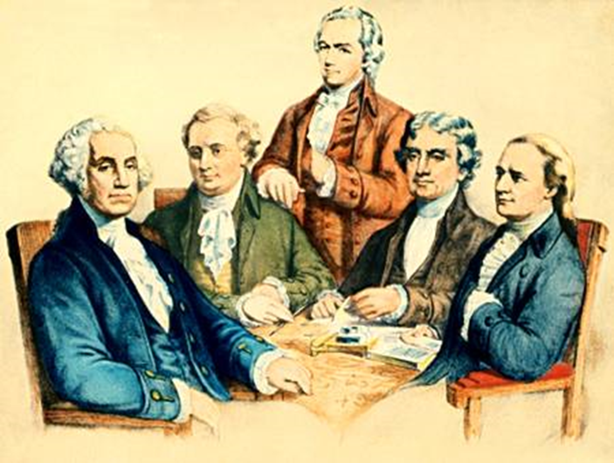
Washington’s First Cabinet Secretaries

- Hopefully you completed your SAQs for Unit Test 3.1 but if not you have until Friday September 11th The MCQ is Tuesday. If you want to read to prepare for the test on the online text here is the link
- https://s3.amazonaws.com/scschoolfiles/3191/americas_history_for_the_ap__-_james_a_henretta_complete.pdf
It runs roughly from pp 135 – 200 (not all of this is actual text of course)
- This week we will start the other half of Unit 3 (HP3 1754 – 1800.) this week which will include quite a lot of political and economic history.
- I’ve heard a rumor that we have some kind of class elections on Wednesday, and it’ll be during 4th period so our schedule that day might be a bit wonky.

MONDAY
NO CLASSES for Labor Day

TUESDAY
- SWBAT analyze primary and secondary sources (IOT) complete Unit Test 3.1

Materials Strategy/Format
Test forms, paper, pen Evaluation

Student Skills
Chronological Reasoning (1,2,3)
Comparison and Context (4, 5)
Historical Arguments (6,7)
Historical Interpretation (8)(9)

Instructions
Today’s unit test covers the following
- The French and Indian War
- Anglo-American tensions (taxes and responses)
- The Revolutionary War
- Impact of the war on class, gender
- The online text reading pp:135-200

Homework
Continue with the SAQs

WEDNESDAY (Begin Unit 3.2)
- Examine the formation of the new state governments of the United States and the weakness of the Articles Government (NAT-1,2) (CUL-2) (POL-1,2)

Materials Format
PPT Lecture-discussion/review

Student Skills
Chronological Reasoning 1,3
Comparison/Context 5,6

Set/Overview
- We are now moving into a new era of US History called “the early Republic 1776 – 1814. There had never been a republic as large as the US. There was no question that the government would take this form. However there seemed to be general agreement that states should be the sovereign entities and that there should be a weak central government. Why was this case?
- This was the plan for the government known as the Articles of Confederation (after its constitution). The idea of state’s rights and sovereignty was born. This will be one of the major causes of the Civil War in 1861 and countless disputes since that time. What are some recent examples of states asserting their sovereignty?
- Today we will examine both the new state governments and the Confederation government that developed after 1783.

Procedure
The New State governments
14 original (Vermont became the first actual state before the Revolution was officially over)
Common Characteristics
- Nearly all saw a battle and sometimes heated ones between conservatives (law, order, gentry) and liberals (individual rights, liberties, democracy). This will shape the national battle later on for a new Constinitution in 1787
- Written constitutions became the order of the day and bicameralism (except PA and GA) These new state constitutions nearly all still had property qualifications for voting and only white males could vote. MD created an electoral college. Why?
- Weak executives (governors) PA had none for a while.
- By the 1780s however we see the influx of conservative ideology about property and citizenship. Is this elitism? Is it a bad idea? Why was it that land defined political power????
- Important to note, the path to land ownership was opened more by ending primogeniture laws or similar entailments. Also, loyalist property was taken over and finally westward migration to lands closed since 1763 opens up.
- Established religions such as Anglicanism were generally abolished (see Jefferson’s Statute of Religious Freedom). Though some continued to collect the religious tithes as part of the tax base. Surprisingly that state was Massachusetts!
- Slavery was abolished in all of New England, gradual emancipations existed in the former middle colonies (now called Mid Atlantic States), NJ and De did not abolish it nor did any of the Southern states.

The Articles of Confederation Grew out of the 2nd Continental Congress
One look at the powers shows the fear realized in that this central government really had no power.
- Unicameral w/2 Reps per state and these had to agree to cast a single vote for the state
- No taxing, regulation of commerce, judicial system, declare war
- It could make native treaties and run postal system
- Committees w/a rotating President

Immediate Problems
- Robert Morris proposed an import tax (tariff) of 5% to fund the government but the measure was defeated easily by the veto power of the states. Alexander Hamilton apparently schemed to fake an army uprising among unpaid soldiers. This was called the Newburgh Conspiracy. It failed when George Washington got wind of it.
- British tariffs against American exports especially hurting the northeast and they would allow no trade in the West Indies at all. The nation could not borrow money and many states still owned money to foreign powers like France.
- Native problems were expected as whites now surged past the old Proclamation Line.
- Shays Rebellion
- Only three years after the American Revolution ended, thousands of Massachusetts citizens took up arms against their new state government. The uprising occurred in western Massachusetts. In a period of economic depression and land seizures for debt collection, several hundred farmers led by Daniel Shays (1747? – 1825), who had served as a captain in the Revolutionary army, marched on the state supreme court in Springfield, preventing it from carrying out foreclosures and debt collection. The State of Massachusetts would no longer take paper money for taxes and demanded specie. Shays then led about 1,200 men in an attack on the nearby federal arsenal, but they were repulsed by troops.
- Several of the rebels were fined, imprisoned, and sentenced to death, but in a general amnesty was granted. Although most of the condemned men were either pardoned or had their death sentences commuted, two of the condemned men were hanged on December 6, 1787 Shays himself was pardoned in 1788 upon the request of George Washington.
- This was significant because just before this time concerned businessmen had called a meeting to discuss the weakness of the government at Annapolis (The Annapolis Convention) and there was little interest. Now after Shays Rebellion the issue seemed more pressing. It was a major wake-up call for the Constitutional Convention.

Homework
Complete SAQs

THURSDAY and FRIDAY (SAQs for Unit 3.1 test are due in AP Classroom)
- SWBAT Examine the political compromises inherent in the Constitution (IOT) complete quiz and primary sources (POL-1,2) (NAT-1) MIG-1)

Materials Strategy/Format
PPT and Video Lecture-discussion/close text reading

Student Skills
Chronological Reasoning (1,2,3)
Comparison and Context (4, 5)
Historical Arguments (6,7)
Historical Interpretation (8)(9)

Introduction
- Earlier this week we pointed out the inherent weaknesses of the Articles government. However they did get one very important check in the positive column related to new states and how that they would enter the union. The Land Ordinances of 1785 and the more important Northwest Ordinance set important patterns about how states would be organized and join the union. It also had some important social side effects.
- However, an important death blow had already been dealt to the weak Articles government: Shays Rebellion. The creation of the Constitution was a direct response to the fears of Shays Rebellion and fears about the weakness of the nation in general.
Shays Rebellion
- Only three years after the American Revolution ended, thousands of Massachusetts citizens took up arms against their new state government. The uprising occurred in western Massachusetts. In a period of economic depression and land seizures for debt collection, several hundred farmers led by Daniel Shays (1747? – 1825), who had served as a captain in the Revolutionary army, marched on the state supreme court in Springfield, preventing it from carrying out foreclosures and debt collection. The State of Massachusetts would no longer take paper money for taxes and demanded specie. Shays then led about 1,200 men in an attack on the nearby federal arsenal, but they were repulsed by troops.
- Several of the rebels were fined, imprisoned, and sentenced to death, but in a general amnesty was granted. Although most of the condemned men were either pardoned or had their death sentences commuted, two of the condemned men were hanged on December 6, 1787 Shays himself was pardoned in 1788 upon the request of George Washington.
- This was significant because just before this time concerned businessmen had called a meeting to discuss the weakness of the government at Annapolis (The Annapolis Convention) and there was little interest. Now after Shays Rebellion the issue seemed more pressing. It was a major wake-up call for the Constitutional Convention.
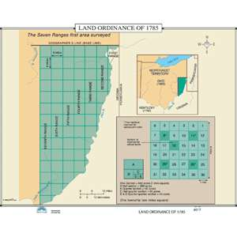
The Land Ordinances 1785-1787
- The proposal: sell land to investors to organize the territories and create $$
- Each square would be sold for a set amount and part of the income would
go to create a tax funded public school (Jefferson’s idea)
- Regrettably this created little revenue because people just did not have the
- Money to buy land and speculators grabbed most squares and would resell
later at a profit. However, this still should be seen as a success if for no other
reason than schools

The Northwest Ordinance 1787
- A plan to organize states once the land ordinance of 1785 had started the
process of organization. Increasing numbers of settlers and land speculators were attracted to what are now the states of Ohio, Indiana, Illinois, Michigan and Wisconsin. This pressure together with the demand from the Ohio Land Company, soon to obtain vast holdings in the Northwest, prompted the Congress to pass this Ordinance.
- The ordinance established population requirements before a territorial governor and legislature was appointed. Congress would approve a constitution once the next population figure was reached.
The most critical aspect of the ordinance was the prohibition of slavery
while still a territory. After the requisite number of population and with the
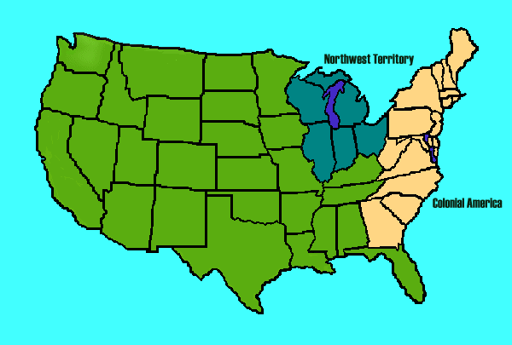
approval of Congress, the new state would decide the slavery question by a
popular vote. None of these states ever adopted slavery but the vote was close
in Illinois. This is an important precedent for the slavery issue because the
idea of letting states vote on slavery was seen as democratic in the late 18th
century but by the 19th century the issue will be more explosive. Stay tuned!

The Constitutional Convention of 1787
The basic issues to be addressed in Philadelphia
  - The delegates had to decide upon alterations or scrap the Articles?
They also had two basic issues to address:
  - How best to represent the people?
  - How to balance the interests of states?

- The meeting was held in Philly was secret. 55 men from all states except RI
- Thomas Jefferson was away in France as ambassador and was somewhat leery of the meeting. To him it smacked of treason. Some like Patrick Henry were 100% against any changes at all. John Adams was also not there as he was ambassador to Britain. Washington was chosen as the President of the meeting.

The Important Decisions
- Most of the delegates realized that they would scrap the old Articles government but were also attuned to those that would claim that this new government was dangerous to liberties of individuals and states. This was mostly because of the proposal to create an executive and judicial branch. A system of Checks and Balances (based upon the book Spirit of the Law by French philosopher Montesquieu) was created whereby certain veto power rested with each branch.
- A Republic and Federal system of shared power (based upon a model of how the Swiss operated) was proposed by Madison.

The 1st Controversy related to representation.
  - Virginia Plan called for a two-house legislature with representation of each state based on its population. This was reasonable b/c the larger populations represented more people and thus, should have more power.
  - New Jersey Plan called for set number of reps. Like the Articles. This was to insure that small states were not consistently outvoted.
  - Connecticut Plan (Great Compromise) created our current system of Senate with set numbers and a House of Representatives based upon population. The only major change to this arrangement was the amendment to allow the Senate to be popularly elected instead of chosen by state governments
  - The Slave issue was very contentious because southern states reasoned that they would always be outvoted having smaller populations. They wanted their slaves to be counted for population census at a rate of 3 slaves out of every 5 should count when making districts. Those three would of course never vote. The result was the ridiculous 3/5Compromise and Slave import ban after 1808

The creation of the Executive and Judiciary were left largely ambiguous especially a National court system.
The President was allowed a cabinet of advisors and would be the chief law enforcement officer. Also, it was deemed necessary to place military power in his hands as a civilian as a check on potential military take overs.

The Ratification Process would be at the state level. 9 of 14 states must ratify.
1. State committees were formed to vote 2. Simple majority to ratify

Conclusion
The Constitution was basically treason, but it was necessary. Though many of the Revolutionary Generation feared a strong government, others knew that it was necessary for the survival of the nation. The next issue would be to get the bill passed

Homework
No written assignments but study for quiz on the Articles and Constitution. The Quiz today will combine documents and non-document questions. It will also take the whole period.

