AP US History
August 24 – 28 2026
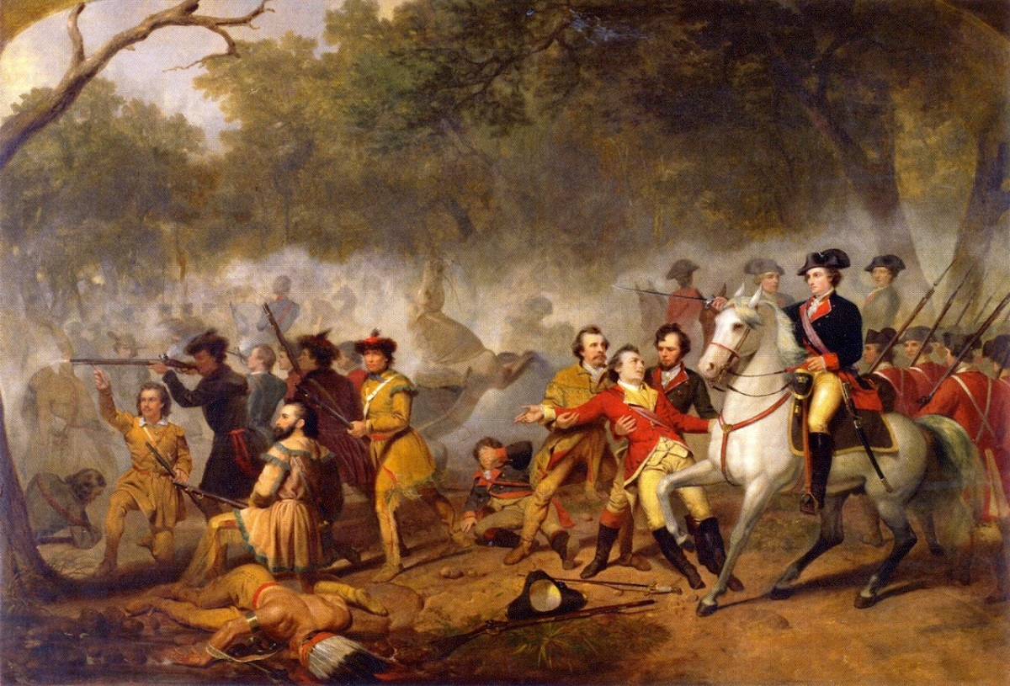
- Turn in your SAQ. Remember this had to be handwritten or typed and it has been open for several days there so should be no excuses!
- This week we will begin Unit 3 (1754 – 1800) with the events that led to the American Revolution. In addition to notes we will be using a couple of primary source books and textbooks.
- In addition to primary sources, we have 2 online assignments. The first one is on AP Classroom Progress Check 2 and is due Monday August 31st at 7:15. This is all review and can be completed anytime before the due date. The other is a section called American Voices The Debate over Representation pp: 172 – 173 questions 1,2,3 from the online reader due in class on Friday
https://s3.amazonaws.com/scschoolfiles/3191/americas_history_for_the_ap__-_james_a_henretta_complete.pdf

MONDAY and TUESDAY (begin New Unit and HP3)
- SWBAT Examine the causes and effects of the French and Indian War 1754 – 1763 (NAT-1) (POL-1) (WOR-1) (IOT) complete recap questions

Materials Strategy/Format
Ppt/video Lecture/discussion

Introduction and Background
- Today we begin our discussion of the American Revolution in what might seem like a curious way. We will look at the last time that British Colonists would feel an identity for that feeling.
- The French and Indian Wars was a situation when victory had too high a cost for the British crown. The series of taxes and levies that followed amounted to economic warfare in the eyes of many colonists. So in very real sense the growing animosity between the British and the American colonists started in the 1750s. In twenty years that Anglo-American tension will erupt into revolution and bloodshed.
- The background tension for the war involved a series of commercial conflicts in Europe for supremacy over the mercantile system. You may recall that this system often times caused conflicts because it was a zero-sum game. For every winner, someone had to lose. In addition to the commercial challenges, there had been questions of succession among European royalty and competing claims over kingdoms. Generally speaking, the major European powers feared the French were growing too powerful under Louis XIV. This created competing alliances which escalated every conflict into a multi-national fight.
- Many of the wars in Europe spilled over into North America.
King William’s War 1689 – 1697 (Which you will recall set up the flood of refugees into Salem that some say helped to spark the infamous “Witch Trials”)
Queen Anne’s War 1702 -1713
King George War 1744 – 1748 (Also known as the War of Austrian Succession)
- In these conflicts the French and their native allies squared off against the British army and their Native allies. The colonial militias also played a key role in these wars. The first turning point in the Anglo-American relationship came following King George’s War when a key French fort called Louisbourg was returned to French control in exchange for the end of French control of India. From an imperial British standpoint, this was an incredible victory for the British Empire but it angered colonists because of the heavy losses in taking the fort. The colonists fought for the empire but felt that their losses were ignored. This is very important because it is the first step in an “us versus them mentality” where colonists were called part of the empire but came to feel cheated. Very soon this will stimulate a sense of American nationalism rather than British loyalty to the Crown.

War Erupts in Europe
This was known as the Seven Years War in Europe pitting once again the French versus the British and each of their supporting alliances. Some historians have called this the first true “world war” because of the numbers and locations involved. However in reality, the French and Indian War was already being fought here by 1752. It was really imperial aims in North America that helped to start the war in Europe rather than the above conflicts.

The Causes
- Control of the Ohio River Valley had been contested for decades between the
French and the British (not to mention various colonies in the area like PA and
NY.
- Another big objective involved the future of Canada and control of the
lucrative West Indies sugar trade.

Combatants
The French, The British (including colonial militias), the Mohawks, and what was
left of the Iroquois Nations

The Spark
In the 1740s the French began to build a series of forts along the Ohio River including
one at Duquesne (Pittsburg area). This one was critical because it controlled the confluence of three rivers.
Virginia (who claimed the territory) sent a militia under young George Washington to expel French, the result was not good. After a brief exchange the militia forces retreated an Washington was forced to surrender his force.

The Fighting
1. The British send 1,500 British regulars under General Edward Braddock to deal w/French. Washington’s militia was placed under British command and they returned to take the fort
2. General Braddock’s forces are routed and Braddock was killed. The remainders were saved by Washington’s quick thinking!

In the Colonies
1. A sense of panic erupts b/c there is nothing really to stop Native attacks now along the frontier areas. The memory of King Philip’s War in New England was particularly strong. There was little that could have been done to save people in areas to the west.
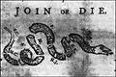
2. The Albany Plan of Union was important step in colonial history because it was the first attempt to unite all of the colonies into a single government. The image to the right was created by Ben Franklin to inspire support for unity in the face of grave danger. The fact that the plan came to nothing illustrates the fact that the time was too early for a sense of separation from Britain and colonial unity.

A Turning Point
Prime Minister William Pitt made a fateful decision in handling the war
a. He convinced Parliament to commit more troops to America believing that French would not invade Britain
b. Inspire colonial militias to handle more of the fighting and promise colonial legislatures’ reimbursement following the war.

The Defeat of the French
- The first major problem for the French was that they lost support of the some of the Iroquois. That had a major impact on their fighting strength because they had few troops or colonists to fight. The native often switched sides hoping to keep both the French and British from gaining full control. This mistake was made because the Iroquois believed that the French were winning the war.
- The defeat of French forces in Quebec (1759) and Montreal (1760) were major loses and would lose them control of Canada as a whole and weaken their forces to the point that really they could no longer hold on.

The Treaty of Paris 1763
- Fighting continued in Europe for another 3 years before a negotiation ended the conflict. What the English gained from the fight can be seen from this map. The 13 small colonies huddled near the Atlantic were now an area nearly as large as Western Europe in area. Other than a small island in Caribbean the French lost everything (including India) to the British or Spain (Britain’s ally).
- *Side bar* Where did Cajuns came from? They were exiled from Acadia in Canada and ended up settling in Spanish held Louisiana

Conclusion
The paradox on Anglo-American relations was one major result
from this war. The expense of the war nearly bankrupted the British
and Pitt had promised to reimburse the colonies. The manner of
reimbursement ended up being a new levy of taxation aimed at
the colonies themselves.

Homework
None or work ahead.
WEDNESDAY
- SWBAT analyze primary text sources Thinking Like a Historian: Beyond the Proclamation Act (IOT) complete analysis questions

Materials Strategy/Format
The “Big Ugly” textbook Close text reading and analysis

Student Skills
Analysis and Evaluation

Instructions
- Today we will use the text to examine the relationship between the British colonies and Native on the eve of the American Revolution,
- You will use pp: 164 – 165 and analysis questions 1-4 You can omit the “putting it all together” section.

Homework
- American Voices pp: 172 – 173 questions 1,2,3 from the online reader due in class on Friday
https://s3.amazonaws.com/scschoolfiles/3191/americas_history_for_the_ap__-_james_a_henretta_complete.pdf

THURSDAY and FRIDAY (The American Voices section is due today)
- Examine the impact of the Sugar Act 1764 and Stamp Act 1765 (NAT-1) (POL-1) (WXT-1)
- Describe the methods used by the colonists to fight these measures (NAT-1) (POL-1) (WXT-1)

Materials Strategy/Format
PPT and Document book Lecture/Discussion/documents

Student Skills
Causation
Periodization
CCOT

Introduction
- As we have seen the victory over the French created a series economic problem for Britain. Not only did the war cost money but now they had a much larger global empire to fund. This strained the Bank of England and since there was no such thing as a “debt ceiling” to raise, they were forced to create a new revenue stream. Tensions between the colonists and British were not only monetary. The Pontiac Rebellion had forced them to enact a Proclamation Line of 1763 that would allow no colonial settlement beyond the Appalachian Mountains. This also angered colonists because expansion was needed and the French Canadians (now British citizens) were allowed to freely settle as they were already beyond these mountains. Finally, there was anger in Parliament over having to fund militia armies who they believed fought half-heartedly.
- Today we will begin our examination of the various tax measures enacted by Parliament to raise money and to save their economy. The American positions on tax measures are an important place to begin.

The Basic American Positions
- The money is being raised by taxation of colonists to pay back debts owed to the colonies.
- The taxes are not falling fairly upon all citizens because Americans have no direct voice in tax matters (or actual representation).
- There are enforcement mechanisms that are not legal.
- The meaning of an internal tax vs. external tax. Colonies had always been allowed to raise their own taxes for their own operations. This policy sometimes called Salutary Neglect had existed as a policy since King William’s time but had existed really in the early 17th century. External taxes created by Parliament were rarely enacted.

The Basic British Positions
- All citizens of the empire have certain rights but also responsibilities. This includes fighting and paying taxes.
- The American colonial standard of living is higher therefore they should pay more taxes.
- King and Parliament supersede any colonial legislature.
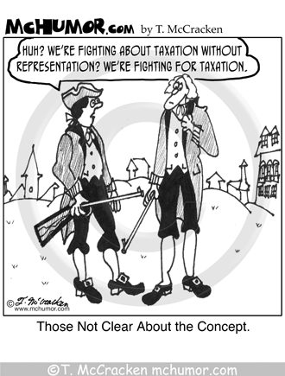
- The Parliament represents all citizens no matter where you live in matters of taxation (called virtual representation)

The British Revenue Measures

The Navigation Acts were a reflection of British
Mercantilism and had existed for decades. Generally,
American colonists had never gripped much about levies
designed to regulate trade within the empire. It was
understood that the British Navy protected trade and it had
to be funded. The British had named certain high value
commodities or “enumerated goods” that must only be sold
in the British market as a monopoly. The problem was that
some items could be sold for more money outside of Britain.
This was illegal.

The issue was a new method of enforcing the laws against
Black marketers who wanted to trade w/France, Holland, or
Spain. Writs of Assistance were search warrants that
allowed authorities to search for contraband. Was this legal
under British law? Yes and No. Unlawful search and seizure was already and issue but Parliament allowed businesses to be searched. In America, this created an issue because many lived in their place of business!

The Sugar Act (1764)
- Purpose: raise money to defray the costs of stationing Brit. Army in America
- Enforcement: This is where things are gonna get nasty!!!!!
  - The first issue was with the stationing of an army in the colonies during peacetime. This was an issue because many saw it not as protection but a way to enforce unjust laws (like the Proclamation of 1763)
  - This also had a “rider” increasing the number of “enumerated goods” from the Nav. Acts
  - Increase in confusion of documentation and innumerable regulations led to crimes that no one really understood
  - If a person was accused of black market activities they were tried in military and not civil court. Admiralty courts and change of venue, no court appointed attorney, guilty until innocent, judges received a portion of contraband’s value.

- Colonial Opposition
  - This was seen as an external tax to make money and not for regulation of trade.
  - No real opposition from Southern colonies nor the western regions of most colonies because they were not really in the sugar market. NY, MASS, PA colonies were most outraged. As the producers and shippers of rum (made from sugar)
  - No organized protests per se, but smuggling became common place.
  - Lord Grenville lowered the tax as a pay incentive but it cost more to enforce than the money gained, by 1766 it was revoked because it was costing more to enforce than it was making.

The Stamp Act 1765
- The purpose: raise money to defray military costs in North America
- Enforcement: paper was to be bought with special embossing (see page 123)
a. Taxation of legal documents, newspapers, others 12-20% revenue was hoped for by Parliament.
b. Internal tax designed to impact all parts of the colonies (more fair?)

3. Colonial Opposition
a. Internal taxes had always been levied directly by colonists themselves
b. Never had paid a revenue measure, only trade regulations.
c. British supporters of American position in Parliament included the former Prime Minister
William Pitt was argued by John Otis before members of Parliament

Conclusion
Another important step towards unity is seen. The Stamp Act Congress met to discuss ways to avoid paying the tax and to bring pressure against Parliament to overturn the tax. It was decided that a general
boycott of all British imports might do the job. If you hope to make money off of us then
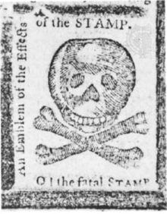
you will lose more revenue. In the end the protest worked because British middle class
protests in London itself hammered home the point. Some people, including Thomas
Jefferson felt that really this was the first step in colonial independence. Parliament
revoked the measure but also reiterated its sovereignty with the Declaratory Act. No one
in the colonies seemed to notice. The Stamp Act Congress disbanded itself and for a while,
tensions relaxed.

Homework Thursday-Friday
Progress Check 2 on AP Classroom. This is a review activity that covers much of the
Material that we tested last week. Hopefully a good grade for everyone!

