AP US History
August 17 – 21 2026
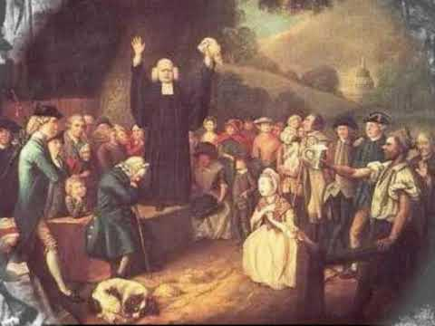

- This week you will have your first Unit Test. It will be MCQ in class. We’re talking about old school scantrons or, if I don’t find enough, writing letters on paper. And an SAQ section that will be completed at home and submitted Monday in class. This can be typed or handwritten but NO EMAILS.
- Also this week we will be completing another reading assignment but this time you only need to write (or type) your answers due on Wednesday in class. You will open the link to an article on the Gilder-Lehrman website and answer the seven questions found below.
- If you have not signed up on AP Classroom, then you have a zero or need to discuss it with Mrs, Fleming…and likely 2 zeros since you couldn’t access Progress Check 1 to complete over the weekend. But you still must sign up or you’ll be dropped from the AP roster! You cannot take the AP exam otherwise and you might as well see if Honors or Dual Enrollment will take you in.

MONDAY and TUESDAY (some of these notes are carried forward from last week)
- Explain the decline of the Puritan errand and the expansion of New England (MIG-1 CUL-1, NAT-1)
- Examine the causes and effects of the Great Awakening 1700 - 1750 (NAT-1)(CUL-1)

Materials Strategy/Format
Ppt and primary sources Lecture-discussion SL.CCR.1

Student Activities/History Skills
I Chronology and Reasoning (1, 2, 3)
II Comparison and Context (4, 5)
III Historical Argument 6,7
IV Interpretation and Synthesis (8,9)

Introduction
- Many paradoxes surround the Puritans. They left England because of religious persecution and emphasized freedom from a controlling church hierocracy, but exiled their own members who had small theological differences. They encouraged hard work and well-earned riches, but opposed worldly excesses (this is sometimes the “protestant work ethic”). Their tight-knit, restrictive society could not maintain itself as their numbers and territory increased.
- However, the Puritans left America with key values that would lead the country toward prosperity, a republican form of government (known as congregationalism). The Puritan value placed upon education. Not only was Harvard a legacy of their interest but also the Puritans created the first publicly funded education laws. Called the Old Deluder Law, Puritans believed that one must become educated as a way to avoid sin (the “old Deluder was a nickname for Satan).
- Of course, for Puritans fear of Satan was ever present. Today we will watch a quick video on the Salem Witch Trials and then discuss the most important social and cultural movement of the early colonial period.

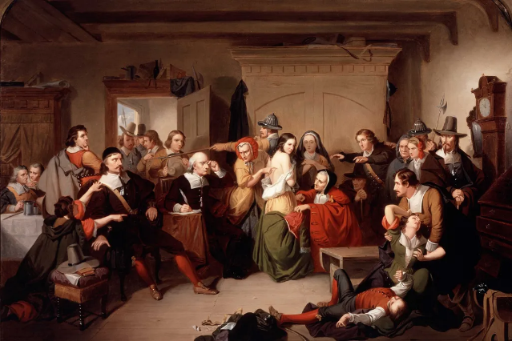
In 1692-1693 over 200 people were accused of witchcraft and 20 executed. The event reflected multiple social and cultural anxieties but was also a byproduct of economic inequality. The blend of religious and civil law common in Mass Bay Colony meant that the accusation of witchcraft meant that a person could be tried and punished in civil court. The most problematic nature of the trials was the admittance of “spectral evidence” against the accused. This was not legal under English law but was used in Salem.

The number of accused were overwhelmingly women and were often people of lower economic circumstances. Most of the women were older and some widowed or never married. Others who faced accusations were more recent arrivals. The tensions and those executed reflected the final blow to Puritanism and the trials were not stopped until the governor’s wife was accused of witchcraft. The history of the event is also reflected in later history. In the 1950s the search for communists and McCarthyism was also referred to as a witch hunt and Donald Trump has used the term more times than I can recall.

The Great Awakening Late 17th - Early 18th century
Introduction
- Earlier this week we looked the rising middle class in America and what drove this prosperity. We saw that far from being a complete negative, the mercantile system (known as the Navigation Acts in Britain) helped to create exclusive markets for many American products and helped develop our first merchant marine fleet.
- By the start of the 18th century a cultural movement in Europe, the Enlightenment, made its impact in America particularly among this new middle class. Reason and Logic found its way into the discussions of many people and some took this as far creating a new enlightened theology called deism. In this believers hoped to rein in the emotions and superstitions that they believed had led to religious crusades, death, and destruction.
- Today we will see a reaction that occurred in part to these new deist beliefs. This was known as the Great Awakening, the largest cultural and social movement of the colonial era.

Procedure
Beginning in the late 17th century but really heating up in the early 18th century the religious movement known as the Great Awakening took off in New England but becoming even more popular in the middle colonies of New York and Pennsylvania. The influence of the movement died out the further south one moved.

I Background Causes
a. Social and Economic Instability
b. A wave of disease outbreaks (particularly cholera)
c. The impact of the Enlightenment in major urban areas
d. The discontent (particularly among the youth) with boring Anglican and Congregational
(the former Puritan/Calvinist) teaching methods.

II The Movement Begins
- “The Old Lights vs. The New Lights”
- The Old lights emphasized scholarly approach to theology whereby sermons became more. Like scholarly lectures on the Bible in often excruciating detail. There was often a heavy emphasis on obeying one’s elders and uppers (sometimes in a class oriented meaning).
- The New Lights focuses primarily on the issue of salvation as the only means of salvation. Here, the emphasis was upon the individual’s role and not good deeds or obeisance to the church itself. These sermons highly emotional and charged with energy. This was the origins of what came to be known as “hellfire and brimstone preaching”

III The Leaders of the Movement

- George Whitefield
  - An Anglican minister from England who began his life as an actor. His sermons were so popular that it is estimated that he preached to over 20% of the colonial population personally!
  - The origins of tent revivals can be traced to this event. The movement is sometimes called revivalism for this reason. He specialized in “hellfire and brimstone preaching”
  - Basic teachings: freewill and personal accountability, role of women in a family’s salvation, all God’s people are important and all have souls to save (including Slaves and Natives). This is also the origins of evangelicalism in America!

- Others were Jonathan Edwards Sinners in the Hands of an Angry God which was the most published sermon and was often preached by other New Light Ministers especially Anglicans.

IV Major Results of the Movement
  - Denominationalism (all Christian faiths are acceptable largely due to Whitefield’s personal salvation sermons
  - Baptist, Methodists, and Presbyterians began to attract thousands of new converts and would soon replace the older Anglican, Puritans, and Quakers.
  - A wave of education spreads as new colleges and universities started to train people in the new faiths and create ministers for the new churches: U of Penn., UNC, Princeton, Dartmouth, and Rutgers
  - The impact on African-Americans and Natives: mass conversions and the origins of the African Methodist Episcopal church
  - Women become more involved in church in lay offices
  - Political impact? Some argue that this movement helped spawn a sense of rebellion against Anglicanism a political instrument of control. Why will this matter by mid-18th century?

Conclusion
This was the largest ecclesiastical movement that we will see in American history until the early 19th century when we shall encounter yet another Great Awakening (The Second Great Awakening). One of the essays on your next test this week will be on the causes/effects of the Great Awakening.

Homework (Due on Wednesday)
Begin reading the essay on the Gilder-Lehrman website by Dr. Ira Berlin. The topic is the Middle Passage or the Trans-Atlantic slave trade. You will open the link and simply read and answer the guided questions found below the link. This is a homework grade and is due in class on Wednesday.
https://www.gilderlehrman.org/ap-us-history/period-2

Questions
1. In the opening paragraph the other mentions 3 migrations of African-Americans in history. Briefly describe these.
2. What was the Middle Passage and what contradictory pov did the author give in the second paragraph?
3. This is more of a review question from the summer work but explain how slavery fit into the mercantile system.
4. How did the nature of slavery start to change in North America once the plantation system started developing?
5. While slaves could be imported at any port where did they most commonly enter North America? Also, what was different about the slaves arriving in the late 17th century?
6. Though it didn’t end legally until 1808 why did the number of imported slaves start to decline by the 18th century?
7. What two southern colonies (future states) based upon the reading would ultimately have the largest slave populations?
WEDNESDAY (Reading questions due today)
- Analyze primary sources on colonial America (IOT) complete reading questions

Materials Strategy/Format
AMSCO Study Guide and Teacher Made source Close Text Reading

Student Skills
Analysis and Contextualization

Today as we round out our examination of History Period 2 we will be working with some important primary sources. Obviously, you have figured out that source analysis is a fact of your life. The entire AP exam is built around primary and secondary sources. On Thursday you will be taking your first Unit Test assessment. I have pulled a few sources from the summer work and first week of school to integrate into this test. The development of mercantilism, the Middle Passage, and the patterns of Spanish settlement will all be on this assessment in addition to our History Period 2 discussions.

Homework
Begin working on the SAQ and study for the Unit Test

THURSDAY
- Multiple Choice Unit test on Colonial period and unit 2

Materials Strategy
Scantron and pencil Assessment and Review

Instructions
The Material for the Unit Test will fall in these categories:
1. Spanish Patterns of Settlement and Motives in the New World
a. Encomienda System
b. Conquistadors
c. patterns of settlement
d. the International Slave trade

2. Patterns of Settlement French and Dutch
a. This was from the reading links and bell work

3. Patterns of Settlement for English (1607 – 1700)
a. The establishment of Jamestown (and the rest of VA)
b. Maryland and Delaware
c. The New England Colonies
d. Restoration colonies (outside reading and quia quiz)

4. Social Disruptions in the Colonies
a. Powhatan Wars and Bacon’s Rebellion (Chesapeake)
b. Demise of Puritanism, King Philip’s War, and Salem Witch Trials
c, The reading on the Middle Passage

5. The Great Awakening
a. Causes and Effects

FRIDAY (activity schedule)
- SWBAT analyze primary and secondary sources (using the big ugly) (IOT) complete reading questions

Materials Strategy/Format
Textbook and guided questions Guided reading and analysis

Instructions
Today using the “big ugly” we will open our examination of History period 3 1754-1800. This is obviously a very long period of time and we will break this material up into a couple of unit tests.

Homework for the weekend
Complete the SAQs See Below
2026 AP US History Unit One Test
SAQ Section

Instructions and Information
Directions
The most effective way to do successfully answer the SAQ section is to use the ACE method. Here is what you want to do
A = Make sure that you ANSWER the Question
C = CITE evidence using key terms, people, concepts, events appropriate to the prompt
E = EXPLAIN how your evidence answers the question is a bit of detail
**You will want to do this with A, B, and C parts of each question!

When completing the Short Answer Question Section make sure that you do the following
- Answer in a paragraph with complete sentences (never in bullet points)
- Make sure that you are answering what the prompt is asking. For example, “compare” also means “contrast”.
- Always explain as fully as you can and support with examples to support your response. Otherwise you probably will not get full credit.
- Make sure to answer all parts of the question and show the reader clearly, you’re A, B, and C sections

Question 1 is Based Upon the Excerpt Below
“… Virginia was for the most part at first peopled by Persons of low Circumstances, and by such as were willing to seek their Fortunes in a Foreign Country. Nor was it hardly possible it should be otherwise, for ’tis not likely that any Man of a plentiful Estate [wealth] should voluntarily abandon a happy Certainty to roam after imaginary Advantages in a New World. Besides which incertainty, he must have propos’d to himself to encounter the infinite Difficulties and Dangers that attend a New Settlement. These Discouragements were sufficient to terrify any Man that could live easy in England from going to provoke his Fortune in a strange Land.”

Robert Beverley, Jr., The History and Present State of Virginia, 1705, excerpts.
National Humanities Center
Part A
Explain the Main Idea and Tone of the Passage.

Part B
List and explain ONE specific event or development that would support Robert Beverley’s position in the excerpt.

Part C
List and explain ONE specific event or development that would refute Robert Beverley’s position in the excerpt.

Question 2
Using the excerpt and your knowledge of period answer the questions below
“What happened in Salem likely had many causes, and as many responses to those causes…While each book puts forward its own theories, most historians agree that there was no single cause for the witchcraft that started in Salem and spread across the region. To borrow a phrase from another tragic chapter of Essex County history, Salem offered a ‘perfect storm’ a unique convergence of conditions and events that produced what was by far the largest and most lethal witchcraft episode in American history.”
Emerson W. Baker, A Storm of Witchcraft, 2016

Part A
Explain what role that class divisions and age differences might have played in causing this infamous event.

Part B
How might Puritanism itself have played a role in causing this infamous event?

Part C
Choose another 17th century British colony explain the role that religion played in the founding of the colony.

Question 3
Using the map and your knowledge of period answer the questions below

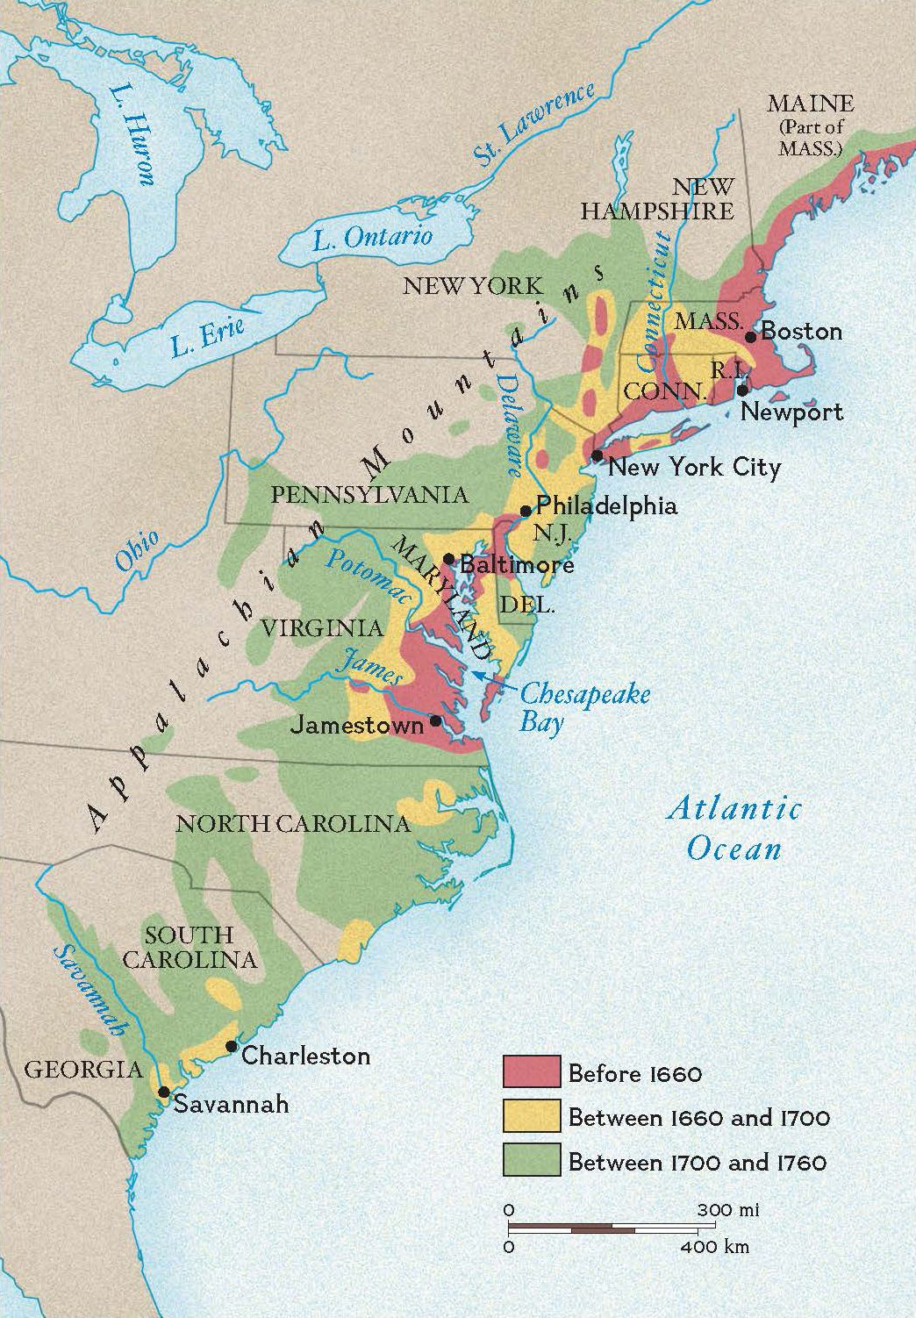

Part A
Compare the economic development of TWO of the regions found on the map
The Chesapeake New England Middle Colonies Southern Colonies

Part B
Compare the native relations with settlers in TWO of the regions found on the map.
The Chesapeake New England Middle Colonies Southern Colonies

Part C
Choose ONE region from the map and explain what role that events in England played in colonial development.

