AP US HISTYORY
August 14 - 18 2023

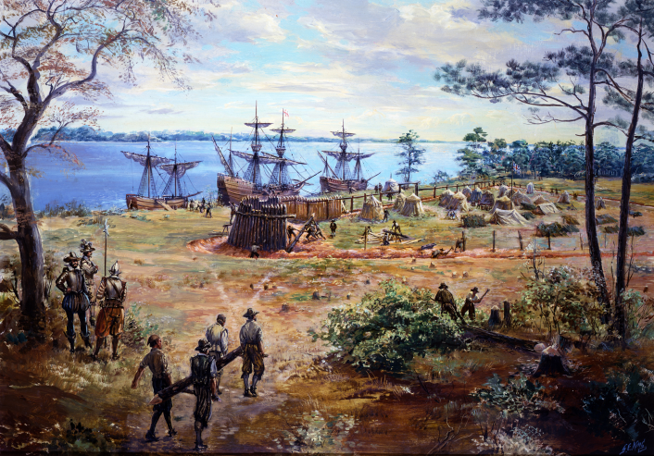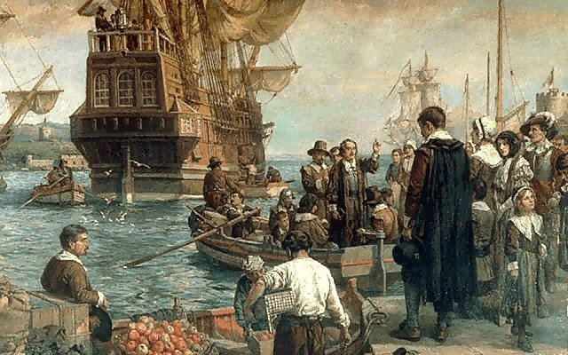
Massachusetts Bay Colony, MA 1630
Jamestown Colony, VA 1607

- This week we will historical period 2 1607-1754 and English colonization.
- If you have not done so already go to myap.collegeboard.org and sign up. Even though you will get a late grade if its not complete, this is something that you still MUST do. You CANNOT take the AP exam otherwise and thus you will not get credit for the class (and you have to have US History to graduate).
- You should also have completed the Quia Recap of the Summer assignment by today Monday August 14th.
- Look below at assignments and due dates and looking ahead we will have our first formal unit test towards the end of next week and this will include a SAQ writing sample.
- You should be getting your online textbook this week. Remember the book is called America's History although it might be a while before we use it.
- Assignments this week: your first Progress Check on AP classroom (see links below), another document analysis on colonial period, your first formal quiz assessment, and on the weekend another quia.com assignment. See information below.

MONDAY(Quia is due today)
- SWBAT Explain the origins of English colonization in the late16th-Early 17th centuries (IOT) complete assessment on Friday (NAT1,6) (SOC5),(MIG-1)(GEO3), (WOR2)
- SWBAT Examine the development of Jamestown and expansion of Virginia/Chesapeake region (IOT) complete assessment on (NAT1,6) (SOC5),MIG1)(GEO3), (WOR1)
Materials Strategy/Format
Ppt Socratic and lecture/discussion L.CCR.2-3

Student Skills
Skill Types
I Chronological Reasoning (1, 2)
II Comparison and Context (4, 5)
III Constructing Historical Arguments (7)
IV Interpretation and Synthesis (8)

Introduction
- I carried over some of the class notes from last week related to Jamestown settlement since we as a class are just getting on track. I hope that you will find them useful going forward. Today we are going to look a bit more at life in the Chesapeake and hopefully view a video clip on a pivotal 1675 event known as Bacon’s Rebellion. We will view this in class but here is the link if you would like to view it before your unit test:
https://www.google.com/search?client=firefox-b-1-d&q=youtube+bacon%27s+rebellion#fpstate=ive&vld=cid:6da35f88,vid:Z_VpwQ-yTa4

- As you saw from your weekend research, the Spanish and Portuguese were earliest European colonizers but, by the start of the 17th century they were no longer the only game in town. The French and the Dutch had both made inroads into North America. While neither found much gold and silver, both developed a lucrative trade employing the natives as partners in fur trade. Also fetching a good price were lumber and fishing. The French settled a vast stretch of forest lands from Canada to near the Gulf Coast using river travel to tie the empire of New France together. The empire was centered along the St. Lawrence river at Quebec. From here courirs des bois, frontiersmen spread out along the existing Native trade routes.
- For the Dutch the area around NY and NJ began New Netherlands and the domineering Peter Stuyvesant controlled New Netherlands for the Dutch East India Company
- Today we will begin a very important part of our course work. This period is known as the “Colonial Era” and it spans roughly from 1607 to 1754. This is generally pertaining to English settlement. In this unit we will basically discuss the formation of the original 13 English colonies and important aspects of their founding.
- The English had developed a pattern of settlement similar to that of the French and Dutch. They developed joint-stock companies to establish colonies to create a profit stream. One of the primary investors in the company was the crown itself through the process of royal charters and commissions. What were some of the other ideas that will mark English patterns of settlement?
- The first English attempt was miserable failure as the colony of Roanoke became known as the lost colony. Most theories on the disappearance center around the fact that the inhabitants themselves were completely unprepared for the world that awaited them. Being mostly city dwellers, they were generally not suited for the arduous task ahead.
- However, in 1607 a new venture will be made in the Chesapeake region with the establishment of Jamestown in modern day Virginia. Other colonial ventures in the region will follow establishing modern day Maryland in 1634 and Delaware in 1664 (though it became a colony due to settlers from other colonies go there at first). One of the important tasks in our understanding of the colonial period is to know less about when colonies formed but key details about the region (The Chesapeake), politics, economics, and society.

Jamestown Colony
- Origins
  - The ascendancy of the Stuart Dynasty marked the first wave of successful empire building. King James I granted a charter to explore the Virginia area and establish a colony. The Pattern of settlement was established of land grants to establish colonies. The colonies were nominally controlled by Parliament/king but were largely independent. This will establish an important precedent of self-government!
  - In 1607 104 settlers landed and established Jamestown. The problems developed immediately. What types of difficulties might we expect? By 1608 on 38 men survived “the starving time” which lasted until 1610. This period could easily have marked the failure of another colony. Diseases and the inability to grow crops may have even resulted in cannibalism if some accounts are true.
  - Relations with the natives at first were somewhat civil as there are accounts of Natives coming and going in the colony and some seem to have lived there as servants of some type. At this juncture the English probably did not seem threatening. The Powhatan Confederacy in those early years was alliance of tribes in the region and could easily have wiped out the settlers in those early years.

II Turning the Corner
- One of the crucial steps toward the survival of the colony can be marked with the arrival of John Smith 1611. Smith, a former mercenary brought rigorous disciple to the colony. Though he was hated by many in Jamestown, his “no work no eat policy” established order. Another important move made by Smith was the normalizing of relations with natives in the region. The symbolic marriage of Pocahontas (translation of her real name) to John Smith was the result of this negotiation. As we will see this was ultimately a mistake for the natives. Pocahontas actually married John Rolfe.
- Another critical mark of success for Jamestown came with development of a key cash crop usually attributed to John Rolfe in 1612. This was a major export and immediately created a profitable market as cheaper tobacco flooded Europe.
- Within a decade of its establishment settlers to Virginia planted other colonies many of which became towns that still exist today. The colony of Henrico became modern day Richmond.
- A further important development followed in 1619 as the House of Burgesses was established to govern Virginia. This was bicameral legislature patterned on the Parliament model. The two houses were reflections of the growing class nature of the colonies. The upper house was populated with land owners and the lower with smaller land owners. Land was the defining attribute of political power for nearly 200 more years.
- The Population of Virginia grew largely due to the head-right system. In 1618, the headright system was introduced as a means to solve labor shortages. It provided the following:
- Colonists already residing in Virginia were granted two headrights, meaning two tracts of 50 acres each, or a total of 100 acres of land.
- New settlers who paid their own passage to Virginia were granted one headright. Since every person who entered the colony received a headright, families were encouraged to migrate together.
- Wealthy individuals could accumulate headrights by paying for the passage of poor individuals. Most of the workers who entered Virginia under this arrangement came as indentured servants— people who paid for their transportation by pledging to perform five to seven years of labor for the landowner

III Jamestown nearly founders
- The Algonquians (members of the Powhatan Confederation) eventually became disenchanted and with the spread of English settlers and in 1622, attacked the out plantations killing over 300 of the settlers. Even though a last-minute warning spared Jamestown, the attack on the colony and mismanagement of the Virginia Company at home convinced the King that he should revoke the Virginia Company Charter; Virginia became a crown colony in 1624.
- A royal governor would be dispatched to run the colony but the House of Burgesses still played a role in administration.
IV The Class Struggle in Later Jamestown Bacon’s Rebellion
- In the Chesapeake region the class system of England was transplanted to a degree. Tensions soon began to develop as former indentured servants and small holders were un represented by the colonial government
During the 1670s, the administration of Governor Sir William Berkeley became unpopular with small farmers and frontiersmen, because of the following reasons:
- Restrictions on the right to vote — the institution of a new land ownership requirement
- Higher taxes
- Low tobacco prices (because of overproduction
- A pervasive sense of subordination to an aristocratic minority
- Lack of protection from Native American attacks (though these were provoked by the Virginians who pushed west on to Native lands)
- Nathanial Bacon, a landowner himself, raised a small army again and marched on Jamestown . The governor fled and the burgesses hastily enacted measures designed to subdue the Indians. Berkeley quickly returned with soldiers of his own and branded Bacon a rebel. The rebel forces initially prevailed, but they doubted their ability to hold out in Jamestown for an extended period and opted to torch the village instead.
Bacon became ill with dysentery and died in the fall of 1676; the rebellion collapsed immediately. Berkeley briefly returned to power and relentlessly hunted down the rebels before being recalled to England.
- Two important results come from this brief but important rebellion; Bacon’s Laws as they came to be known ended indentured servitude with the regrettable side effect of increasing demand for African slavery.
- As a side note, settlers now poured into the western mountain areas of Virginia but the land there was less productive for wide-scale cash crop development. As a result, the slave system was much smaller there. In 1863 after Virginia seceded from the Union, these western counties petitioned to join the Union as loyal members of the United States. Thus, was born the state of West Virginia.
The Development of Maryland and Delaware
- The establishment of Maryland was a direct reflection of the religious tensions in England that would soon help to create a bloody civil war there. In 1629, George Calvert a.k.a. Lord Baltimore applied to King Charles I for a new royal charter for what was to become the Maryland. Calvert's interest in creating a colony derived from his Catholicism and his desire for the creation of a haven for Catholics in the new world. In addition, he was familiar with the fortunes that had been made in tobacco in Virginia.
- Calvert always knew that despite being designed as a Catholic haven, Protestants would eventually outnumber them. As a result, he attempted to establish religious toleration but keep Catholics in the highest positions. When Virginia established Anglicanism as the state religion, many of the more Puritan leaders migrated to Maryland, a curious decision given tensions in England between the two groups. But they began to fear royal controlled Anglicanism as a bigger threat. The good relations were short-lived as Puritans revolted against the Catholic hierarchy.
- In 1654 the 2nd Lord Baltimore sent an army to overthrow the rebel-controlled government but it was defeated. A formal edict of Toleration was enacted when; in 1658 the Calverts regained control. In another twist of fate Catholicism was outlawed in Maryland 1688 following the Glorious Revolution in England itself. Catholics were no longer allowed to worship openly until after the American Revolution.
- Delaware was established out of the pre-existing colonies of Pennsylvania and Maryland. Cash crops were the main economic mode and small-scale slavery would develop there but for a time, free blacks outnumbered slaves.
The Socio-Economic Nature of Maryland
- Since Maryland developed along a similar pattern as Virginia the process was similar. Cash crop cultivation of tobacco was the main mode of profits. However, the city of Baltimore was a good port and this helps to generate a more diverse economy were shops and very small-scale industry can develop.
- Another feature of the state will also be slavery. The tensions in Virginia were largely avoided here because laws were passed early on limiting indentured service. There was also a free black population there. There was also a bicameral government that institutionalized land ownership as the requisite of political power.

Homework MONDAY/TUESDAY Night
You will be completing your first timed progress check in AP classroom. You must log in by your class period
Assignment: Unit 1 Progress Check: MCQ
Class: 1stPeriodAPUS
Available as of: 8/12/2023 8:32 AM CDT
Due: 8/16/2023 8:00 AM CDT
Link for students to take test: https://apclassroom.collegeboard.org/1/assessments/assignments/52809008

Assignment: Unit 1 Progress Check: MCQ
Class: 3rdPeriodAPUS
Available as of: 8/12/2023 8:32 AM CDT
Due: 8/16/2023 8:00 AM CDT
Link for students to take test: https://apclassroom.collegeboard.org/1/assessments/assignments/52809009

Assignment: Unit 1 Progress Check: MCQ
Class: 4thPeriodAPUS
Available as of: 8/12/2023 8:32 AM CDT
Due: 8/16/2023 8:00 AM CDT
Link for students to take test: https://apclassroom.collegeboard.org/1/assessments/assignments/52809010

Assignment: Unit 1 Progress Check: MCQ
Class: 7thPeriodAPUS
Available as of: 8/12/2023 8:32 AM CDT
Due: 8/16/2023 8:00 AM CDT
Link for students to take test: https://apclassroom.collegeboard.org/1/assessments/assignments/52809011

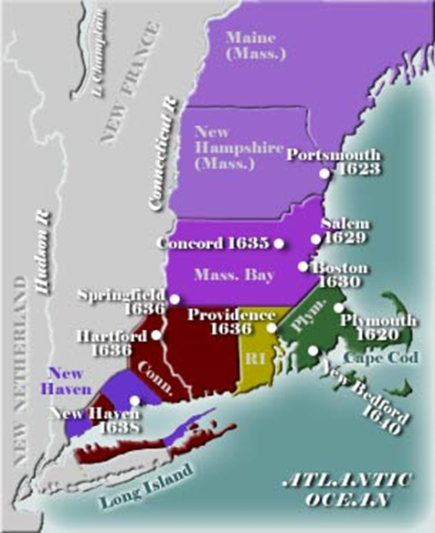
TUESDAY
- Examine the development of the New England colonies at Plymouth and Mass. Bay in the 1620s and Explain key impact of Puritanism on New England society (NAT1,6),(MIG1,2)(GEO1)(SOC5)
SOC1) (PPE-1)

Materials Strategy/Format
PPT/video Lecture/discussion/Socratic

Skill Types
I Chronological Reasoning
II Comparison and Context
III Constructing Historical Arguments

Introduction
- The development of New England is a perfect reflection of the religious tensions in England and how the would impact settlement. Religious turmoil brewed in England from the time of Henry VIII break with Catholicism (a break that became even stronger during the brief reign of his son Edward VI). During the reign of Mary I Catholicism returned briefly as she persecuted many Anglican leaders. The reign of Elizabeth I had created a period of general stability with an edict of toleration.
- However, tensions would return under the Stuart Dynasty. This was partly due to religion (the Stuarts were Protestants but leaned toward Catholicism). An additional and ultimately more important cause of tension lay in the fact that they believed in divine right rule, an idea that only the king is the head of state and is commissioned directly from God. For centuries the Parliament had existed and it became more important in the years of the Tudors. This set the stage for a conflict as many Anglicans feared the power of the king over religious affairs and doubted his Protestantism. These people became known as Puritans.
- In 1642 a Civil War erupted between the forces of King Charles I and Parliamentary forces under Oliver Cromwell. The King would be executed in 1651 and for brief period England was ruled without a king (the Protectorate was essentially a military dictatorship under Cromwell). In 1660 the monarchy was returned under King Charles II another period of relative stability and progress occurred. This will also be one of the most important periods of colonization in America.

I Plymouth Plantation (The Pilgrim Colony 1620)
- In 1620 Thomas Weston led a group of Separatists to settle in America. He and his followers had a charter to settle but were blown off course. They decided before landing to establish a set of rules that came to be known as The Mayflower Compact, the first written law code in our history and a forerunner of written constitutions. The separatists believed in a complete break with Anglicanism unlike the Puritans who simply wanted to purify Anglicanism of certain rituals. The prime motive of this colony would be profits and many settlers were not separatists at all.
- One of the enduring myths of American History centers around the first Thanksgiving (not a holiday until the Civil War) Early relations w/the Natives were pretty good. The event of what we know as Thanksgiving did happen but only once and it was only a brief respite in the growing tensions between the English and Natives.
- The financial base was the fur trade and fishing. Cash crop development was less common (therefore a tradition of slavery was less common). The colony was largely overshadowed by the larger and more successful Massachusetts Bay Colony to the north.
- The end of Plymouth started with a brutal war that was known as King Philip’s War in 1675. Beginning in June 1675, the Wampanoag tribe led by Chief Metacom (called Philip by the English), outfitted with rifles and armor, attacked a series of settlements and took the lives of dozens of colonial men, women and children. English forces retaliated in kind by destroying native villages and slaughtering the inhabitants. Soon other tribes, including the Narragansett, joined the fray and the entire region fell into conflict. The tide turned in April 1676, when the Narragansett were decisively defeated and their chief killed. Hostilities ground to a halt a few months later when Philip was betrayed, captured and killed. His corpse was drawn and quartered and his severed head placed on a stake to be paraded through Plymouth Colony. Philip's son was sold into slavery in Bermuda and many other captives were forced into servitude in homes throughout New England. One of the lon- range effects of this was the basic end of tribal independence in all of New England.
- By 1688 Plymouth was absorbed by an new administrative system called the Dominion of New England that was organized by the new king and queen of England, William and Mary.

III Mass. Bay Colony 1630
- 1630 1,000 settlers mostly merchants established this colony in the area of modern day Boston. One of the main motives was religious freedom and the key founder John Winthrop. Unlike the Pilgrims of Plymouth, the Puritans under Winthrop sought to create what he called “A city upon a hill” to serve as a model for the Anglican world to follow. Like Virginia, Anglicanism was the state faith but it was more strictly puritanical. Unlike most of the other colonies, Mass Bay had no real “starving time” and while King Philip’s War and the lesser known 1637 Pequot War did present danger, by the 1670s Native conflicts were largely over as most had converted (praying Indians) or simply migrated away.
- The Economy in Mass Bay was diverse because of the good port at Boston but also because farming was supplemented by other businesses. The shipping fishing and whaling industries would make the colony prosperous without the need of cash crops.
- The political structure Mass Bay was based around a concept of citizenship where the “saints” or the “elect” would dominate politics. Therefore, instead of land being the pre-requisite of political power, church status controlled. The system was Congregationalist meaning church served as the state and there developed a tradition of wider democracy and political independence. Perhaps it is no mistake that the American Revolution will occur here 100 years later.
Homework
Progress Check is due tomorrow

WEDNESDAY (Progress Check One is due) and THURSDAY
- SWBAT Explain the decline of the Puritan errand and the expansion of New England (IOT) answer document questions (MIG-1 CUL-1, NAT-1)
- SWBAT analyze primary sources (IOT) answer document questions on Puritan Society CUL-1, NAT-1)

Materials Strategy/Format
Ppt Lecture-discussion SL.CCR.1

Student Activities/History Skills
I Chronology and Reasoning (1, 2, 3)
II Comparison and Context (4, 5)
III Historical Argument 6,7
IV Interpretation and Synthesis (8,9)

Introduction
- Many paradoxes surround the Puritans. They left England because of religious persecution and emphasized freedom from a controlling church hierocracy, but exiled their own members who had small theological differences. They encouraged hard work and well-earned riches, but opposed worldly excesses (this is sometimes the “protestant work ethic”). Their tight-knit, restrictive society could not maintain itself as their numbers and territory increased.
- However, the Puritans left America with key values that would lead the country toward prosperity, a republican form of government (known as congregationalism). The Puritan value placed upon education. Not only was Harvard a legacy of their interest but also the Puritans created the first publicly funded education laws. Called the Old Deluder Law, Puritans believed that one must become educated as a way to avoid sin (the “old Deluder was a nickname for Satan).
- Today we will look at several factors that brought down the old Puritan ideas transforming the culture of New England.

The Dissenting Puritans
- As the 17th century went Puritan New England was starting to change. Between 1630 and 1640 around 20,000 emigrants, not all of them Puritan, crossed the Atlantic to New England. This number reached 70,000 within another 20 years as part of the Great English Migration. After the English Civil War’s political upheaval in England would practically end emigration, but the colonists would continue to expand in numbers and in territory, spreading westward and along the coast into Indian property. But as their numbers increased and as Puritans of slightly different persuasions arrived in New England, losses of unity were inevitable.
- The Puritans’ normal recourse was to send troublemakers back to England, but a man named Roger Williams (who supported Indians’ rights and greater religious freedom) escaped this and led a group who broke off in 1636 and started a new colony, building the town of Providence and eventually obtaining a royal charter for the territory of Rhode Island. Another split came when John Davenport and Roger Hooker(Connecticut) founded New Haven in 1640.

Anne Hutchison and the Antinomian Heresy
- Anne Hutchinson, the wife of a prominent leader of the community taught that God couldn't care less whether his people sinned, that there was no rule of law for Christians, and that Christians were not obligated to pray. Furthermore, she held that the men who led the colony were, like all men evil and as such, not able to lead people to salvation. Salvation was a personal issue and not one that could be coaxed or forced. Hutchison's major claim to fame was her trial and conviction for Antinomian heresy, which led to her banishment from the Puritan settlement near modern-day Boston in 1638.
- In the trial, she was charged with committing "thing(s) not tolerable nor comely in the sight of God nor fitting for your sex," which mostly consisted of holding meetings in which she and other women discussed theology. Hutchison’s challenge had important political implications because her ideas struck at the heart of Puritan power. The political leaders were known as “the elect” or “visible saints.” She essentially challenged the basic idea that the “elect” had power and that the “conversion relation” forced upon all young Puritan males was meaningless. This also struck at some socio-economic tensions.
- As newer groups came into Mass Bay and as the colony expanded to include multiple towns, many merchants chaffed at the laws against making profits (called usury).
- The charges were clearly motivated more by gender than creed, at least up until the point that Hutchinson told the court she was taking her orders directly from God, who came to her in visions. Hutchinson also claimed that God had given her special powers, including clairvoyance and precognition. This was enough for the leaders of Mass Bay. Young people were starting to resist becoming members of the Church.
The Half-Way Covenant
- By 1662, even the mainstream Puritans were realizing that they couldn’t maintain such a tightly restricted environment. Change came in the form of the Half-Way Covenant, which essentially expanded the possibility of partial membership – a halfway position in which a person could be baptized but had not yet had a conversion “experience”. Specifically, children of partial members could now also be baptized. The aftermath of the tragic Salem Witch Trials, which marked a huge travesty on justice and killed twenty people, further weakened the integration between government and religion

King Philips War 1675
- This was one of the most brutal wars in American History. By 1675 Wampanoags and other tribes dependence upon English manufactured goods led them into ever-increasing land sales, resulting in further resentment and tension. In that year, three tribal members were tried and executed by the English for the murder of a converted Wampanoag, touching off more than a year of hostilities.
- Beginning in June 1675, the Wampanoag, outfitted with rifles and armor, attacked a series of settlements and took the lives of dozens of colonial men, women and children. English forces retaliated in kind by destroying native villages and slaughtering the inhabitants. Metacom, a chief or sachem successfully united several tribes against the English settlers. Soon other tribes, including the Narragansett, joined the fray and the entire region fell into conflict.
- The tide turned in April 1676, when the Narragansett were decisively defeated and their chief killed. Hostilities ground to a halt a few months later when Philip was betrayed, captured and killed. His corpse was drawn and quartered and his severed head placed on a stake to be paraded through Plymouth Colony. Philip`s son was sold into slavery in Bermuda and many other captives were forced into servitude in homes throughout New England.
- Also, suffering tremendously during the conflict were the so-called "Praying Indians," who had been converted to Christianity, but were distrusted by both sides.
- The colonists prevailed in King Philip`s War, but the cost was tremendous. It would be more than two decades before all of the devastated frontier settlements could be reoccupied, and longer still before they began further expansion in the West. The New England Native Americans had been decimated to the extent that their impact on future events would be almost nonexistent.
Homework
Look over the materials on English colonization. This includes materials from New England and the Chesapeake. Don’t forget the information on Maryland that was not covered in class.

FRIDAY
- Quiz on English colonial development of the Chesapeake and New England colonial development.

Materials Strategy/Format
Quiz form Assessment and Review

Skill Types
I Causation
II Comparison and Context
III CCOT

Instructions
- Today will be your first short answer format quiz of the year. Notes may not be used on this assignment and you cannot work together.
- Expect several questions to have multiple parts. Look over the following materials
  - The Chesapeake (Origins of Jamestown and expansion of Virginia, Maryland)
  - The development of the New England colonies (Plymouth and Massachusetts Bay)
  - The development of Puritanism
  - Be ready to make several comparisons and contrasts between the two regions:
- Religious and governmental structure
- Gender roles and education
- Geography
- Native-American relations
- Economic bases

Weekend Homework (Due by 7 AM MONDAY August 26th )
Here is the procedure:
You will read the link below and the complete a quia.com quiz on the Restoration colonies. I highly advise that you read the articles first before starting the quiz. See below for the link to the Quia Quiz
https://courses.lumenlearning.com/suny-ushistory1os2xmaster/chapter/charles-ii-and-the-restoration-colonies/
Read the following link for a short quiz on the Restoration Colonies on these sections (you can omit the Navigation Acts for now)

- The Introduction on Charles II and the Restoration
- The Carolinas
- New York and New Jersey
- And Pennsylvania

For information on Georgia use the link below (You can just look at the founding and Ruling Georgia
https://www.thoughtco.com/facts-about-the-georgia-colony-103872

After reading about these Restoration Colonies, open the quiz below and complete it
The Restoration Colonies
http://www.quia.com/quiz/7342744.html

https://www.google.com/search?client=firefox-b-1-d&q=youtube+bacon%27s+rebellion#fpstate=ive&vld=cid:6da35f88,vid:Z_VpwQ-yTa4

