AP US Plans
November 9-13-2020

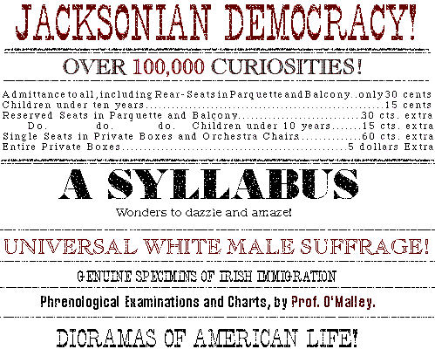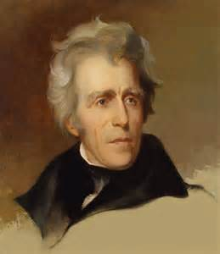

- Short week this week again for Veteran’s Day but there is still an assignment due on the Marshall Court cases
- On Friday-the weekend is our first quiz of the second quarter. See below for details.
- I will be opening some video sections on AP classroom but again these are not for a grade

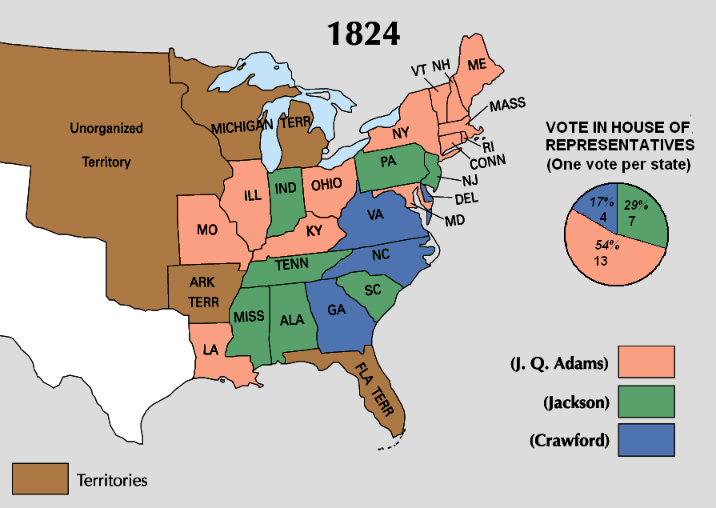
MONDAY
- Examine the Election of 1824 and John Quincy Adams
Administration (POL-2)(CUL-2) (NAT-2)(POL-2)(WXT-2)
Materials Strategy/Format
Ppt and video Lecture-discussion

Student Activities
I Chronological Reasoning (3)
II Comparison and context (5)
III Crafting Arguments (6,7)
IV Historical Interpretation (9)

Introduction
- In 1824 one of the strangest and most important elections in US History took place. President Monroe stepped aside leaving no incumbent. This often creates a mess. Another factor that led to the craziness as that the demise of the Federalist Party. Following the war with the stain of secession from the Hartford Convention and anger over the Panic of 1819 the Federalists ceased to have a national power base.
- Traditionally, a caucus of the Republican Party’s members of Congress selected the Republican Party’s candidate. At the 1824 caucus, the members met in closed session and chose William Crawford, Monroe’s secretary of the Treasury, as the party’s candidate. Not all Republicans, however, supported this method of nominating candidates and therefore refused to participate.
- When Crawford suffered a stroke and was left partially disabled, four other candidates emerged: Secretary of State John Quincy Adams, the son of the nation’s second president and the only candidate from the North; John C. Calhoun, Monroe’s secretary of war, who had little support outside of his native South Carolina; Henry Clay, the Speaker of the House; and General Andrew Jackson, the hero of the Battle of New Orleans and victor over the Creek and Seminole Indians. About the latter, Thomas Jefferson commented dryly, one might as well try “to make a soldier of a goose as a President of Andrew Jackson.”
- The election results proved Jefferson wrong. Jackson received the greatest number of votes both in the popular and in the electoral college, followed (in electoral votes) by Adams, Crawford, and then Clay. John C. Calhoun was the unopposed Vice President. But Jackson did not receive a clear majority (similarly to the 1800 Election). As provided by the Twelfth Amendment of the Constitution, the election was therefore thrown into the House of Representatives, which was required to choose from among the top three vote-getters in the Electoral College.
The “Corrupt Bargain”
- The voting in the House was contentious and a deal was struck between JQ Adams and Clay. Three days later, Adams’s nomination of Clay as secretary of state seemed to confirm the charges of a “corrupt bargain.” Jackson was outraged, since he could legitimately argue that he was the popular favorite.
- This practically guaranteed the creation of a new party to support a Jackson candidacy in 1828. The Democratic Party will form espousing most of the beliefs that we saw people complaining about in during the 1819 panic. We will go into the party beliefs a little more later on.
The John Quincy Adams Years 1824-1828
- There was no question that the younger Adams was qualified for the office. A deeply religious, intensely scholarly man, he read Biblical passages at least three times a day--once in English, once in German, and once in French. He was fluent in seven foreign languages, including Greek and Latin. During his remarkable career as a diplomat and secretary of state, he negotiated the treaty that ended the War of 1812, acquired Florida, and conceived the Monroe Doctrine. But brilliance does not always guarantee a successful Presidency. Like his father, wanting of certain political skills.
- One of the major problems that JQ Adams faced was that the Republican Party had split into two distinct camps. Adams and his supporters, known as National Republicans, favored a vigorous role for the central government in promoting national economic growth, while the Jacksonian Democrats demanded a limited government and strict adherence to laissez-faire principles. This made it difficult to get his legislation passed.
- JQ Adams was staunch Nationalist. He supported Clay’s “American System” of Federally funded building projects and internal improvements, support for the BUS, and a high import tariff. Adams proposed an extraordinary program of federal support for scientific and economic development that included a national university, astronomical observatories (“lighthouses of the skies”), federal funding of roads and canals, and exploration of the country’s territory--all to be financed by the high tariff.
- Adams’s advocacy of a strong federal government and a high tariff enraged defenders of slavery and states’ rights advocates who clung to traditional Jeffersonian principles of limited government and strict construction of the Constitution. They feared that any expansion of federal authority might set a precedent for interference with slavery. Thomas Jefferson himself condemned Adams’s proposals, declaring in a stinging statement that they would undermine the states and create a national elite.
- Adams’s Indian policies also cost him supporters. Although he, like his predecessor Monroe, wanted to remove Native Americans in the South to an area west of the Mississippi River, he believed that the state and federal governments had a duty to abide by Indian treaties and to purchase, not merely annex, Indian lands. Adams’s decision to repudiate and renegotiate a fraudulent treaty that stripped the Georgia Creek Indians of their land outraged land-hungry Southerners and Westerners. You will recall from your Supreme Court research that two major cases will come from this situation during the Jackson years.
Foreign Policy
- For a man who ranks among the most accomplished of America's diplomats, John Quincy Adams achieved little of consequence in foreign affairs as President. Part of the explanation for this poor record lies with the determined opposition of Adams's rivals in Congress to deny him any mark of success that might help him in the election of 1828. For example, when the new Latin American republics, which had formerly been Spanish colonies, convened a congress in Panama to promote cooperation in the Western Hemisphere, it was logical for them to ask for delegates from the American President who had authored the Monroe Doctrine. When Adams requested funding to send two delegates, southern congressmen strongly objected. The new Latin American nations had outlawed slavery, and southerners feared that the conference might call for a united stand in favor of emancipation everywhere in the hemisphere. Another issue that bothered many in Congress was Adams public statement that Haiti, be given diplomatic recognition. As you may recall (or maybe not as many people missed this question) that Haiti was the product of a slave uprising. That frightened southern slave owners.
Conclusion: The 1828 Election
- The 1828 Election featured terrible mudslinging (personal attacks not necessarily based on the issues) Adams’s supporters dug up an old story that Jackson had begun living with his wife before she was legally divorced from her first husband (which was technically true, although neither Jackson nor his wife Rachel knew her first husband was still living). They called the general a slave trader, a gambler, and a backwoods buffoon who could not spell more than one word out of four correctly. One Philadelphia editor published the Coffin handbill picturing the coffins of 12 men showed another dozen coffins, representing regular soldiers and “Indians” who were put to death under Jackson’s command. Jackson’s followers repeated the charge that Adams was an “aristocrat” who had obtained office as a result of a “corrupt bargain.” The Jackson forces also alleged that the president had used public funds to buy personal luxuries and had installed gaming tables in the White House. They even charged that Mrs. Adams had been born out of wedlock. One more interesting allegation charged Adams with being a pimp, getting a “girl” for a Russian dignity.

Homework
Work on your Supreme Court cases if needed, if you finished, take a break

TUESDAY
- Examine key issues of the 1820s and 1830s (IOT) understand how they related to the Democratic Party (NAT-2) (POL-2) (MIG-3) (WTX-2) (CUL-2)

Materials Strategy/Format
PPT Lecture-Discussion (SL.CCR.1)

Student Activities
Chronological Reasoning (1)(2)(3)
Comp. and context (4)
Crafting Arguments (7)
Interpretation and Synthesis (8)(9)

Introduction
Last week we saw an important election in 1824 which was a real mess. What were some of the unusual aspects of the 1824 election? What was the “corrupt bargain” and how did it impact the development of the new Democratic Party?
The period of the 1820s roughly though 1840 is known as Jacksonian Democracy. This like the Era of Good Feelings is a part of the much larger period known as the Antebellum Era It is so named because Jackson was the towering figure of the period. The series of electoral changes were not all due to him but he certainly capitalized upon them. In the end the Democratic Party will reign supreme for the next 12 years with Jackson and Van Buren.
Our first task of this week is to look at some of the key changes of the period. Then, we will look at Jackson’s Presidency and assess him as a nationalist who supported a strong central government as the National Republicans did or a states’ rights supporter as the Democrats.
Procedure

1 Internal Improvements and who should fund them?
The post war period was an era of intense economic development and the National Republicans under JQA and Clay had believed that federal funding was necessary for infrastructural improvements. Democrats believed that these only favored northern industrial states. A few wealthy southerners did support Clay’s American System but not enough to allow many projects to be completed.
2. The BUS and should it be re-chartered?
The arguments against the BUS were intensified as a result of the Panic of 1819. Many believed that the BUS had failed in its regulatory capacity. Southern and western states believed that the BUS had too much power and believed that state banks were more important.

3. Import Tariffs should we have them?
The Democrats had constant support against Import tariffs because farmers feared European retaliation. National Democrats still believed as their Federalist forebears that tariffs were critical protectionist measures needed to allow industrial growth.

4 The nature of money hard or soft?
This is known as the money question and it will follow us for months to come. The National Republicans (and later Whigs and Republicans) favored a currency backed by gold. This was called hard currency. They reasoned that it always had value and rarely ever declined in value. The problem with this system was that it constricted credit and guaranteed a wealthy class would always exist as a minority since they controlled most of the gold.
The Democrats favored a currency that was either bi-metallic so that the money would go farther and that credit was facilitated. This is called soft currency. Some radicals in the post-Civil War years called for a non-specie currency (like we have now).
5. The very beginnings of an abolition movement
As yet the idea of abolitionism was still not common. This term means the ending of the slave system. This could be gradual emancipation or more radically, immediate emancipation. The Missouri Crisis started a process of radicalization of both pro and anti-slave forces. The year 1831 will be a turning point in this because of Nat Turner’s Rebellion (more on this later)
6. Patronage or “the spoils system”
Andrew Jackson believed that one of the greatest threats to liberty was the notion of an entrenched elite group that governed without the will of the people. To address this concern he created a system called “patronage” or as some called it, the “spoils system” from the old expression about war that said “to the victor goes the spoils.” So, Jackson fired many people and replaced them with his own. This is not to e confused with naming one’s own cabinet.

WEDNESDAY (No Class Today, Supreme Court cases due Today in Teams)
Go Tell a Veteran “thank you for your service.”

THURSDAY
- Identify the key issues of the Jackson Administration (IOT) understand creation of the Second Party System 1828 – 1836 (NAT-2)(POL-2)(WXT-2)

Materials Strategy/Format
PPT Lecture-discussion (SL.CCR.1)

Student Activities
Chronological Reasoning (1)(2)(3)
Comp. and context (4)
Crafting Arguments (7)
Interpretation and Synthesis (8)(9)

Introduction
- When Andrew Jackson became President in 1828 he represented a real departure from politics as usual. Some feared that he represented instability (“King Mob”) others feared his dictatorial reputation for ignoring the wise counsel of others (“King Andrew I”).
- However, the truth of the matter was that Jackson resisted definition. His policies (like Jefferson’s) often times went counter to the beliefs of his own supporting party. In general Jackson refused to toe the party line especially since the Democratic Party was his creation. One of the reasons that Jackson did not consistently act in the interests of the farming south and west was that he now commanded a national party with support in Pennsylvania, New York, and New Jersey.
- One of the main reasons for his support beyond his power base was the work of his second VP and future one term President Martin Van Buren. Van Buren was the master of what was called “machine politics.” He created an organization called “the Albany Regency” that consistently brought in Northern Democratic votes from urban lower classes (many of whom still support the Democrats today). In addition, urban political bosses such as William Marcy Tweed (Boss Tweed) and his Tammany Hall organization sometimes used illegal practices to get out the vote for the Democratic Party.
- Today and tomorrow we will look at the key issues of Jackson’s Presidency and assess him as more nationalist or more state’s rights.

The Jackson Years 1828 - 1836
The War on the BUS and early attempts to re-charter
The so-called Bank War really started in 1829 when Jackson made clear his disdain for the institution and his preference for state banks. When he ran for President in 1824 he had made no outward attacks on the BUS but it became an issue when Nicholas Biddle (the chairman of the BUS) and Henry Clay applied to renew the bank's charter four years earlier than necessary in order to make it an election issue. But when Jackson easily won in the election of 1832, he interpreted this victory as a mandate to terminate the bank entirely.

- Jackson believed that attempts to re-charter the BUS before its charter was up amounted to a political attack. Before this time he had not liked the BUS but never really attacked it. He said that it was an institution of elites/ “monied class”
- The Pet banks were how Jackson killed the bank. Deprived the BUS of Fed. Income, it would essentially cease to exist. In exchange Jackson placed revenue in state banks. Is this a good idea? Will there be enforcement of banking laws?

The Money Question
- The three positions on the nature of money: Gold, bimetallic, no real specie backing. Democratic Position (bimetallic or even perhaps just paper) Why? More money in circulation equaled easier credit. This is good for farmers and small business.
- Jackson’s position was toward a more solid gold foundation. He worried about paper and preferred specie backing because of its stability while paper can wildly fluctuate and lead to inflation. The “Locofocos”
were a Democratic group that hated Jackson over this position!
- Jackson’s position became evident when in 1836 when he issue what was known as the “specie circular” when he feared the sale of public land would be compromised over worthless paper currencies. The sudden contraction of land sales will drive another depression, the Panic of 1837 ruining Van Buren’s administration!

The Nullification Crisis
This involved the passage of a new tariff bill in 1832. The 1828 Tariff passed before Jackson entered office was called the “tariff of abominations” by many southerners, especially in South Carolina. The Tariff of 1832, despite pleas from Southern representatives, failed to moderate the protective barriers erected in earlier legislation. When Andrew Jackson signed the new tariff bill, it created a firestorm in South Carolina
- The South Carolina passed an ordinance of nullification on November 24, 1832, and threatened to secede if the federal government attempted to collect those tariff duties. Nullification as you remember was not new. Virginia and Kentucky had threatened the refusal to obey the Alien and Sedition Acts.
- In reality the anger over the tariff was a reflection of economic woes that predated the two tariff bills. South Carolina was one of the first to cultivate cotton and as cultivation spread to the Deep South, prices declined. The lack of diversification, a recent slave uprising, and soil exhaustion all equated to a siege mentality.
- Robert Hayne had resigned from the Senate to run for governor of South Carolina. John C. Calhoun resigned the vice presidency and took Hayne’s seat in the Senate. Calhoun’s resignation was also due to a small treatise that he had written, The South Carolina Exposition and Protest asserting the right of a state to resist a Federal law. A further souring of relations occurred because of ridiculous infighting in Jackson’s cabinet over how the Secretary of War’s wife was treated at social events (The Peggy Eaton Affair) These two men spearheaded the nullification drive. A real possibility of secession and war existed.
- President Jackson thought that nullification was tantamount to treason and quickly dispatched ships to Charleston harbor and began strengthening federal fortifications there. Congress supported the president and passed a Force Bill in early 1833 which authorized Jackson to use soldiers to enforce the tariff measures.
- Enter the hero again: Henry Clay again took up his role as the. On the same day the Force Bill passed, he secured passage of the Compromise Tariff of 1833. This latter measure provided for the gradual reduction of the tariff over 10 years down to the level which had existed in 1816. This compromise was acceptable to Calhoun who had not been successful with finding any other state to support him on nullification (Georgia refused because Jackson had supported them on Indian Removal as you will see later). Jackson signed both measures.

The Maysville Road Bill
As we saw previously, when Jackson took office, the leading controversies in Congress concerned the "American System" of economic development policies propounded by Henry Clay and furthered by the previous Adams administration. As a senator in 1824, Jackson had backed the System's twin pillars of a protective tariff to foster domestic industry and federal subsidies for transportation projects (known as "internal improvements"). These policies were especially popular in the country's mid-section, from Pennsylvania west through Ohio to Indiana, Illinois, and Missouri. They were widely hated in much of the South, where they were regarded as devices to siphon wealth from cotton planters to northern manufacturers
- Jackson announced his new policy by vetoing a bill to aid the Maysville Road in Kentucky in 1830. A string of similar vetoes followed, essentially halting federal internal improvement spending. He may have chosen this particular example as a slap against his political adversary and author of the American System Henry Clay because Kentucky was his home state.

Indian Removal
One distasteful acts of Jackson’s Presidency involved removing Natives from the southeast. It is difficult to know how to look at Jackson on this issue. Jackson did not hate Indians as a race. He was friendly with many individual Indians, and had taken home an Indian orphan from the Creek campaign to raise in his household as his adopted son. It is much better to look at the Indian Removal Act and subsequent “Trail of Tears” as a political event rather than simple racism.
- The inherent conflict between tribal and state authority came to a head just as Jackson assumed office. The Cherokee nation had well-established boundaries and had adopted a constitutional form of government and the National Council had made it clear that it would not agree to further cessions of territory. Under its treaties with the federal government going back to the Articles of Confederation, the tribe claimed sovereign authority over its territory, which Georgia and adjoining states also claimed as within their borders. Georgia, Alabama, and Mississippi countered by asserting state jurisdiction over Indian domains within their boundaries.
- Jackson backed the states. He maintained that the federal government had no right to defend the Cherokees against Georgia's encroachments. If the Indians wished to maintain their tribal government and landownership, they must remove beyond the existing states. For Jackson, this meant the future state of Oklahoma which he suggested would forever be reserved (hence the term “reservation”) for Natives.
- In a stunning turn of events, the Cherokee appealed their case to the Supreme Court. Tentatively in Cherokee Nation v. Georgia in 1831 and more forcefully in Worcester v. Georgia the next year, the Supreme Court upheld the tribes' independence from state authority. However, because Jackson supported the states that supported him, the Indian Removal Act 1830 was enforced over the rulings of the Marshall court.

Homework
Look over your notes for this week for short answer format Quiz in class on Friday (due Monday 3:00 pm)

FRIDAY
Analyze primary sources (IOT) answer Assessment questions on Jacksonian Democracy (NAT-2) (POL-2 )(WXT-2)

Materials Strategy/Format
Doc. Based Quiz format Assessment and Review

Student Activities
Chronological Reasoning (1)(2)(3)
Comp. and context (4)
Interpretation and Synthesis (8)(9)

Instructions
This is a short answer format quiz using primary sources on the Jacksonian Period. The answers should be uploaded in Teams by 8:00 AM Tuesday 11/17/2020
HW
Complete the quiz questions on Jacksonian Primary Sources Quiz

