AP US History
October 19– 23 2026
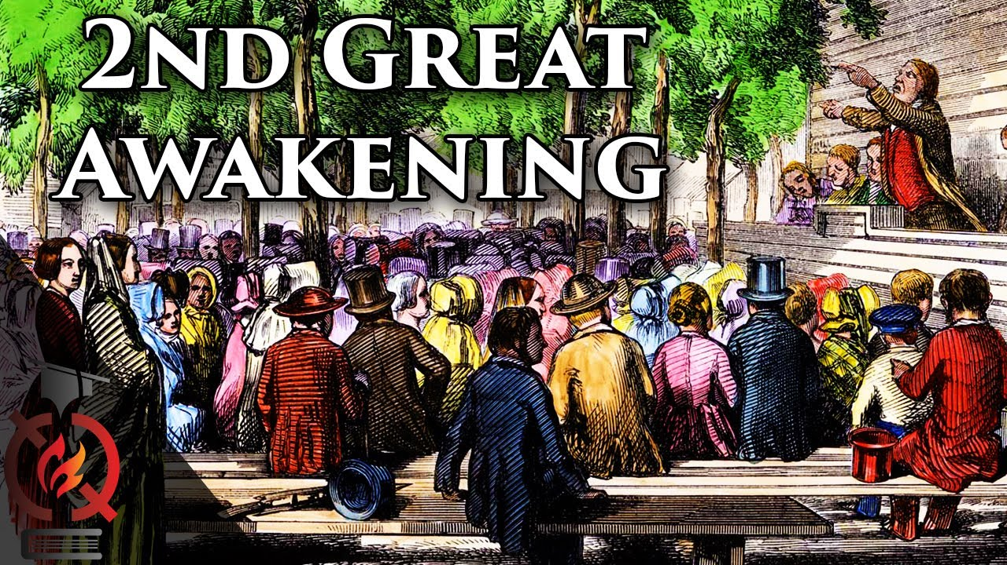
- Well, it looks like we will also lose class time on for the PSAT, but I haven’t seen a schedule for that. It is supposed to be on Thursday but due to the computer shortage who knows if we will also be interrupted on Friday? The material below, however, still needs to be covered and there are a couple of assignments to be completed outside of class. So, this is the reason why the lesson plan looks a bit weird this week.
- While you do already have a grade for Q2 we will dive in more this week. Besides the usual document sets we also have an assignment using one of the AP classroom videos about American culture during the early antebellum period. The questions and link are found below, and it is due in class on Friday. Also, on AP Classroom there is a review activity called Quarter 1 Review that is a MCQ sampling of materials from Unit1-Unit4 (we have not finished unit 4 obviously so the questions reflect only what we have covered).
- Our next unit test will be toward the end of next week after we cover the Causes-Effects of the Great Awakening and the impact of antebellum immigration. The unit test will be MCQ-SAQ format.

MONDAY
No classes….enjoy one last day of fall break

TUESDAY
- SWBAT explain key ideas of the Whig Party and the 2nd Party System (IOT) complete primary-secondary sources

Materials Strategy-Format
PPT and Document reader lecture and close text reading

Introduction
Before we headed out for the fall break, we had been discussing the Democrats and Jacksonian Democracy. The Democrats had formed during the 1824-1828 period when JQ Adams had become President and the
Jackson people claimed that a “corrupt bargain” had been made. We discussed how the Democratic Republics had rebranded themselves ahead of the 1820 election reflecting the collapse of the Federalists but by 1824 regional disputes. Now following Jackson’s landslide in 1832 a new party begins to form branding itself the Whigs, a reflection of the pro-Revolutionary faction during the Revolution and the more liberal British party that often agreed with American arguments.

The Second Party System forms
As I have mentioned about a hundred times the Second Party System is far more complex than the first version partly b/c both parties changed names but also because new issues developed.
The Powerbase of the new Whig Party
a. Not surprisingly they reflected much of the ideas of the earlier Federalists so we would find widespread support in the New England area and as they supported ideas such as internal improvements, tariffs and a 3rd BUS. The upper classes and many in the middle class supported the party for its economic policies.
b. But here is where it gets weird; many in the large planter class (slave owners) supported the party b/c they understood that federally funded internal improvements would also benefit them. It was still difficult to get their crops to market. Yet, among many New England Whigs there was a strong anti-slavery sentiment (known as “conscience Whigs). Some of these abolitionists would even break in the 1840s to form the Liberty Party. This split will also eventually lead to the end of the party by the early 1850s.
c. Another change in politics from the first party system involved social issues such as immigration and temperance. The Whig Party while not necessarily being anti-immigrant were concerned about Irish immigration in particular that brought a huge influx of Catholicism. This was largely a byproduct of the Potato famine. There was also a wave of German immigration larger in fact than the Irish. For many urban dwelling Whigs their concern was beyond religion but also what they believed to be a dangerous culture of drinking and also a need to “Americanize” immigrants. This will also lead to the first major push for public education and even the teaching of American History.

The Election of 1840 the “Log Cabin and Cider Campaign”
In 1836 the Whigs ran 4 regional candidates perhaps in hopes of driving the election into Congress but this failed and Martin Van Buren became President and then almost immediately a panic stuck. In 1819 no one would have used a panic as a campaign ploy but in this case the Specie Circular was used against MVB as he had been the VP under Jackson (another reason why running as a former VP can be tough). However in 1840 the Whigs selected William H Harrison the hero of the 1811 defeat of Tecumseh at the Battle of Tippecanoe. The Democrats poked fun at Harrison’s age and rustic background. Calling him old granny and suggesting he just wanted to be left alone to drink (hard cider is an alcoholic Beveridge). Instead of deflecting the criticism the Whigs embraced it. They flipped the “common man” ideology of Democrats. Also they selected future President John Tyler as Harrison’s running mate. They even created a jingle. “Tippecanoe and Tyler too.” This was also significant because some Democrats flipped their support out of anger toward Jackson even though he wasn’t running. The map reflects deep south support for the Whigs as well as northern support.
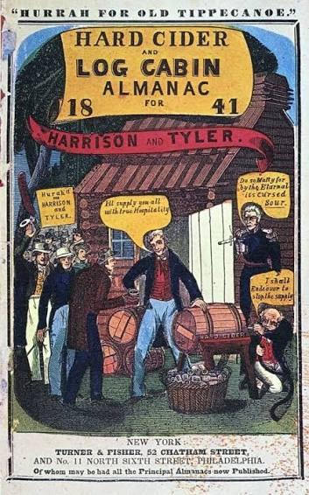
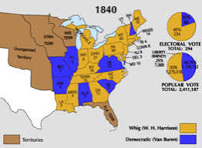

WEDNESDAY (Not sure what Thursday or Friday will look like??)
- SWBAT identify and explain causation of the Second Great Awakening (IOT) complete primary sources

Materials Strategy/Format
PPT and Document Book Close text reading-direct instruction

Student Skills
Contextualization Causation Evaluation

Instructions and Introductions
- The Second Great Awakening 1800 – 1850s was another massive revival movement that swept the antebellum period in America. Like the first version during the colonial era, religion played a major role in the development. This movement featured two important components that were different from the first wave. Evangelism is the idea that one must spread the faith and convert non-believers. A synthesis can be drawn with the Catholic attempts during the 16th and 17th centuries in Latin America. A second important component is a spirit of utopianism centered around the idea of spiritual renewal. This was different b/c the first GA preachers never really preached a message that people could work towards grace. If the person can be spiritually reformed then so can the community, nation, and perhaps the world. As a synthesis we will see a similar idea as a motive for American imperialism. This utopianism will lead some groups to close inward and become more tightly knit as they face growing condemnation from mainline Protestant faiths.
- The main denominations that exemplify the Second GA are the Mormons, Shakers, Millerites, and Unitarians. While each was unique in some of its tenets, they all share the evangelism and utopianism of the period. It should also be noted that there were also non-religious communities that experimented with communal living such as Brook Farm, New Harmony, and right here in Shelby County a commune created by Francis Wright. Many of these were inspired by a growing spirit of utopian socialism brought here by immigration.
- The reform movements that characterized the Second Great Awakening DIRECTLY related to a wave of reform movements in the antebellum period. The central theme of spiritual renewal and the belief that people could attain a state of grace led to a huge wave of reforms. The antebellum experienced no bigger cultural and social reform movement. Remember social history is almost 40% of the AP exam and the antebellum movement makes up a large portion of the exam questions. Strategy dictates that we pay close attention to this period.

The Key Reform Movements
Overview
No subject this semester is as important as the Civil War and today marks a very important change in thinking about it. Remember Slavery beliefs of the past? Why is the women’s movement related to abolition?

I The Early Abolition Movement
- American Colonization Society (1817)
a. What goals? b. Procedure c. Why it did not work?

- The Quakers and Benjamin Lundy
  - 1821 first abolitionist newspaper was called the Genius of Universal Emancipation

- The pivotal years of the 1830s
  - The Nat Turner Rebellion was the largest and most bloody slave insurrection in American History. It effectively created what I call a " siege mentality" among many slave owning southerners. Perhaps more importantly even those southerners who hated the "peculiar institution" felt threatened by the perceived radicalism of the abolition movement. Though it was likely untrue, many in the south felt that Turner's Rebellion had been inspired by abolitionists. The net effect of the Turner's Rebellion was also a stiffening of slave codes. In other words, not only did his rebellion fail, it made matters worse for slaves.
  - The publication of William. Lloyd Garrison’s paper The Liberator also accelerated awareness of the plight of slaves. Though it had a small readership, Garrison's paper wasthe clarion for northern abolitionism.
  - Frederick Douglass and Sojourner Truth became key former slaves in the abolition fight. Both shared a passion for abolition and were equally eloquent in their attacks.
  - A lesser known but historically important event occurred when publisher Elijah P. Lovejoy was killed in 1837. This shocked northerner because he was killed by a pro-slavery white mob in a northern free state: Alton Illinois. This event in the 1830s perhaps second only to the Nat Turner Rebellion stoked fears about the future of the slave debate.

- Split in the Movement
  - The abolition movement weakened in this period because a difference over how to attack slavery. Some believed that the only way to succeed was to work within the political system. The Political Arm of Abolitionism was The Liberty Party. The fielded candidates in 2 elections in the 1840s and was the only party to be completely dedicated to abolition of slavery while most others claimed only to seek to halt the spread of the slave system.
  - Others blended their Christian zeal by employing the language of revival against slavery in the north. The connection between the Second Great Awakening becomes clear when ministers such as Lyman Beecher begins to preach against system and take funds to halt the spread.
  - William Lloyd Garrison’s view called for a non-violent resistance and later overthrow of government. He stated publically that this was the only way to end the system. Another radical was David Walker whose publication The Appeal called for an armed slave uprising to end. As a young adult he moved to Charleston, a mecca for upwardly mobile free blacks, where he was affiliated with a strong African Methodist Episcopal Church community of activists.
  - One of the main reason for a split in the abolition movement was over the role of women. Many women joined the movement but the more moderate men did not want them to play a political role. They wanted the women to stay in the background and saw this as the only proper role. Douglass and Garrison both supported women's rights to be political. It was this stance that also helped to create the movement below.

II Women’s Rights
- As we mentioned in class last week, women were starting to become more political and the early temperance movement was one of the first occasions that we see this. However, the exclusion from abolitionism played a major role. As you know no suffrage yet existed for but public involvement in protests did.
- Lucretia Mott and Elizabeth Cady Stanton were two of the earliest leaders to call for women's suffrage and complete equality for women
- Seneca Falls Declaration was the statement of demands for the early women's suffrage movement. It was also supported by many moderate men in the abolition movement like Frederick Douglass as radicals such as Garrison. Though they accomplished none of the goals, the platform continued for the next 100 years.

Two of the most important social mvts. To arise from 2nd GA is the move toward temperance and school reform. Ironically on the issue of alcoholism it seems that we may have moved back to a pre-GA belief that it was somewhat out of our hands to control. Also, education reform seems to be moving away from public education.

III Temperance (The Anti-Saloon League)
- Why was there such an increase in alcohol consumption? Farmers and grain alcohol, better transportation)
- Was this a problem exclusive to men or just more noticeable? The answer is hard to discern because only men drank publicly. Women who did were considered low class so most in the middle and upper classes stayed away from bars. This does not mean that women didn't become alcoholics.
- There were many social and economic problems that followed such drunkenness. Women were also victimized and families threatened by male alcoholism. One of the greatest supporter of the movement were actually middle and upper class business owners who saw alcoholism as a threat to reduce profits. The Whig Party that supported these reforms for both political and social reasons.
- There was some success of the movement because consumption did go down and the state of Maine actually abolished alcohol for a time.

IV Education Reform
- The reason for the sudden interest in reform involved political, economic, and social factors. The new wave of immigration coupled with an interest in the more technical nature of the economy played major roles in the movement. The wave of German and Irish migrations seen in the 1840s were of particular concern.
- Americanization and those who opposed these measures: As we mentioned in class Catholics and Jews created their own school systems when it became apparent that at least some reformers tried to push a protestant line.
- Horace Mann, the education commissioner in Massachusetts played a major role and his reforms are still around: grades (both levels and marks to show success, textbooks, standardized curriculum and teacher training are all his legacies.....for better or worse, LOL.
- Success of the movement? It was highly successful but only in the North at this point. State sponsored and taxpayer funded education was not an interest in the South. Also, the agrarian nature played a role. However, if one looked for college education, the South more than competed because southern elites were some of the most highly educated men in America.

V Prison Reform
1. Dorothea Dix launched an investigation of the system in Massachusetts and the results were appalling. There was no set standard of sentencing and this meant that murderers were housed with petty thieves, children were housed with hardened criminals, and the insane imprisoned for no crimes at all.
2. Here again was a movement with some success. Not only did she reform the state prisons, Dix was instrumental in pushing the idea of reforming felons and not simply locking them away.
3. Another aspect of prison reform was known as the Auburn System. This was basically the idea of isolating inmates in their cells but also potentially rehabilitating them by placing them in work assignments. The Whig Party were big supporters of this idea in that they hoped that it retrained the inmate and our modern lower security prisons still attempt to reflect these ideas. In the 20th century (especially the 1930s in the American south this took the form of chain gangs (If you've ever seen the movie O Brother Where art Thou you know what I mean….if not it's pretty funny so watch it…the film is actually based upon the Greek play Odysseus

Homework (due in class on Friday)
View the following video and answer the associated questions. This can be typed or handwritten but no emails unless you will be out on Friday.
https://apclassroom.collegeboard.org/1/home?apd=ux56woqp2q&unit=4
The Growth of American National Cultural
1. Who was Noah Webster and what was his contributions to American Culture?
2. Very evident in Washington D.C. what foundations of architecture were noted in the video?
3. What was the Hudson River school?
4. Give a brief description of music during the antebellum period.
5. Who were the “Knickerbockers” and who were the two authors cited as examples?
6. What European philosophical movement influenced the American Transcendental movement? Give a brief discussion on the movement and include the importance of Henry David Thoreau.
7. What was the importance of the “penny press.” How do you think that this impacted literacy in America?

Weekend Homework (Due Monday)
Quarter 1 Review on AP Classroom. This is a 50 question MCQ sampling of materials from UNIT1 – UNIT4

