AP US History Unit 3.1 Test
Annotated Answers
Questions 1-3 Relate to the Image Below
“These colonies ought to regard the act with abhorrence. For who are a free people? Not those over whom government is reasonably and equitably exercised but those who live under a government, so constitutionally checked and controlled, that proper provision is made against its being otherwise exercised. The late act is founded on the destruction of constitutional security.… In short, if they have a right to levy a tax of one penny upon us, they have a right to levy a million upon us. For where does that right stop?...To use the words of Mr. Locke, ‘What property have we in that, which another may, by rights take, when he pleases, to himself?’…We are therefore—I speak it with grief—I speak with indignation—we are slaves.”
John Dickinson, Letter from a Farmer, 1768
1. The passage above was written in response to
a. calls for a stronger central government. b. British efforts to tax the colonies.
c. debates over the issue of slavery. d. the perceived corruption of the British government.
This was about the Townshend Duties and was one of the primary sources.
2. Which of the following historical developments most directly precipitated the conditions leading to the argument in the passage above?
a. The growth of the Atlantic economy during the 18th century
b. The spread of French revolutionary ideas throughout Europe
c. The large British debt incurred from the Seven Years’ War
d. The indifference of the British government to colonial governance
The word precipitated means to cause or start something. The debt was the issue for all of the revenue measures.

3. Which group would most likely have supported the sentiments expressed in the passage above?
a. Loyalists in the 1770s and 1780s b. Backcountry rebels in the 1780s and 1790s
c. Whigs in the 1760s and 1770s d. Republicans in the 1850s and 1860s
The Patriots called themselves Whigs after the more liberal party in Parliament.
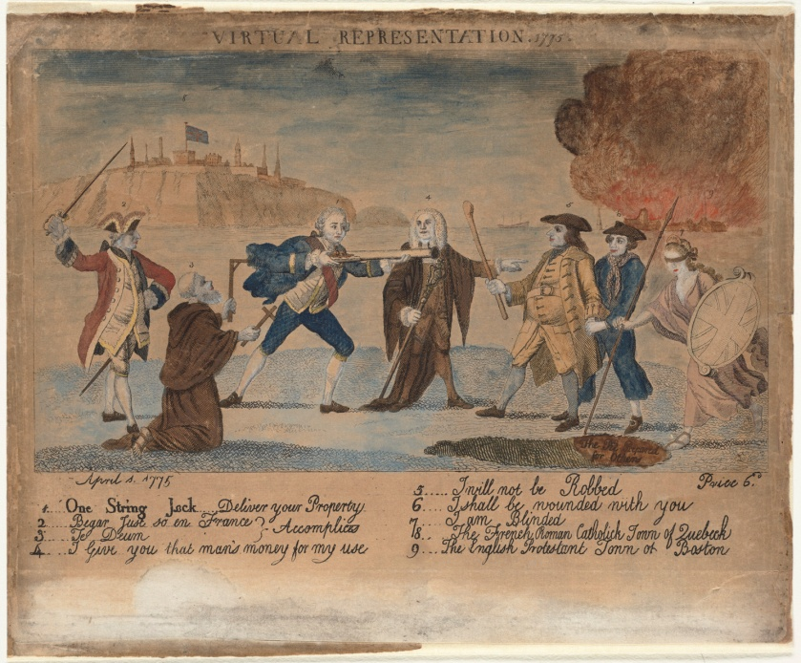
Questions 4-7 Relate to the Image Below

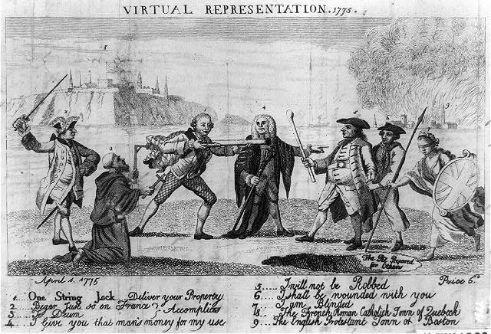
Political Cartoon on Virtual Representation, etched engraving, April 1775
4. The image above can best be seen as depicting
a. the support of colonial independence by European allies.
b. loyalist opposition to colonial independence movements.
c. the dangerous influence of the French Revolution.
d. the British government constraining colonial rights.
This related to the idea of virtual representation where all members of Parliament spoke for everyone was questioned by Americans who wanted a direct voice in Parliament (actual representation)

5. Which of the following turning points set the stage for the controversy depicted in the cartoon above?
a. Britain’s victory over France in North America
b. The spread of French revolutionary ideas throughout Europe
c. The signing of the Declaration of Independence.
d. The American Revolutionary War
Again it was about the war debt.

6. Which of the following British revenue measures first drove the colonial arguments related to unfair representation?
a. The Navigation Acts b. The Stamp Act
c. The Sugar Act d. The Quebec Act
This was the first revenue measure designed to tax colonists to pay down the war debt. Not only were colonists not allowed to implement the tax nor vote it, it represented several betrayals traditional rights of the accused

7. The American independence movement was least fueled by
a. the impact of revivals and evangelical ideas. b. Enlightenment political thought.
c. colonial economic concerns. d. the fear of attack from other European powers.
This played no role in the colonial protests.

Questions 8- 10 Relate to the Map Below
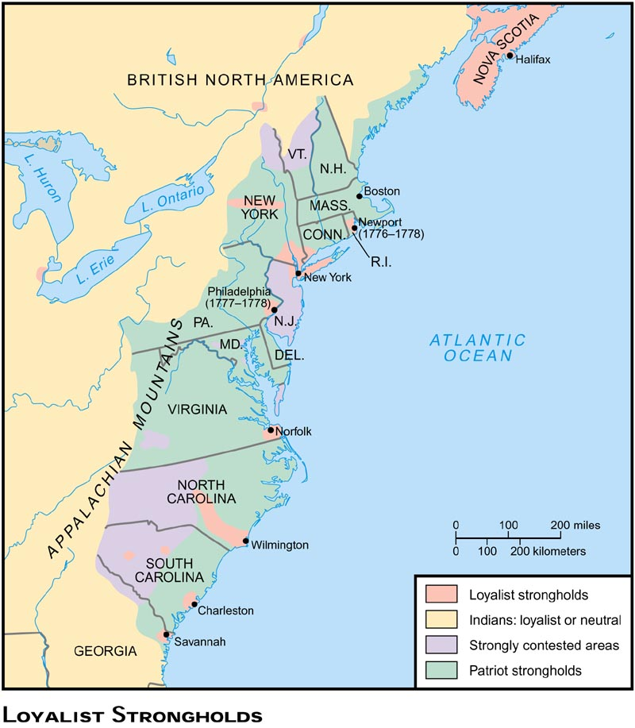

8. Which of the following areas could most accurately be considered a Whig stronghold?
a. New England coastal regions b. The Old Restoration colonies
c. The Deep South d. Nova Scotia
Meaning the most likely to rebel and join the Patriot cause

9. The British strategy culminating in the 1777 Battle of Saratoga played upon loyalist sympathies in
a. Georgia b. New York c. Connecticut d. Pennsylvania
The British strategy was to divide the county and isolate the New England states.

10. What factor most likely explains the strength of Tory support in major port cities?
a. Most recent arrivals settled there and were staunchly pro-British
b. Most Irish Catholics were poor and were forced to live in coastal regions
c. The "middling classes" were tied to trade with Britain
d. Nearly all educated people lived in port cities
The middle class on both sides of the Atlantic tended to trade and so a break from Britain threatened many people’s livelihoods.
Questions 11- 13 Relate to the Passage Below

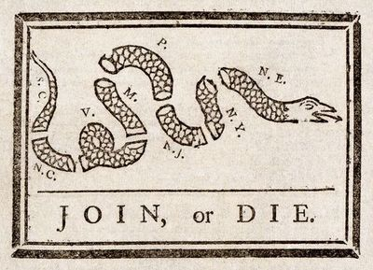

11. The historical context for the illustration to the left was
a. A Recruiting poster for the Sons of Liberty
b. The 1760s during the French and Indian War
c. A banner for the Stamp Act Congress
d. A propaganda leaflet issued by Federalist newspapers

12. The illustration related to
a. The Stamp Act Congress b. The Albany Plan of Union
c. The First Continental Congress d. The Suffolk Resolves

13. The image suggests the lack of colonial unity but which of the following first showed a growing sense of American identity?
a. The Albany Plan of Union b. The Stamp Act Congress
c. The House of Burgesses d. The First Continental Congress
This was the Ben Franklin illustration in 1760 to create unity against the French as part of the Albany Plan

Questions 14 – 16 Relate to the Passage Below
“Friends and Fellow Subjects,
When a Nation led to Greatness by the Hand of liberty, and possessed of all the Glory, the Heroism, Munificence, and Humanity can bestow, descends to the ungrateful Talk of bringing Chains to her Friends and Children, and, instead of Giving Support to Freedom, turns Advocate for Slavery and Oppression, there is reason to suspect she has either ceased to be virtuous, or been extremely negligent in the appointments of her rulers....
At the conclusion of the late war...under the influence of that man [Lord Grenville], a plan of enslaving your fellow subjects in America was concerted, and has ever since been pertinaciously carrying into execution….”
Continental Congress, 1774

14. Which of the following events led directly to the convening of the Continental Congress?
a. The Stamp Act Crisis b. The Battles of Lexington and Concord
c. The Boston Tea Party d. The Boston Massacre
The congress was a response to the Coercive Acts
15. The mention of the “influence of that man” was a direct reference to
a. The Stamp Act Crisis b. The writs of Assistance
c. The Townshend Duties d. The Boston Massacre
They are targeting Lord Grenville who initially bypassed the normal tax procedure with the Stamp Act.

16. The historical context of the source would have been in response to Britain’s
a. Writs of Assistance b. The Coercive Acts
c. The Navigation Acts d. The Townshend Duties
see 14 above.

Questions 17 - 19 Relate to the Passage Below
Philadelphia, 1776
Resolved,
That these United Colonies are, and of right ought to be, free and independent States, that they are absolved from all allegiance to the British Crown, and that all political connection between them and the State of Great Britain is, and ought to be, totally dissolved.
That it is expedient forthwith to take the most effectual measures for forming foreign Alliances.
That a plan of confederation be prepared and transmitted to the respective Colonies for their consideration and approbation.
Record Group 360: Records of the Continental and Confederation Congresses and the Constitutional Convention, 1765 - 1821

17. Which of the following most precipitated the above resolution?
a. The Boston Massacre of 1770 b. The Battle of Breed's Hill 1775
c. The Administration of Justice Act 1774 c. The Boston Tea Party 1773
Called the “Murder Act” it was part of the Coercive Acts

18. Which of the following states would have least supported the above resolution?
a. Massachusetts b. Virginia c. New York d. New Hampshire
It was early a hotbed of loyalist support.

19. Which of the following countries would have been most sought as an American ally in 1776?
a. Canada b Ireland c. France d. Russia

Questions 20 – 23 Relate to the Passage Below
"It is inseparably essential to the freedom of a People, and the undoubted Right of Englishmen, that no taxed be imposed upon them, but with their own consent, and given personally, or by their own representatives…That it is the indispensable duty of these colonies, to the best of sovereigns…to procure the repeal of the act for granting and applying certain stamp duties, of all clauses of any other acts of Parliament…for the restriction of American commerce."
Thomas Jefferson 1765

20. The resolution of the Stamp Act Congress in 1765 expressed respect for which of the following
a. Colonial Merchants b. Merchants in Britain
c. Leaders in Parliament d. The Archbishop of the Anglican Church
Recall that some like William Pitt the former PM supported our claims related to taxation

21. For some time the Stamp Act placed on the colonies a tax that was
a. A property tax b. Direct c. To Regulate Trade d. To support the Church
Meaning no colonial voice and this bypassed traditional taxation.

22. Which of the following was a direct British response to the colonial views expressed by the Stamp Act Congress?
a. The Quartering Act for British Soldiers b. The Sugar Act for taxing luxuries
c. The Coercive Act closing the port of Boston d. The Declaratory Act stating the right to tax
Passed on the same day that the Stamp Act was repealed.
23. Which event in British history would have most inspired Jefferson to pen the above comments?
a. The English Civil War b The Establishment of the Protectorate
c. The Restoration of the Stuarts d. The Glorious Revolution
This was a generally bloodless overthrow of James II and resulted in the English Bill of Rights
Question 24 -25 Relate to the Image Below
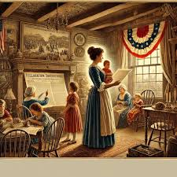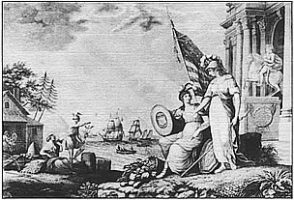
24. The creator of the illustrations above would most likely have supported which of the following?
a. The ideal of “republican motherhood”
b. The antebellum women’s movement
c. The rise of Gilded Age women’s clubs
d. The efforts of women to gain the right to vote

25. Women were critical to the Revolutionary Movement because
a. they began to earn the right to vote in most places.
b. they helped to enforce non-importation agreements in the 1760s.
c. they fought frequently as front-line soldiers
d. they served as ambassadors to foreign governments.
Such as Committees of Correspondence

Questions 26 - 27 Relate to the passage below
“There is one thing more to which I would take the liberty of soliciting your most serious and constant attention; to wit, the clothing of your Troops, and the procuring of every possible supply in your power from time to time for that end. If the several States exert themselves...in this instance, and I think they will, I hope that the Supplies they will be able to furnish in aid of those, which Congress may immediately import themselves, will be equal and competent to every demand. If they do not, I fear, I am satisfied the Troops will never be in a situation to answer the public expectation and perform the duties required of them. No pains, no efforts on the part of the States can be too great for this purpose. It is not easy to give you a just and accurate idea of the sufferings of the Army at large of the loss of men on this account. Were they to be minutely detailed, your feelings would be wounded, and the relation would probably be not received without a degree of doubt & discredit. We had in Camp, on the 23rd Inst. by a Field Return then taken, not less than 2898 men unfit for duty, by reason of their being barefoot and otherwise naked. Besides this number, sufficiently distressing of itself, there are many Others detained in Hospitals and crowded in Farmers Houses for the same causes. In a most particular manner, I flatter myself the care and attention of the States will be directed to the supply of Shoes, Stockings and Blankets, as their expenditure from the common operations and accidents of War is far greater than of any other articles. In a word, the United and respective exertions of the States cannot be too great, too vigorous in this interesting work, and we shall never have a fair and just prospect for success till our Troops (Officers & Men) are better appointed and provided than they are or have been.

George Washington to the State of New Hampshire, December 9, 1776

26. The situation above would have most precipitated which of the following events?
a. The Battle of Trenton and Princeton b. The Battle of Breed's Hill
c. The Battle of Lexington and Concord d. The Battle of Yorktown
He is asking for supplies and when he had not received these he decided to the attack at Trenton, which was also a supply base for the Hessians.

27. All of the following would have been weaknesses plaguing the Continental Congress except?
a. The inability to trade with foreign powers to gain supplies
b. The lack of colonial manufacturing to supply the army
c. The lack of paper money to purchase supplies
d. The unwillingness of some states to supply the army.
In fact all that they had was worthless paper money at the start of the Revolution

Questions 28-30 Relate to the Passage Below
I beg leave to state to you my necessitous circumstances, that through your intervention I may obtain that succour, which suffering humanity ever requires. Borne of African parents...and apprenticed in Boston, from whence I was removed to Roseley and from thence again to Andover into the family of Locerage, with whom as was then the lot of my unfortunate race, I passed the best part of my life as a slave. In the year of our Lord 1775 or 6 and in the twenty fifth of my age I entered into the service of the U.S. as a private soldier wherein I continued five years and contracted a complaint from which I have suffered in a greater or less degree ever since and with which I am now afflicted. After leaving the army to become a sailor for two years I was for some time in Newtown, from whence I went to Natick where I remained for a short time and then removed to Dover whence I was a day labourer during the period of seven years. Eight years past I removed to the place where I now live and have until this time by my labor assisted by the kindness of the neighboring inhabitants been enabled to support myself and family. At present having arrived at the fifty-eight year of my life and afflicted with an unusable arm as I apprehend with incurable diseases where by the labor of my hands is wholly cut off, am with it is the only means of my support. My family at this time consists of a wife and four children three of whom are so young as to be unable to support themselves and the time of their mother is wholly occupied in taking care of myself & my little ones--thus gentlemen in this my extremity I am induced to call on you for assistance; not in the character of an inhabitant of the town of Westfield for I have no such claim but as a stranger accidently falling within your borders, one who has not the means of subsistence, and in failure one who must fail through want and disease unless sustained by your care.
Peter Kiteridge to the Selectmen of the Town of Newfield, Massachusetts, 1806

28. What seems to be the major reason why Peter Kiteridge was petitioning the town council?
a. He feared being made a slave after the war ended.
b. He believed that he had been freed due to his service in the war.
c. He hoped that his service would result in support for his family.
d. He was seeking help for his family so that they would not be enslaved.

29. What was the general attitude that the "revolutionary generation" have related to slavery.
a. It was a necessary evil and would likely never end.
b. It was a positive good and should be maintained for the good of Africans
c. It was a necessary evil and would one day end through gradual emancipation
d. It was morally reprehensible and must be immediately abolished.

30. What impact did the Revolutionary War have upon the slavery debate in the America?
a. A distinct division was revealed between slave and non-slave regions
b. Slavery began to disappear immediately in most Chesapeake states
c. The Mid-Atlantic states immediately abolished the practice
d. Indentured servitude was extended to Native-Americans due to labor shortages

Questions 31- 32 Relate to the Passage Below
"I have not the least doubt that African-Americans will make excellent soldiers given the proper management. I foresee that this project will encounter severe opposition due to prejudice and self-interest. The contempt that we have taught to entertain is not based upon logic nor experience…and an unwillingness to part with property considered so valuable will furnish thousands of pernicious and impractical arguments. But it should be considered that if we do not make use of them that our enemy surely will. An essential part of the plan is to give to them their freedom with their muskets."
Alexander Hamilton, A Proposal to Arm and Free Negros, 1776

31. To encourage African-Americans to fight, Hamilton suggested in the excerpt that they should be promised
a. Effective leadership from the officers. b. An end to prejudice
c. Equal wages with white soldiers d. Emancipation from slavery
Slavery was still legal in every colony so his suggestion was important
32. Which of the following was the primary reason for Hamilton's call for African-American soldiers?
a. The New York militia was short of soldiers
b. The British were recruiting black soldiers
c. The Declaration of Independence declared that "all men are created equal."
d. General Washington trusted their use in combat.
When slaves were encouraged to escape to British lines they became part of the army.

Questions 33 – 34 Relate to the excerpt Below
“Article VIII. The Bonetta sloop-of-war to be equipped, and navigated by its present captain and crew, and left entirely at the disposal of Lord Cornwallis from the hour that the capitulation is signed, to receive an aid-de-camp to carry despatches to Sir Henry Clinton; and such soldiers as he may think proper to send to New York, to be permitted to sail without examination. When his despatches are ready, his Lordship engages on his part, that the ship shall be delivered to the order of the Count de Grasse, if she escapes the dangers of the sea. That she shall not carry off any public stores. Any part of the crew that may be deficient on her return, and the soldiers passengers, to be accounted for on her delivery.

Article X. Natives or inhabitants of different parts of this country, at present in York or Gloucester, are not to be punished on account of having joined the British army.
This article cannot be assented to, being altogether of civil resort.

Article XI. Proper hospitals to be furnished for the sick and wounded. They are to be attended by their own surgeons on parole; and they are to be furnished with medicines and stores from the American hospitals.
The hospital stores now at York and Gloucester shall be delivered for the use of the British sick and wounded. Passports will be granted for procuring them further supplies from New York, as occasion may require; and proper hospitals will be furnished for the reception of the sick and wounded of the two garrisons.

Article XII. Wagons to be furnished to carry the baggage of the officers attending the soldiers, and to surgeons when traveling on account of the sick, attending the hospitals at public expense.
They are to be furnished if possible.

Article XIII. The shipping and boats in the two harbours, with all their stores, guns, tackling, and apparel, shall be delivered up in their present state to an officer of the navy appointed to take possession of them, previously unloading the private property, part of which had been on board for security during the siege.

Done at Yorktown, in Virginia, October 19th, 1781.
Cornwallis, Thomas Symonds. Done in the Trenches before Yorktown, in Virginia, October 19th, 1781.

George Washington, Le Comte de Rochambeau, Le Comte de Barras, Le Comte de Grasse
33. British forces at Yorktown were forced to surrender
a. because they had suffered tremendous losses
b. because the British Navy had been scattered and there was no hope of retreat.
c. because Washington threatened to unleash Native his native allies
d. because King George III had already formally surrendered in Paris
The original strategy was to keep to the coast and to be supported by the Royal Navy

34. The inclusion of the French as part of the surrender was directly related to the results of which battle?
a. Saratoga b. Brandywine Creek c. Long Island d. The Cowpens

Questions 35 – 37 Relate to the Image Below
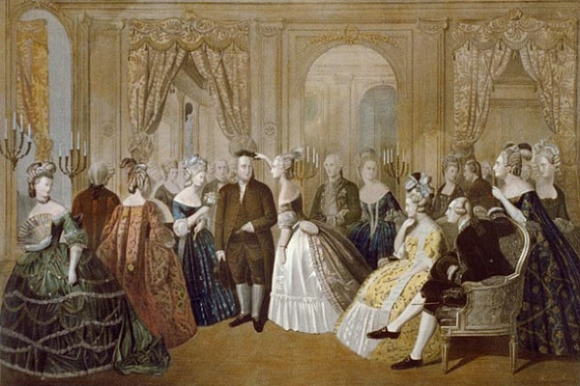
Anton Hohenstein, Benjamin Franklin at the Court of France, 1778
35. Which of the following best explains the historical context of this painting?
a. Franklin was negotiating the 1763 Treaty of Paris
b. Franklin was negotiating the 1783 Treaty of Paris
c. Franklin was seeking diplomatic recognition for the American colonies.
d. Franklin was negotiating the Louisiana Purchase.

36. Following which event did the French pledge military support?
a. The Declaration of Independence bong signed.
b. The conclusion of the Battle of Saratoga
c. The Conclusion of the Battle of Yorktown
d. The start of the war of 1812

37. Which of the following best explains the impact that France had upon the Revolutionary War?
a. The massive influx of troops overwhelmed the British
b. The treaty with the Americans initiated another European-wide conflict.
c. The French relocated their entire army to North America
d. The entire British Navy was sunk.
This was an elimination question where you just had to figure out the ones that didn’t apply.

Questions 38 – 40 Relate to the Passage Below
“I long to hear that you have declared an independency—and by the way in the new Code of Laws which I suppose it will be necessary for you to make I desire you would Remember the Ladies, and be more generous and favourable to them than your ancestors. Do not put such unlimited power into the hands of the Husbands. Remember all Men would be tyrants if they could. If perticuliar care and attention is not paid to the Laidies we are determined to foment a Rebelion, and will not hold ourselves bound by any Laws in which we have no voice, or Representation.
That your Sex are Naturally Tyrannical is a Truth so thoroughly established as to admit of no dispute, but such of you as wish to be happy willingly give up the harsh title of Master for the more tender and endearing one of Friend. Why then, not put it out of the power of the vicious and the lawless to use us with cruelty and indignity with impunity. Men of Sense in all Ages abhor those customs which treat us only as the vassals of your Sex. Regard us then as Beings placed by providence under your protection and in immitation of the Supreem Being make use of that power only for our happiness.”
Abigail Adams Letter to John Adams, 1776

38. In the letter, Abigail reminds to John to not forget the contribution of the ladies when he works on the Code of Laws (this would follow the Declaration of Independence). Which of the following would have been the greatest contribution?
a. Fighting against the British on the front lines.
b. Giving love and support to the fight patriots.
c. Aiding in the boycotts against British tax policies
d. Serving as spies against the British

39. What interesting threat does Abigail make if women are not are not recognized under the new law?
a. That she will divorce him for being sexist.
b. That women will rebel against the new Code of Laws
c. That the place of a woman as a mother should be awarded
d. That women will stop aiding the Revolutionary cause.

40. At the time, which would have been the most radical demand that women could seek?
a. The right to vote and hold political office
b. The right to own property in their own names
c. The right to trial by jury
d. The right to seek equal education with men.
Few women and even fewer men would have called for this at this juncture of history

Questions 41 – 43 Relate to the excerpt below
“…And this sudden Courage in the field, & the Humanity afterwards hath had so good an Effect that there hath been no farther Attempt, and the very Spirit of Revolt seems over. About 30 escaped from the fight, of which ten marched about 30 miles Southward, and being overtaken by the Planters on horseback, fought stoutly for some time and were all killed on the Spot. The rest are yet untaken. In the whole action about 40 Negroes and 20 whites were killed. The Lieutenant Governour sent an account of this to General Oglethorpe, who met the advices on his return from the Indian Nation He immediately ordered a Troop of Rangers to be ranged, to patrole through Georgia, placed some Men in the Garrison at Palichocolas, which was before abandoned, and near which the Negroes formerly passed, being the only place where Horses can come to swim over the River Savannah for near 100 miles, ordered out the Indians in pursuit, and a Detachment of the Garrison at Port Royal to assist the Planters on any Occasion, and published a Proclamation ordering all the Constables &cª. of Georgia to pursue and seize all Negroes, with a Reward for any that should be taken. It is hoped these measures will prevent any Negroes from getting down to the Spaniards.—”
“An Account of the Negroe Insurrection in South Carolina, 1739

41. The historical context of the passage relates to which of the following events?
a. Nat Turner’s Rebellion b. The Le Place Revolt
c. The Haitian Uprising d. The Stono Rebellion

42. The rebellion mentioned in the excerpt was inspired by
a. News of the success of Toussaint L’Ouverture’s success in defeating a French garrison in Haiti
b. News that the Spanish governor in Florida had offered freedom for runaway slaves.
c. A slave preacher who equated the uprising to Moses liberating the Jews from Egypt.
d. An abolitionist who wanted to start a slave uprising in Virginia
Florida was still Spanish and an enemy of Britain. Georgia was established as a buffer.

43. Which of the following best describes the result of this 1739 event?
a. Slavey was banned in South Carolina and Georgia
b. The international slave trade was abolished by the British government.
c. Treatment of slaves on plantations became harsher and more brutal.
d. Efforts were made to liberalize the treatment of slaves and encourage emancipation.

Questions 43 – 45 Relate to Excerpt Below
“WHEREAS WE have taken into Our Royal Consideration the extensive and valuable Acquisitions in America, secured to Our Crown by the late Definitive Treaty of Peace, concluded at Paris...and being desirous that all Our loving Subjects...may avail themselves with all convenient Speed, of the great Benefits and Advantages which must accrue therefrom to their Commerce, Manufactures, and Navigation, We have thought fit...to issue this Our Royal Proclamation....
And whereas it is just and reasonable and essential to Our Interest and the Security of Our Colonies, that the several Nations or Tribes of Indians with whom We are connected, and who live under Our Protection should not be molested or disturbed...no Governor...in any of Our other Colonies or Plantations in America, do presume for the present...to grant Warrants of Survey, or pass Patents for any Lands beyond the Heads or Sources of any of the Rivers which fall into the Atlantic Ocean....
And whereas great Frauds and abuses have been committed in the purchasing Lands of the Indians, to the great Prejudice of Our Interests, and to the great Dissatisfaction of the said Indians; in order to prevent such Irregularities for the future, and to the End that the Indians may be convinced of Our Justice and determined Resolution to remove all reasonable cause of Discontent, We do...enjoy and require that no private Person do presume to make any Purchase from the said Indians of any Lands reserved to the said Indians....
King George III, The Proclamation of 1763

43. What was the historical context of the excerpt
a. The defeat of the French at the Battle of Quebec.
b. The impact of the Pontiac Rebellion
c. Bacon’s Rebellion in colonial Virginia

44. Which of the following best describes why American were angered over the royal proclamation?
a. It gave rights to French Canadians that it threatened to take away from Bostonians.
b. It placed British troops along the Proclamation Line as a police force.
c. It forced civilian colonists to stand trial in a military tribunal.
d. It forced colonists to yield unused property to quarter British troops.

45. The American anger at the above proclamation was a violation of
a. The English Bill of Rights b. The Mayflower Compact
c. The U.S. Constitution d. The Petition of Right

