The Reformation and Age of Religious Wars
SAQ Section

Question 1
“Where at the death of our late sovereign lord King Edward VI there remained one uniform order of common service and prayer, and of the administration of sacraments, rites, and ceremonies in the Church of England, which was set forth in one book, intituled: The Book of Common Prayer, and Administration of Sacraments, and other rites and ceremonies in the Church of England; authorized by Act of Parliament holden in the fifth and sixth years of our said late sovereign lord King Edward VI, intituled: An Act for the uniformity of common prayer, and administration of the sacraments; the which was repealed and taken away by Act of Parliament in the first year of the reign of our late sovereign lady Queen Mary, to the great decay of the due honour of God, and discomfort to the professors of the truth of Christ's religion: Be it therefore enacted by the authority of this present Parliament, that the said statute of repeal, and everything therein contained, only concerning the said book, and the service, administration of sacraments, rites, and ceremonies contained or appointed in or by the said book, shall be void and of none effect, from and after the feast of the Nativity of St. John Baptist
next coming; and that the said book, with the order of service, and of the administration of sacraments, rites, and ceremonies, with the alterations and additions therein added and appointed by this statute, shall stand and be, from and after the said feast of the Nativity of St. John Baptist, in full force and effect, according to the tenor and effect of this statute; anything in the aforesaid statute of repeal to the contrary notwithstanding.”
The Act of Uniformity, England, 1559

a. Based upon your knowledge of the period and the excerpt, what are the 2 conflicting position on religion between King Edward VI and Queen Mary I?

b. List and explain a specific difference between the Anglican Church under Queen Elizabeth and the demands of English Calvinist (Puritans).

c. List and explain ONE example of how religious tensions in England also led to foreign policy problems.

Question 2
“The European reformation was not a simple revolution, a protest movement with a single leader, a defined set of objectives, or a coherent organization. Yet neither was it a floppy or fragmented mess of anarchic or contradictory ambitions. It was a series of parallel movements; within each of which various sorts of people with differing perspectives for a crucial period in history combined forces to pursue objectives which they only partly understood. First of all, the Reformation was a protest by churchmen and scholars, privileged classes in medieval society, against their own superiors. Those superiors, the Roman papacy and its agents, had attacked the teachings of a few sincere, respected academic churchmen which had seemed to threaten the prestige and privilege of clergy and papacy. Martin Luther, the first of these protesting clerics, had attacked ‘the Pope’s crown and the monks’ bellies,’ and they fought back, to defend their status. The protesting churchmen—the ‘reformers’— responded to the Roman counter-attack not by silence or by furtive [hidden] opposition, but by publicly denouncing their accusers in print. Not only that: they developed their teachings to make their protest more coherent, and to justify their disobedience. Then the most surprising thing of all, in the context of medieval lay people’s usual response to religious dissent, took place. Politically active laymen, not (at first) political rulers with axes to grind, but rather ordinary, moderately prosperous householders, took up the reformers’ protests, identified them (perhaps mistakenly) as their own, and pressed them upon their governors. This blending and coalition—of reformers’ protests and laymen’s political ambitions—is the essence of the Reformation.”
Euan Cameron, historian, The European Reformation, 1991

a. What is the main idea of the excerpt?
b. List and explain ONE argument that made by “Protesting Clerics” such as Martin Luther.
c. Choose a “protesting cleric” not mentioned in the excerpt and explain their theological challenge against the Church
Question 3
“Today I was called to a particular conference at the residence of one of the bishops of this kingdom, along with many others of his rank and some other deputies from the nobility. There a certain formula of association was proposed, whose purpose was to break the last edict of pacification and to place the king at war against those of the so-called Protestant religion. . . . I remarked that it seemed to me that the king ought not to be counseled to go to war, because of the recent injuries the kingdom has suffered, and that anyone who favors civil war is ungodly and deserves our prayer. . . . Concerning the present formula of association, I say that I cannot sign it and call myself a servant of the king. I know that war is unjust if it is not conducted and undertaken by the king in his faithful and holy council.”
Pierre de Blanchefort, French nobleman, diary entry, 1576
a) List and explain one historical development illustrated by the passage.
b) Describe Blanchefort’s argument regarding war against the Protestants.
c. Choose another region or county in the 16th -17th century and explain the similar political developments there.
Question 4
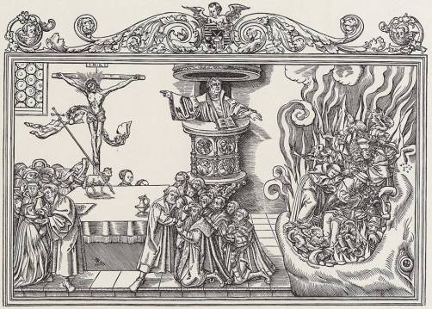
Lucas Cranch Woodcut, “The True Church and the False Church, 1540

a. What is purpose and point of view of the artist in this woodcut?

b. How does this work resemble the late Renaissance works of Hieronymus Bosch?

c. Why would an image like this resonate with so many people in 16th century Germany?

