2026 AP European History Unit Test 1.1 SAQ Section

Instructions and Information
When completing the Short Answer Question Section make sure that you do the following
- Answer in a paragraph with complete sentences (never in bullet points)
- Make sure that you are answering what the prompt is asking. For example, “compare” also means “contrast”.
- Always explain as fully as you can and support with examples to support your response. Otherwise you probably will not get full credit.
- Make sure to answer all parts of the question.

Question One Relates to the Except Below
“Those who are the closest to these [the theologians] in happiness are generally called "the religious" or "monks", both of which are deceiving names, since for the most part they stay is far way from religion as possible and frequent every-sort of place. I cannot, ho*ever, see how a life could be more gloomy than the life of these monks if I did not assist them in many ways. Though most people detest these men so much that accidentally meeting one is considered to be bad luck, the monks themselves believe that they are magnificent creatures. One of their chief beliefs is that to be illiterate is to be of a high state of sanctity, and so they make sure that they are not able to read. Another is that when braying out their gospels in church they are making themselves very pleasing and satisfying to God, when in fact they are uttering these psalms as a matter of repetition rather than from their hearts.”
Erasmus, In Praise of Folly, 1511
Part A
What is the main idea of the above excerpt?

Part B
Explain how this excerpt would embody the Northern Renaissance idea of humanism?

Part C
Contrast the Northern Renaissance view on humanism with that of the Italian Renaissance.

Question Two Relates to the Artwork Below (see page 2)

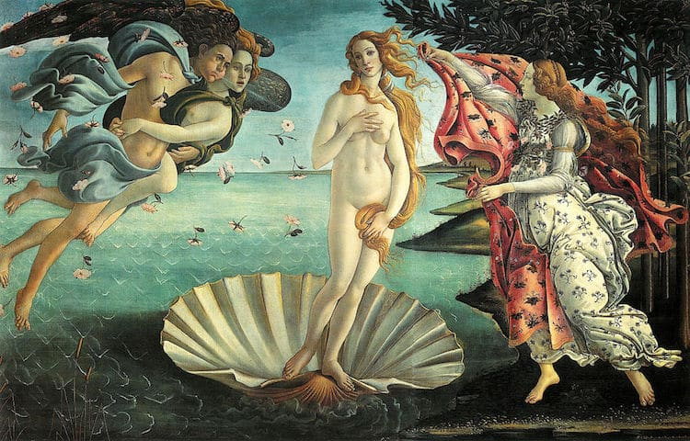
Sandro Botticelli, The Birth of Venus, 1486

Part A
Explain how this painting reflects Italian ideas on humanism.

Part B
Besides its humanist characteristics, list and explain TWO other notable traits that embody the art of the period.

Part C
Contrast TWO Northern Renaissance compositions with that of the Italians and, cite in your answer an example masterpiece.

Question 3 Relates to the Except Below
Concerning Cruelty and Clemency, and Whether it is Better to be Loved than Feared
Upon this a question arises: whether it is better to be loved than feared or feared than loved? It may be answered that one should wish to be both, but, because it is difficult to unite them in one person, it is much safer to be feared than loved, when, of the two, either must be dispensed with. Because this is to be asserted in general of men, that they are ungrateful, fickle, false, cowardly, covetous, and as long as you successed they are yours entirely; they will offer you their blood, property, life, and children, as is said above, when the need is far distant; but when it approaches they turn against you. And that prince who, relying entirely on their promises, has neglected other precautions, is ruined; because friendships that are obtained by payments, and not by nobility or greatness of mind, may indeed be earned, but they are not secured, and in time of need cannot be relied upon; and men have less scruple in offending one who is beloved than one who is feared, for love is preserved by the link of obligation which, owing to the baseness of men, is broken at every opportunity for their advantage; but fear preserved you by a dread of punishment which never fails. Nevertheless, a prince ought to inspire fear in such a way that, if he does not win love, he avoids hatred; because he can endure very well being feared whilst he is not hated, which will always be as long as he abstains from the property of his citizens and subjects and from their women.”
Niccolo Machiavelli, The Prince, 1551

Part A
What is the main idea and purpose of the excerpt?

Part B
While the excerpt is geared toward “the prince” discuss the other levels of society in Milan or any other typical city-state. Be sure to also include peasants and slaves in your response.

Part C
Based upon the advice given by Machiavelli how did the Tudor King Henry VII create both fear and support among the nobles in England?

Question 4 Parts A, B, and C
Part A
The so-called New Monarchies all solidified power creating strong nation-states. List and explain TWO characteristics of a nation state.

Part B
List and explain a political and economic example of how Charles VII and Louis IX of France strengthened their realms.

Part C
List and explain a political and social example of how Ferdinand and Isabella of Spain strengthened their realm.

