2024 AP US History Unit One Test
HP 1-2 SAQ Section

Instructions and Information
Directions
The most effective way to do successfully answer the SAQ section is to use the ACE method. Here is what you want to do
A = Make sure that you ANSWER the Question
C = CITE evidence using key terms, people, concepts, events appropriate to the prompt
E = EXPLAIN how your evidence answers the question is a bit of detail
**You will want to do this with A, B, and C parts of each question!

When completing the Short Answer Question Section make sure that you do the following
- Answer in a paragraph with complete sentences (never in bullet points)
- Make sure that you are answering what the prompt is asking. For example, “compare” also means “contrast”.
- Always explain as fully as you can and support with examples to support your response. Otherwise you probably will not get full credit.
- Make sure to answer all parts of the question and show the reader clearly, you’re A, B, and C sections

Question 1 is Based Upon the Excerpt Below
“… Virginia was for the most part at first peopled by Persons of low Circumstances, and by such as were willing to seek their Fortunes in a Foreign Country. Nor was it hardly possible it should be otherwise, for ’tis not likely that any Man of a plentiful Estate [wealth] should voluntarily abandon a happy Certainty to roam after imaginary Advantages in a New World. Besides which incertainty, he must have propos’d to himself to encounter the infinite Difficulties and Dangers that attend a New Settlement. These Discouragements were sufficient to terrify any Man that could live easy in England from going to provoke his Fortune in a strange Land.”

Robert Beverley, Jr., The History and Present State of Virginia, 1705, excerpts.
National Humanities Center
Part A
Explain the Main Idea and Tone of the Passage.

Part B
List and explain ONE specific event or development that would support Robert Beverley’s position in the excerpt.

Part C
List and explain ONE specific event or development that would refute Robert Beverley’s position in the excerpt.

Question 2
Using the excerpt and your knowledge of period answer the questions below
“What happened in Salem likely had many causes, and as many responses to those causes…While each book puts forward its own theories, most historians agree that there was no single cause for the witchcraft that started in Salem and spread across the region. To borrow a phrase from another tragic chapter of Essex County history, Salem offered a ‘perfect storm’ a unique convergence of conditions and events that produced what was by far the largest and most lethal witchcraft episode in American history.”
Emerson W. Baker, A Storm of Witchcraft, 2016

Part A
Explain what role that class divisions and age differences might have played in causing this infamous event.

Part B
How might Puritanism itself have played a role in causing this infamous event?

Part C
Choose another 17th century British colony explain the role that religion played in the founding of the colony.

Question 3
Using the map and your knowledge of period answer the questions below

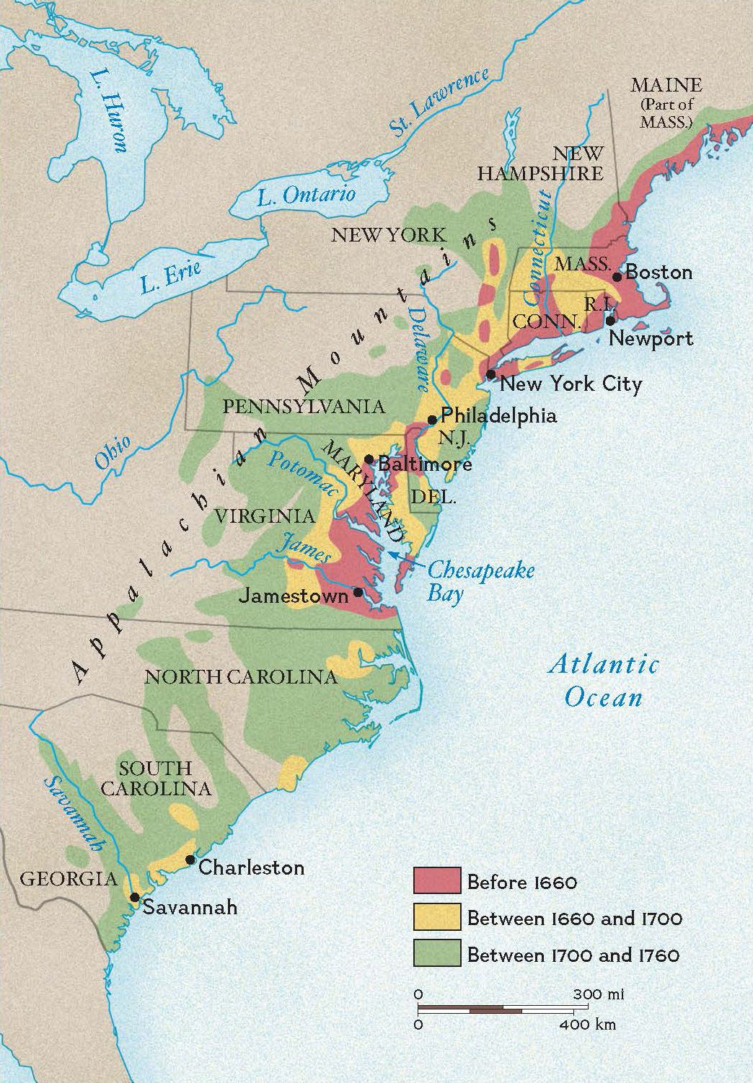

Part A
Compare the economic development of TWO of the regions found on the map
The Chesapeake New England Middle Colonies Southern Colonies

Part B
Compare the native relations with settlers in TWO of the regions found on the map.
The Chesapeake New England Middle Colonies Southern Colonies

Part C
Choose ONE region from the map and explain what role that events in England played in colonial development.

