AP European History
August 18 – 22 2025
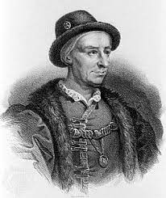
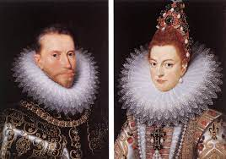
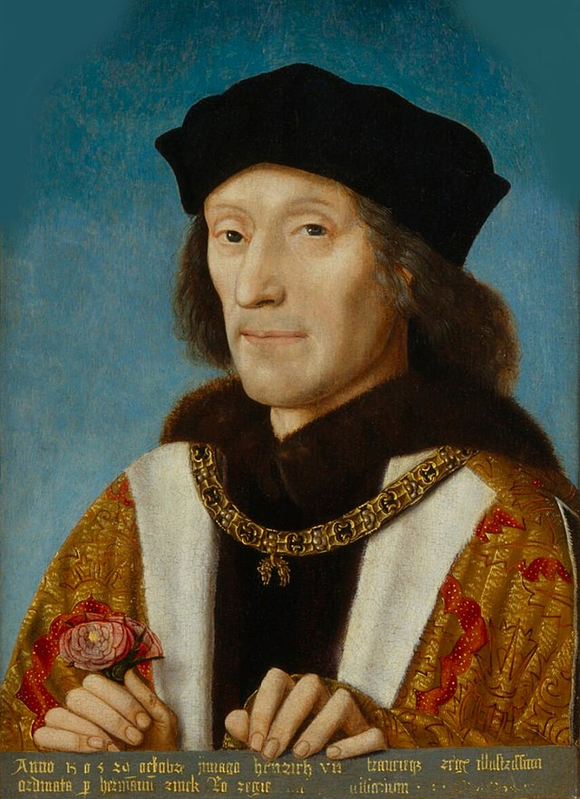
- Hopefully you completed the little review on the glencoe website and screen-shot and email it to me at stephensonmike2112@gmail.com
- It’s time for your first formal assessment covering the Renaissance and the Northern Monarchies. This will be in an MCQ and SAQ format, I will typically break up most units into two or sometimes three sub-tests instead of one massive assessment. Also, I do not 100% follow the College Board Units. Unit One has information about the Age of Exploration and Scientific Revolution but I prefer to save that information for a later time.
- The MCQ will be done in class on Tuesday and the SAQ will be done at home and brought to class on Thursday. This can be typed or handwritten but NO EMAILS.
- Also, this week we will start a new sub-unit on the Protestant Reformation. This is one of the longest units and we will not split it up. There will be a quiz on this for next week on Monday. You’ll have no written homework over the weekend but study for that quiz.

MONDAY
SWBAT analyze primary sources on the Northern Monarchies and the proper format of the SAQ (IOT) prepare for your first sub-unit test.

Materials Strategies
Primary source books Close-text reading

Student Skills
Contextualization
Causation
Analysis

Introduction
- Today we will be discussing the properties of the so-called SAQ. Your sub-unit test will involve MCQ questions in class tomorrow and the SAQ will be due on Friday when you come to class.
- View Heimler on SAQ
https://www.youtube.com/watch?v=xoM4tDOEQ-k
- One your first SAQ section for the Unit Test you will follow a similar process to the SAQ but not 100%. This time it is more about getting you used to the process by answer the question in a A-B-C format.
- Today we are also going to do a review activity in preparation for our first Unit Test.

Homework
Unit Test Tomorrow
See Below for materials

TUESDAY (Test Day)
- SWBAT analyze primary and secondary sources (IOT) complete Sub-Unit Test: The Renaissance and Northern Monarchies.

Materials Strategy/Format
MC Test, Assessment and Review

Student Skills
Contextualization
Comparison
CCOT

Materials to look over
1. The Italian Renaissance
a. Why Italy
b. The Socio-economic and political structures (this also includes social classes, gender issues, and slavery).
c. Humanism in the arts, literature, and education

2. The Northern Renaissance
a. Humanism in the arts, literature, and education
b. Comparisons with Italian Renaissance

3. The Northern Monarchies
a. The characteristics of a nation-state
b. the monarchies of France, England, and Spain

Special Note: While the summer work will not be featured on the Unit Test, there were aspects that directly related such as the Impact of the Hundred Years War and Issues related to the Church. These are far game!!!

Homework
Complete the SAQ section at home and return Friday. This is part of your unit test and it is averaged with your MCQ section score.

WEDNESDAY (new sub-unit) and THURSDAY (SAQ is due in class)
- SWBAT explain causation of the Protestant Reformation and Analyze the theories of Martin Luther (IOT) complete quiz Monday(CID1,3) (SOP-1)
- SWBAT Explain causation why Luther's religious ideas became so political (IOT) complete quiz on Monday. (CID1,3) (SOP-1)

Materials Strategy/Format
PPT/video Lecture-discussion, close text reading

Student Skills
Context
CCOT
Causation

Introduction
- As we have discussed the Reformation was not a sudden event. There had been events and criticisms from within the Church for a very long time. We know the basics of the Reformation probably already. (Review Points) Can it be argued that the Reformation had a start date? How about an end date or can it be argued that the process has never stopped? Do you think that it strengthened or weakened organized religion? What impact did it have upon American History?
- As we start this new and rather long unit be aware that this is an all-encompassing movement. We will examine political results (wars and results), economics (the strengthening of middle class and early capitalist developments), social (a new wave of religious thought, expanded education, middle class development, impact upon women…..), and culture (the development of art, literature, music, and philosophic movements)
- Another key aspect of how we will examine the reformation is how impacted various nation-states.
France and religious civil wars, England and the development of Anglicanism, the Low Countries and their rebellion from Spain, the Holy Roman Empire and its growing weaknesses.
Today we are going to start a deeper look at the Reformation and the sweeping social, political, economic, and cultural impact that this event across Europe and perhaps the world. Furthermore, we will examine the Counter-Reformation launched by the Church.

The Protestant Reformation was perhaps the most important historical period of the early modern period. It had deep socio-political and economic impact as well as a subsequent cultural effect. Like most major events the Reformation was a global phenomenon. The period of religious tensions would not only cause terrible wars in Europe but it would also help spawn a series of migrations to the recently discovered New World. Ultimately the foundations of America were laid in the early 17th century efforts by Puritans (Calvinists) in both America and Canada.

Why Catholicism was Important in Europe
- Obviously the root word is to reform. So, our first step is to see what needed to be reformed but before that step we have to lay a little ground work about the Church itself
- The Catholic Church (We will stay with Roman Catholic at this point)
- It was the only government with international roots
- It was the only welfare system available
- It served as a sanctuary for those oppressed by political leaders
- It served as a repository of knowledge and the only formal education
- And finally but of course not unimportantly it was the pathway to salvation for millions of Christians
- So in effect Catholicism was similar to the UN in its organization. There were several organizational missions of the church beyond its religious mission.

The Church Hierarchy
- The term “catholic” means universal and the Church itself represented this idea (though of course much more now than at that time
- The Pope, Archbishops, Cardinals, Bishops, parish Priests
- The Cardinals choose new popes (college of cardinals) and the Popes choose the rest basically except parish priests

Popular Movements and Criticism Before Luther
What had been some problems plaguing the Church back to the LMA?
- Scholasticism vs. Emotion (a common trend for much of Euro/American History)
- The scholastic method was a form of inquiry that combined the teachings of the Greeks particularly Aristotle with early Church leaders like St. Thomas Aquinas. There was no problem with the philosophy itself. IN fact, the scientific method is based upon it. But there were some who accepted the teachings as the ONLY method to explain anything. Now, the main problem came because it developed into a logical and reasoned explanation for all things. Some early Protestants argued that it made for boring theology. They preferred a more emotional and spiritual theology.
- This would create the foundation of an old argument: strict teachings and fundamentalism against emotional interpretation. This still exists and a sense of Neo-Scholasticism is prevalent among some fundamentalist faiths.
- The expansion of education and the growth of cities
- This was not in itself a problem. The crux of the matter was really a growing unwillingness to use Latin. The Church could no longer extol its own orthodox ideas transmitted though the clergy. As literacy spread (largely due to the printing press) people began to question more openly.
- Of course the spread of liberal education also introduced a higher degree of humanism and Neo-Platonism. This also had the effect of minimizing the message of sin and maximizing the concept of freewill.

- Clerical critics (Erasmus for example) called for a return to “Philosophia Christi” or a reliance upon the basic teachings of Christ. As you saw from your documents, Petrarch expressed the same feelings.

The Modern Devotion
- A lay order started in Holland (community between laymen and clergy)
- No distinction between the two and no special vows (how does this resemble protestant faiths today?)
- Thomas a Kempis Imitation of Christ (Erasmus was his student)
- The Christian Brothers is a similar movement dedicated to education
- The sermons and teachings were NOT in Latin. Why is this critical?

Problems That the Church Faced
- Benefices and Indulgences
- Incompetent priests and a worldly attitude
- Absentee bishops
- A growing sense of regional control and the seeds of nationalism

Political and secularism vs. Church control
- Tithes and church control of lands
- Clerical vs. secular courts
- Who should name a priest, church or state?

The Teachings of Martin Luther
Introduction
Though as we have seen Martin Luther is credited w/starting the Reformation, it was already beginning to take shape. Why is this when already there were criticism? Whatever the case his vehement defense of his beliefs coupled w/ his resistance to the Pope himself was quite powerful. Perhaps this is the reason why he is credited.

Procedure
- Luther’s early days (his conversion)
- Luther the angry monk in Wittenberg Germany

Basic Teachings
- Indulgences (The spark and what was the true story?)
- Good deeds version Salvation: Sola fide (By Faith Alone are we saved)
- The Clergy: Sola Gratia (There is no need of a clergy to guide salvation)
- The Bible: Sola Scriptura (and subsequent use of vernacular to instruct)
- The Sacraments (7 whittled down to 2 Baptism and the meaning of the Eucharist/communion)
This is known as transubstantiation.

The Papacy Acts
- Leo X predicament: silencing Luther will martyr him but doing nothing is a sign of weakness.
- The Diet of Worms (Luther’s trial and excommunication)

The Reformation Turns Political
- Princes vs. the Church vs. the HRE Charles V
- The Schmalkaldic League was an alliance of Lutheran princes and nobles who were preparing for war against Emperor Charles V knowing that he would likely fight.
- The most important result of the war was a decision by Charles V to allow the German princes to choose the religion of their realm. This was known as the Peace of Augsburg

FRIDAY
- SWBAT analyze primary sources on the early Protestant Reformation (IOT) answer guided reading questions

Materials Strategy/Format
Doc. Reader Close Text Reading

Student Skills
Context
CCOT
Causation

Instructions
Today in class you will be doing 2 primary source readings on the early Reformation Period. This must be completed in class today so come in and get to work quickly.

Homework for the Weekend
No written homework but look over your notes on the Early Reformation for a short answer format Quiz on MONDAY in Class. So study your notes. Lesson plan notes, and text reading.
You can view the following video lectures to help you prepare
https://apclassroom.collegeboard.org/d/hx4afdn5ri?sui=15,2
https://apclassroom.collegeboard.org/d/4ffem8ltlb?sui=15,2
https://apclassroom.collegeboard.org/d/e8js8petaw?sui=15,2

