2026 AP US History Unit One-Unit Two Test
Annotated answers

Questions 1 – 4 Relate to the Passage Below
"Yet that same day, or so I am reliably informed by a number of eye-witnesses, the Spaniards seized the great king unawares by means of a trick and held him under armed guard of eighty soldiers, eventually putting him in irons. ....The pretext upon which the Spanish invaded each of these provinces and proceeded to massacre the people and destroy their lands--lands which teemed with people and should surely have been a joy and a delight to any true Christian--was purely and simply that they were making good the claim of the Spanish Crown to the territories in question. At no stage had any order been issued entitling them to massacre the people or to enslave them. Yet, whenever the natives did not drop everything and rush to recognize publicly the truth of the irrational and illogical claims that were made, and whenever they did not immediately place themselves completely at the mercy of the iniquitous and cruel and bestial individuals who were making such claims, they were dubbed outlaws and held to be in rebellion against His Majesty."
Bartholomew de las Casas, 1551

1. What is the historical context of the above document?
a. The order of the Pope to forcibly convert Natives into Christianity
b. The Black Legend detailing the atrocities of French Huguenots
c. The attempts by Catholic friars to stop the violence committed by many Conquistadores
d. The belief by Catholic leaders that Natives were savages and beyond God's grace.

2. The cruelty above was most directly the result of which system?
a. The Barbados Code b. The Encomienda System
c. The Black Legend d. The Reconquista

3. Native slavery largely failed in the late17th Century. Which of the following would LEAST explain why Africans were targeted?
a. Native died very quick or simply ran away since they knew the terrain.
b. Africans were naturally stronger than their Native counterparts
c. Africans were acquainted with growing techniques and animal husbandry
d. Africans were resistant to many European diseases.
This would be a racial stereotype.

4. Which of the following systems may have inadvertently drove the Spanish brutality being recounted by de las Casas?
a. The Enclosure Movement b. The Counter-Reformation
c. Primogeniture d. The Black Legend
For many the arrival was an all or nothing bid to establish lands since they could not back in Spain.

Questions 5-6 Relate to the Excerpt Below
"These things I did not see by the help of man, nor by the letter … but I saw them in the light of the Lord Jesus Christ, and by his immediate spirit and power, as did the holy men of God by whom the Holy Scriptures were written.”
George Fox, The Society of Friends, 1688

5. Why would the British government fear the teachings of Society of Friends founder George Fox?
a. Their emotional power caused them to tremble, and this seemed strange.
b. They advocated Catholicism which was against the Anglican state church.
c. They disavowed rank and titles in a highly regimented English class structure.
d. They were spiritualists who disavowed the divinity of Christ

6. The teachings of George Fox inspired which of the following colonial leaders to establish a colony’s whose original city in Latin means “city of brotherly love?”
a. Lord Baltimore b. The Duke of York c. William Penn d. James Oglethorpe
Questions 7- 9 Relate to the Political Cartoon Below
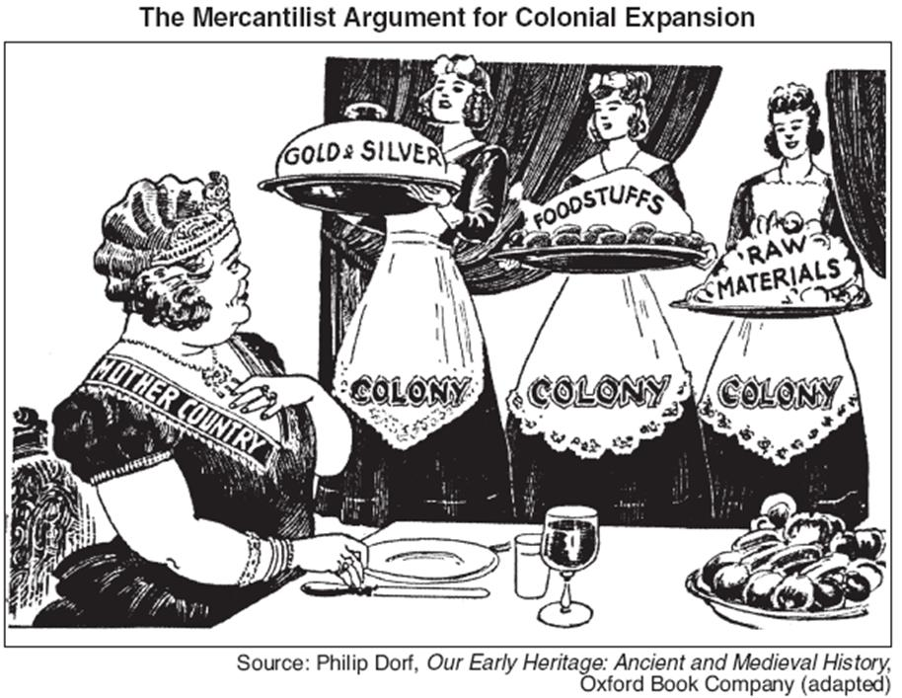

7. What economic principal is being described in the Image above?
a. Laissez-faire economics b. Supply and Demand
c. Capitalism d. Mercantilism

8. The above system first developed as a result of
a. The Columbian Exchange b. The 30 Years War
b. The Treaty of Tordesillas d. The Peace of Augsburg
The demand for exotic high value items from the New World

9.Which maritime power would have developed the most widespread maritime empire during the 17th century largely due to pioneering joint-stock companies?
a. Holland b. England c. France d. Spain
The key phrase was pioneering joint stock companies

The Document below relates to Questions 10 -13
"Be therefore ordered and enacted…That whatsoever person or persons within this Province…shall henceforth blaspheme God, that is curse Him or shall deny our Savior Christ to be the Son of God or shall deny the Holy Trinity…shall be punished with death and confiscation of property. And whereas that no persons thereunto belonging professing to believe in Jesus Christ, shall from henceforth be in any way troubled, molested or discountenanced for in respect of his or her religion nor in free exercise thereof within this province or the islands thereunto belonging nor in any way compelled to the belief or exercise of any other Religion against his or her consent."
-The Maryland Act of Toleration, 1649

10. Which of the following religious groups were the authors the above document?
a. Jews b. Puritans c. Quakers d. Roman Catholics

11. Which of the following best summarizes the attitude toward religious beliefs expressed in this document?
a. All individuals should be free to believe or not believe in God as wished.
b. Religion was a private personal matter that the government should not try and influence
c.Christians should be able to practice their faith without fear of prosecution
d. The Colony should be reserved for the one specific type of Christianity approved by local government.
It would have been phrased this way to appease all groups

12. Which religious denomination would have been most threatened by this so-called Act of Toleration?
a. Jews b. Puritans c. Quakers d. Roman Catholics
Their argument had long been too much Catholic rituals in the Anglican Cgurch

13. Which of the following leaders would have been the inspiration behind the above edict?
a. William Berkeley b. Cecilius Calvert c. George Fox d. The Duke of York
This was Lord Baltimore

Questions 14 – 16 Relate to the Passage Below
"And I have nothing to comfort me, nor is there nothing to be gotten here but sickness and death, except [in the event] that one had money to lay out in some things for profit. But I have nothing at all no, not a shirt to my back but two rags (2), nor clothes but one poor suit, nor but one pair of shoes, but one pair of stockings, but one cap, [and] but two bands [collars]. My cloak is stolen by one of my fellows, and to his dying hour [he] would not tell me what he did with it; but some of my fellows saw him have butter and beef out of a ship, which my cloak, I doubt [not], paid for. So that I have not a penny, nor a penny worth, to help me too either spice or sugar or strong waters, without the which one cannot live here. For as strong beer in England doth fatten and strengthen them, so water here doth wash and weaken these here [and] only keeps [their] life and soul together. But I am not half [of] a quarter so strong as I was in England, and all is for want of victuals; for I do protest unto you that I have eaten more in [one] day at home than I have allowed me here for a week. You have given more than my day's allowance to a beggar at the door; and if Mr. Jackson had not relieved me, I should be in a poor case. But he like a father and she like a loving mother doth still help me…."
Richard Frethorne, Letter from Virginia, 1632

14. Which of the following best describes the social status of Richard Frethorne based upon the above source?
a. A prosperous land owner b. A tobacco shipper
c. An African slaved. d. An indentured servant

15. Which of the following concepts was responsible for a large wave of migration to Virginia by the 1630s?
a. The land grants as part of the Restoration of the Stuart Monarchy
b. The granting of head rights by the House of Burgesses
c. The end of the English Civil War and establishment of the Protectorate under Cromwell
d. The initiation of primogeniture in the Chesapeake
This also resulted in the development of a plantation system
16. In addition to Virginia one might find sources similar to the above passage in studying the history of which of the following future states?
a. North Carolina b. South Carolina c. Maryland d. Pennsylvania
Along with Delaware and VA = Chesapeake colonies.

Questions 17 – 19 Relate to the Excerpt Below

“In excelsis gloria.
Within a lodge of broken bark
The tender babe was found
A ragged robe of rabbit skin
En-wrapped His beauty round
But as the hunter braves drew nigh
The angel song rang loud and high
[Refrain]
Jesus your King is born
Jesus is born
The earliest moon of wintertime
Is not so round and fair
As was the ring of glory
On the helpless Infant there
The chiefs from far before Him knelt
With gifts of fox and beaver pelt
[Refrain]”

Huron Christmas Song, composed by Jean de Brébeuf in the Native American language of the Huron people, 1643

17. The song above was most likely a 17th-century artifact from European colonization efforts of the
a. English. b. French c. Portuguese d. Spanish.

18. The European colonization model evidenced by the song above
a. used trade alliances and intermarriage with American Indians to acquire products for export to Europe.
b. established tight control over the colonization process to convert and/or exploit the population.
c. sent colonists to acquire land and populate their settlements while having relatively hostile relationships with American Indians.
d. integrated a coherent hierarchal imperial structure and pursued economic aims.
The courirs des bois were the original fur trappers and their small number and trade deals were less of a threat to most Natives. The Huron tribe Christianized and intermarried with the French.

19. While the passage above reflects assimilation, what was the most common reason why relations between natives and European settlers soured?
a. European demands for Native conversion to Christianity.
b. European demands for furs and other Native products.
c. European desires for most land and resources
d. European desires to assimilate Natives into democratic traditions.

Questions 20-23 Relate to the Document Below
“Objection 5: But what warrant have we to take that land, which is and has been of long time possessed of others, the sons of Adam?
“Answer: That which is common to all is proper to none. This savage people rule over many lands without title or property; for they enclose no ground, neither have they cattle to maintain it, but remove their dwellings as they have occasion, or as they can prevail against their neighbors. And why may not Christians have liberty to go and dwell amongst them in their waste lands and woods….Secondly, there is more than enough for them and us. Thirdly, God has consumed the natives with a miraculous plague, whereby the greater part of the country is left void of inhabitants. Fourthly, we shall come in with good leave of the natives.”

John Winthrop, General Considerations for the Plantation in New England with an Answer to Several Objections…, 1629

20. Which European approach to colonization is most consistent with the arguments in the excerpt above?
a. Using trade alliances and intermarriage with American Indians to acquire products for export to Europe
b. Establishing tight control over the colonization process to convert and/or exploit the native populations
c. Sending men and women to acquire land and populate settlements while having relatively hostile relationships with the native inhabitants
d. Integrating a coherent hierarchal imperial structure and aggressively pursing economic aims

21. The author of the excerpt above was most interested in
a. participating in the fur trade with the native communities.
b. generating great wealth for the king in England.
c. converting American Indians to Christianity.
d. justifying the takeover of American Indian lands.
Puritans had generally been less interested in converting natives as stealing their land.

22. The attitude expressed by Winthrop in this document would one day lead to which of the following?
a. Queen Anne's War b. Bacon's Rebellion
c. The Stono Rebellion d. King Philip’s War

23. In which colony of British North America would one expect to find the most positive Native Relations?
a. Pennsylvania b. Georgia c. Massachusetts d. New Jersey
At least they bought land from the natives and usually Quakers were less inclined to convert them.

Questions 24-26 relate to the painting of George Whitefield Preaching

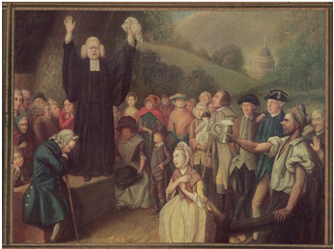

24. Which colonial trend from the 17th and 18th centuries is best illustrated by the image above?
a. The spread of Enlightenment thought
b. The Anglicanization of the British colonies
c. Puritans seeking to establish a community of religious believers
d. Protestant evangelism
The idea of taking faith to the people and preaching was far different from the traditional Anglican/Puritans.

25. By the mid-18th century, the fervor illustrated in the image above
a. contributed to resistance toward imperial control aimed at the Anglican state-Church.
b. stimulated the growth of ideas on race, leading to racial stereotyping.
c. led to the growth of autonomous political communities based on English models.
d. led to increase literacy rates and the advancement of academic developments
A new focus on training New Light minister and a focus of being able to reach/study scriptures.

26. Which of the following would NOT have been a core value that was part the theology of the "New Lights?"
a. Salvation by Faith Alone and not good works
b. All people are sinful yet they can all be saved through their own free will.
c. God has already determined at the beginning of time the sinners from the "elect."
d. One must maintain a close personal connection with Christ as one's Savior
This was the idea of predestination and why Puritans freaked out over signs of evil

The Document below relates to Questions 27`- 29
“These at the head of the James River grew impatient at the many slaughters of their neighbors and rose for their own defense, who choosing Mr. Bacon for their leader, sent oftentimes to the Governor…beseeching a commission to go against the Indians at their own charge; which His Honor as often promised but did not send….During these protractions people were often slain. This day lapsing and no commission to come they marched into the wilderness in quest of these Natives. The Governor denounced the rebels but Mr. Bacon, with 57 men proceeded…They fired and slew 150 Indians.”
Sam Kercheval, Virginia author and lawyer, On Bacon’s Rebellion in Virginia, 1833

27. Based upon the excerpt what is the point of view of Sam Kercheval toward Bacon and his followers?
a. They were wild-eyed rebels who threatened the stability of the colony.
b. They were frustrated men who were taking action because their grievances were no redressed by the governor.
c. They were allies of the Governor acting upon his orders to attack the Natives.
d. They were primarily political supporters of Bacon's attempt to become the new Governor of Virginia

28. Bacon's Rebellion was initiated by a group of men who felt most threatened by
a. An increase in royal taxation b. The power of the eastern planter aristocracy
c. Conflicts with Natives d. The growth of the slave trade in Virginia
They felt that the elite would keep them in a state of servitude. They did fight natives but they were the aggressors and not the natives.

29. The most important effect of Bacon’s Rebellion was
a. The end of Native independence in Virginia
b. The end indentured service in the New England region
c. A dramatic escalation in the demand for African slavery
d. A policy of Christian assimilation forced upon the Natives
If you picked B then you forgot your geography as indentured status was in VA and not N.E.

Questions 30 -33 Relate to the Passage Below
“First, although this Realm be already exceedingly rich by nature, yet might it be much increased by laying the waste grounds (which are infinite) into such employments as should no way hinder the present revenues of other manured [cultivated] lands, but hereby to supply ourselves and prevent the importations of Hemp, Flax, Cordage, Tobacco, and divers other things which now we fetch from strangers to our great impoverishing.
2. We may likewise diminish our importations, if we would soberly refrain from excessive consumption of forraign wares in our diet and rayment,...which vices at this present are more notorious amongst us than in former ages. Yet might they easily be amended by enforcing the observation of such good laws as are strictly practiced in other Countries against the said excesses; where likewise by commanding their own manufactures to be used, they prevent the coming in of others....
3. The value of our exportations likewise may be much advanced when we perform it ourselves in our own Ships, for then we get only not the price of our wares as they are worth here, but also the Merchants gains, the charges of insurance, and freight to carry them beyond the seas...

Thomas Munn, English Economist, 1664

30. The economic policies being asserted above would have been most consistent with
a. Mercantilism b. Socialism c. Capitalism d. Communism

31. Which line from the passage would be consistent with the concept of a nation having a "balance of trade?"
a. "although this Realm be already exceedingly rich by nature, yet might it be much increased by laying the waste grounds."
b. "The value of our exportations likewise may be much advanced when we perform it ourselves in our own Ships."
c. We may likewise diminish our importations, if we would soberly refrain from excessive consumption of forraign wares in our diet and rayment"
d. "But hereby to supply ourselves and prevent the importations of Hemp, Flax, Cordage, Tobacco, and divers other things which now we fetch from strangers to our great impoverishing."
This is known as “balance of trade” where you try to export more than you import.

32. Which commodity list by the author would ultimately been most valuable?
a. Hemp b. Tobacco c. Flax d. Cordage

33. Which region of British North American would have been the producer of the most valuable export?
a. The Chesapeake b. New England colonies c. The Middle Colonies d. The Southern Colonies
While today VA counts as a southern state, tobacco does not grow as well further south.

Questions 34 – 35 Relates to the Passage Below
“For I knew that they were a people who could be more easily freed and converted to our holy faith by love than by force, gave to some of them red caps, and glass beads to put round their necks, and many other things of little value, which gave them great pleasure, and made them so much our friends.…It appeared to me to be a race of people very poor in everything.…They have no iron, their darts being wands without iron, some of them having a fish’s tooth at the end….They should be good servants and intelligent, for I observed that they quickly took in what was said to them, and I believe that they would easily be made Christians as it appeared to me that they had no religion.”
Christopher Columbus upon reaching the West Indies, 1492

34. In the passage above, Columbus likely mentioned the American Indians’ interest in glass beads and weapons
a. to demonstrate the social diversification among societies in these areas.
b. as an example of their largely mobile and nomadic lifestyles.
c. to prove the cultural inferiority of racially mixed populations.
d. because it exemplified the very different worldview of American Indians.

35. After Columbus’s arrival in the West Indies, Spanish religion and Christian conversion were often used as a rationale to
a. racially mixed populations. b. trigger extensive demographic change.
c. transform the diverse environment d. justify the subjugation of American Indians.

Questions 36 – 37 Relate to the Passage Below
The charge of genocide is largely sustained by figures showing the precipitous decline of the Indian population. Although scholars debate the exact numbers, in Alvin Josephy's estimate, the Indian population fell from between fifteen and twenty million when the white man first arrived to a fraction of that 150 years later. Undoubtedly the Indians perished in great numbers. Yet although European enslavement of Indians and the Spanish forced labor system extracted a heavy toll in lives, the vast majority of Indian casualties occurred not as a result of hard labor or deliberate destruction but because of contagious diseases that the Europeans transmitted to the Indians…..”
Dinesh D'Souza “The Crimes of Christopher Columbus, 1995

36. The point of view of the author could best be summarized as
a. Agreeing that Christopher Columbus was only partly responsible as a perpetrator of genocide against native people.
b. Could not have committed genocide because he died soon after the first contact.
c. Agreed that Columbus could not have committed genocide because he did not know about the diseases.
d. Set out to wipeout all Natives as sinful in the eyes of God.

37. The best argument against D’Souza’s position would be that
a. Christopher Columbus was the perpetrator of genocide against native people.
b. Could not have committed genocide because he died soon after the first contact.
c. Columbus could not have committed genocide because he did not know the result of the diseases.
d. Set out to wipeout all Natives as sinful in the eyes of God.

Questions 38 – 40 Relate to the Passage Below
"Certain it is, that there are few Kingdoms in the World more Divided within themselves [by religion than England].... Your Endeavours for a [religious] Uniformity have been many; Your Acts not a few to Enforce it, but they Consequence, whether you intended it or not, through the Barbarous Practices of those that have had their Execution, hath been the Spoiling of several Thousands of the free inhabitants of this Kingdom of their Unforfeited Rights. Persons have been flung into Jails, Gates and Trunks broke open, Goods destroyed, till a stool hath not been left to sit down on, Flocks of Cattle driven, whole Barns full of Corn seized, Parents left with out Children, Children without their Parents, both without subsistence....
Finding then by Sad Experience, and a long Tract of Time, That the very Remedies applied to cure Dissension increase it; and that the more Vigorously a Uniformity is coercively prosecuted, the Wider Breaches grown, the more Inflamed Persons are, and fixt in their Resolutions to stand by their Principles; which, besides all other Inconveniences to those that give them Trouble, their very Sufferings beget that Compassion in the Multitude...and makes a Preparation for not a few Proselytes.."
William Penn, The Quaker Ideal of Religious Tolerance,1675

38. Based upon your reading and your knowledge of the period, which colonial government would probably have been more concerned about the creation of Pennsylvania and its religious policies?
- New York b. Massachusetts c. Virginia d. Delaware
This is similar to the previous question about Quakers.

39. Based upon the passage, what was Penn’s advice to the English government pertaining to religious issues?
a. That religious toleration is better policy than persecution
b. That persecution of some non-Christian faiths with jail terms is appropriate.
c. That all religions are welcome except Catholicism
d. That religious persecution is justified if people are disavowing Anglicanism

40. The idea of creating a religiously tolerant colonial government would have been synonymous with all of the following EXCEPT
a. Maryland b. Massachusetts c. Georgia d. Connecticut
Yep Puritans again.

Questions 41 – 43 Relate to the Source Below
"In America there are fertile lands sufficient to subsist all the useless Poor in England, and distressed Protestants in Europe; yet Thousands starve for want of mere sustenance. The distance makes it difficult to get thither. The same want that renders men useless here, prevents their paying their passage; and if others pay it for 'em, they become servants, or rather slaves for years to those who have defrayed the expense. Therefore, money for passage is necessary, but is not the only want; for if people were set down in America, and the land before them, they must cut down trees, build houses, fortify towns, dig and sow the land before they can get in a harvest; and till then, they must be provided with food, and kept together, that they may be assistant to each other for their natural support and protection...."
James Oglethorpe 1720

41. Which of the following best explains Oglethorpe argument for sending settlers to Georgia?
a. It would be good if debtors were sent there.
b. It would be good for military veterans.
c. It would be a refuge for dissident Anglicans.
d. It would be a good refuge for runaway slaves
The statement in the excerpt where he is discussing the people not being able to pay for passage.
42. Oglethorpe is referring to what labor system that had been outlawed in some of the British colonies to the north of Georgia?
a. Debt peonage b. sharecropping c. indentured servitude d. chattel slavery

43. In addition to being a proprietary colony, which of the following best explains the military function of the Georgia colony?
a. A buffer zone between Spanish Florida and South Carolina.
b. An outpost to launch attacks against Natives
c. A staging area of pirate attacks against Spanish shipping
d. A British naval base in the Western Atlantic whose purpose was to control piracy.
Originally if war erupted with Spain the valuable plantation in SC could be better defended

Questions 44 – 45 Relate to the passage below
“After the English took control of New Netherland, the unusual land tenure arrangements of Van Rensselaer's patroonship were confirmed by the English colonial governors. Settlers who farmed in Rensselaerswyck held life leases or perpetual leases, with feudal-type obligations that typically included a requirement to provide one day of labor service each year, pay "four fat fowls" on rent day, and pay an annual rent fixed in bushels of wheat. The landlord was entitled to reenter the property if these obligations were not fulfilled. Most tenants held perpetual leases, which could be passed to succeeding generations or sold, but if property was sold one-quarter of the sale price was required to be paid to the landlord.”
Killiaen van Rensselaer, 1664

- In the passage which of the following best describes a “patroon?”
- A Dutch landowner in New Netherlands
- A contract to supply slaves to English colonies.
- The exclusive right to use the port in New Amsterdam
- A native leader of the Mohican tribe.
They had built estates in modern New York and were allowed to keep these once Britain took over in exchange for loyalty to the crown.

- In New York colony following the English takeover which of the following best describes the initial treatment of tribes under the Iroquois Colony?
- They were forcibly removed from their lands and relocated to New Jersey.
- They lived peaceably under their own governments on their own land.
- They were wiped out during the King Philip War for having allied with Metacom
- They relocated to French Canada on their own free will.
See above.

Questions 48 – 50 Relate to the image below
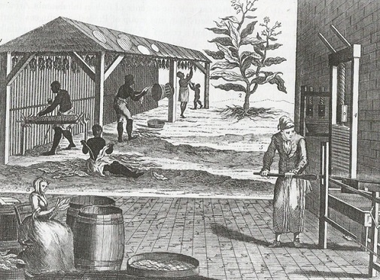

48. Why did slavery become prevalent in the southern colonies but not in New England?
a. Southern colonies relied on more labor-intensive cash crops.
b. New England Puritans were more devout than southern colonists.
c. Slaves were taxed at a higher rate in New England and it made less sense to own them.
d. Slaves died in the colder New England weather but thrived in the climate of the southern colonies.
The southern colonies were almost completely dependent upon cash crops

49. What statement correctly describes the status of slaves in the southern British colonies?
a. It was only temporary and slaves were freed after they worked for their master for a certain number of years.
b. Slaves inherited the status from their father and as a result had many rights except for suffrage.
c. Slaves inherited the status from their mothers thus incorporating a strong racial element into colonial society.
d. Britain banned slavery as a result of Bacon’s Rebellion
This is why when a Plantation owner fathered a child with a slave, that offspring was automatically considered a slave

50. What statement correctly describes the syncretic nature of slave culture in the British colonies?
a. Slaves completely abandoned their traditional beliefs.
b. Slaves refused to abandon any traditional beliefs.
c. Slaves blended new and traditional beliefs.
d. Slaves were prevented from having any culture by law.
This explains why many readily accepted Christianity though sometimes blended with previous traditional views.

