AP European History
August 14– 18 2023
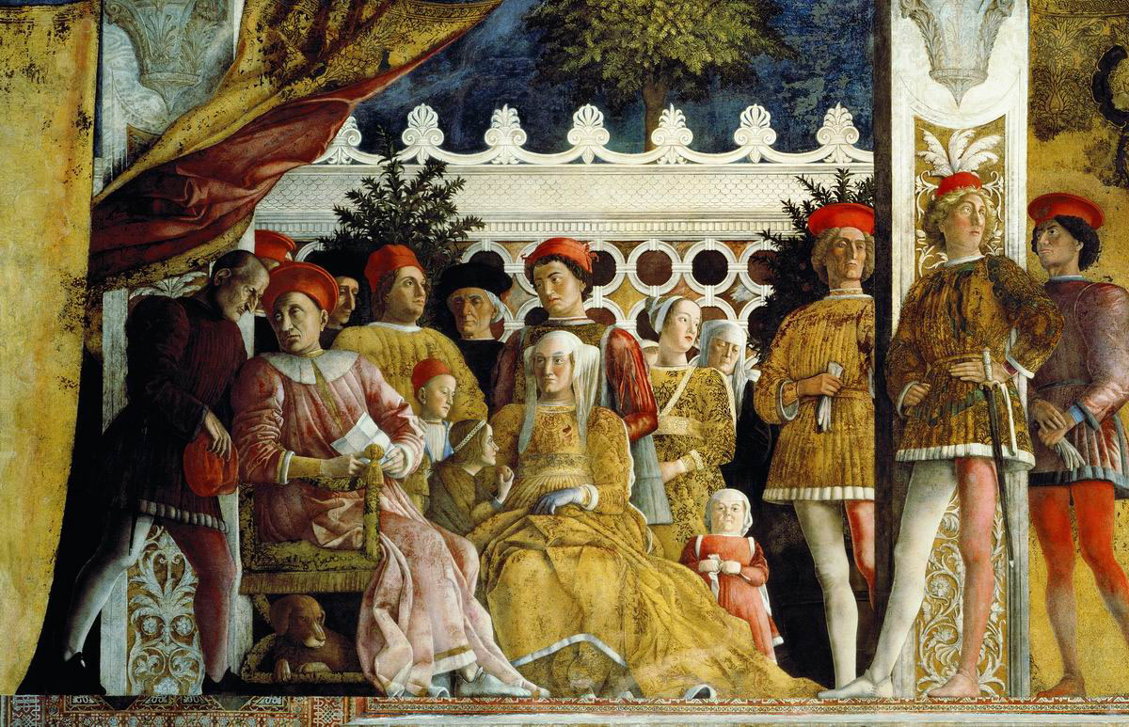
- You should have already signed up in ap.collegeboard.com This should have been completed by the end of last week. You may have a zero at this point if you have not signed up. Additionally, you do have an assignment for the weekend on AP Classroom. So, if you have not signed up, you cannot get on the site.
- Also, hopefully you completed the quia.com review of the summer work which included some of period one on the Italian Renaissance.
- Please note that you have your first actual in-class quiz on Wednesday that will cover all of the Renaissance that we have discussed thus far. This is a 40% Grade. In addition you should watch the 2 videos the night before. You get a pass/fail grade just for watching.
- Hopefully you will get your textbook next week, but this week’s plan assumes that you have not. But I believe that we have enough of them.
MONDAY and TUESDAY (Recap at the end of class)
- SWBAT Comparison/Contrast of Italian and Northern Renaissance culture (IOT) complete assessment on Wednesday (art, literature, philosophy (CID)(TSI).
Material Strategies
PPT images Lecture-discussion, review of arts

Student Skills
CCOT
Contextualization
Causation

Introduction
- One of the most famous and readily recognizable aspects of the Renaissance period involves culture, the art and literature (including poetry) of the period. I mean after all, not everyone has heard of Lorenzo di Medici and Francisco Sforza but most have heard of Michelangelo and Da Vinci. Today and Tomorrow we will look at the art and literature of the Italian and Northern Renaissance. There will be a bell work assignment at the end of class on Tuesday.
- We will do this by doing a comparison/contrast format so that, should you have an LEQ on the topic, your preparation will be easier. We will start out or discussion with examples from literature and the philosophy of humanism. We will see when we get to the arts that, while there were great differences earlier on, there was more blending by the late 16th century.

Literature
Italian
Humanism then became the dominant intellectual movement in Europe in the 16th century. Proponents of humanism believed that a body of learning, humanistic studies (studia humanitatis), consisting of the study and imitation of the classical culture of ancient Rome and Greece, would produce a cultural rebirth after what they saw as the decadent and “barbarous” learning of the Middle Ages. It was a self-fulfilling faith. Under the influence and inspiration of the classical; works of Plato and Aristotle, humanists developed a new rhetoric and new learning. Some scholars also argue that humanism articulated new moral and civic perspectives and values offering guidance in life. While there were many pivotal writers Francisco Petrarch is considered the father of humanism. Pico della Miradola’s Oration on the Dignity of Man is celebrated as a single work that aptly sums up the values. Another famous Italian humanist was Dante Alighieri whose famous works Divine Comedy and The Inferno blended growing humanist values with traditional religious themes. Some other famous writers (that you encountered in the summer work) were Giovanni Bocaccio and Michael Castiglioni whose works The Decameron and The Courtier respectively give us a glimpse of Italian society during the period. There is some debate as to whether Nicolo Machiavelli’s The Prince should be counted as humanist because his advice is often deceitful but others argue that this is a human trait. Most debate has developed with more modern interpretations attempting to link humanism with liberalism in political philosophy.

Northern Renaissance
Literature

In the North, particularly in what we now know as Holland and parts of Germany particularly (the spreading into other areas like England and France) humanism also shared some of the same values as in Italy but with one very great difference. Here, humanism tended toward religious social reform and this often included criticism of the Catholic Church. It is critical to not that since humanism here was somewhat later it is also associated with the Protestant Reformation that catches fire in the 16th century. Sometimes this is known as Christian humanism and its “father” Erasmus Desiderius, a Catholic priest in Holland. Humanism here was similar in that it grew in an academy environment. Erasmus was part of a group known as the Modern Devotion which taught Christian values and service. The message was to return to a more primitive faith centered around Christ. This often placed humanists in the north at odds with the Papacy. Because of the emphasis on Christian values in ancient texts, the focus was not so much on classical values. Another shared value between the two humanist values was an interest in individualism, a value that persists into our own times. In the North this will become the important doctrine of free will, or one’s right to choose Christ as one’s savior. But more on this later.

Italian Renaissance At
Composition and Style
One easy to not aspect of the Quattrocento or 400 years of Italian masterworks, is the influence on balance and symmetry. For the Italians mathematical precision seemed important. The works were often geometrical with balanced right angles and pyramidal structure. (You’ll see this in our class discussions). One of the most famous examples of this (and one we will use a lot) is Da Vinci’s Last Supper. Christ creates a focal point and the figures; the apostles lean to make triangles shapes. The foreground and background are very balanced. Another composition feature in the importance of the foreground vs. the background which is often far less detailed. The colors in these compositions are brighter (though it is hard to tell with centuries of age). The Italians first experimented with perspective (Giotto and Masaccio) in the earliest Renaissance. Later many used sfumoto and chiaroscuro (lighting and shading) to created a greater sense of realism. The attention to the above details was so intense that especially in Florence a guild of artists was formed to maintained these standards. This is going to be far less evident in the North.

Subjects and Patronage
Being in the heart of the Catholic Church it should be no surprise that works tended to be religiously-themed stories or figures from the Bible. The Sistine Chapel by Michelangelo is a classic case but it also noteworthy that the patron for this work was Pope Julius II aka the “warrior pope.” Another rather obvious hallmark of the Italians is that the figures may be religious but certainly they look Greco-Roman figures. Michelangelo’s David is obvious. One of the most famous examples of Italian Renaissance art that combined many of the themes of subjects and composition was the School of Athens by Raphael. The subjects are all figures that one would have learned and appreciated as a humanist educated in the stadia humanitatas idea including of course Plato and Aristotle but also scientists, mathematicians, and earlier Renaissance figures. The idea of patronage also created many portrait paintings like the Duke of Urbino by Raphael and Da Vinci’s Mona Lisa (though some argue that it was actually him in the painting like a self-portrait. Da Vinci is often called the “Renaissance Man” because of his work in so many mediums and his productivity.

Northern Renaissance Art
Composition and Style
The Northern Renaissance Artists like Massys and Van Eyck were less interested in balance though certainly there is some incorporated. This is likely because there was no set style and the fascination with the classical works was abjured. Also, unlike many Italian works, the background seems just as important as the foreground. The colors are generally much darker than in the south and there is often tremendous attention to detail to create realism (a link to a later school of art). The Moneylender by Massys is a great example. These are far more intricate works. Galdolfini and His Wife by Jan van Eyck is another good one and also another example of “tromp d’oeil” sort tricking the eye.
In some cases, the northerners seem to have completely rejected the Italians. There is no better evidence than The Garden of Earthy Delights by Hieronymus Bosch. His work here seems like a throw-back to the Dark Ages. However, his work Praise of Folly is also more in line with other Northerners. Another great example of later Renaissance works would be the realism of Flemish works by Rembrandt (The Night Watch for example)

Subjects and Patronage
Here is an area of great divergence! In the North patronage was often royal. Hans Holbein’s painting of Henry VIII of England is a great example. In the North our “Renaissance Man” was Albrecht Dürer who also worked in many mediums (including woodcuts that helped to illustrate prints as the printing press helped to explode literacy in the north). While religious figures were common there also seemed to be a not so thinly veiled criticism of the Catholic Church (Bosch). Many figures in the North were middle class and even ordinary peasants and townspeople many of whom were clearly not patrons.

A Form of Style Synthesis
By the later 16th century there seemed to be a level of style synthesis. The works of Caravaggio seem to show a northern style by an Italian. Also, just so we don’t leave it out, architecture in Italy and the North begin to show an appreciation of Greco-Roman style (though later in the north). Most churches and later on palaces reveal columns and style resembling the Parthenon or Roman Coliseum. By the way, in the 18th century there will be an era called “neo-classicalism” and our own American architecture reveals it in Washington DC and even Jefferson’s home Monticello.

Homework
Look over you class and online notes for a quiz tomorrow. This will be written and include primary sources. It will be due in class and is timed! This will include a few questions about both literature and art with a bit of overlap with last week. Here are two videos that you should watch on AP classroom. You get a Participation grade just for watching….this means a pass/fail grade!
Italian Renaissance
https://apclassroom.collegeboard.org/15/home?apd=g0qdlaao1u&unit=1

Northern Renaissance
https://apclassroom.collegeboard.org/15/home?apd=g0qdlaao1u&unit=1

WEDNESDAY
- SWBAT analyze primary sources (IOT) complete Assessment on aspects of the Renaissance Period

Materials Strategy/Format
Short answer quiz forms Assessment and Review

Student Skills
CCOT
Contextualization
Causation

Instructions
- Today’s assessment will review the organization of Italian Renaissance society and politics along with our discussion of the culture of Italian and Northern Renaissance. Be aware that NO NOTES may be used. The quiz will generally be non-document but there may be some art examples to critique.
- You will have the entire period to complete this assignment but no extra time unless we lose class time for some reason.

Homework
None.

THURSDAY and FRIDAY
- SWBAT compare key factors in the consolidation of Northern Monarchies during the Renaissance Period) (SOP1)
- SWBAT examine the creation of New Monarchies in Spain, France, and England (SOP1) (INT1)

Materials Strategies
Ppt Lecture discussion

Student Skills
CCOT
Contextualization
Causation

Introduction
- As you saw from the summer work, there were two pivotal events that started the consolidation of power in northwest Europe. The Hundred Years War saw the destruction of much of the power of French nobles allowing the monarchy to rise. In England the defeat set the stage for internal struggles (The War of the Roses) but it also ended any desire to re-conquer in Europe. Their focus soon turned west. The Black Plague also weakened nobility and strengthened the rights of peasants to be respected in England.
- The impact of the Renaissance in the North also played a role in consolidating royal power. The development of a stronger middle class gave monarchs not only a tax base but also more power against restive nobles. The middle class and monarchies joined forces against nobles who wanted to maintain the centuries old status quo.
- Today we will examine the centralization of power in general but also see some particular measures in England, France, and Spain. These were important events because they also reveal why powers in central and eastern Europe did not turn into centralized powers.

Key Factors in Centralizing Power
- By the end of the Middle Ages, most smaller feudal units had been absorbed into bigger states over much of the West, with the exceptions of Germany and Italy. As the modern state system began to take shape in the fifteenth and sixteenth centuries, the three well-organized monarchies of Spain, France, and England dominated Western Europe; Scotland, Portugal, and the Scandinavian states generally played subordinate roles. In central Europe, the Holy Roman Empire, with its many semi- sovereign member states, did not have the kind of internal unity enjoyed by the Atlantic powers. In the east Russia was in most respects still a feudal society where the monarchs in this period enjoyed less power than the nobles (called boyars)
- Monarchs (kings and queen with supreme rule) in France, England, and Spain responded to the chaotic situation in Europe by consolidating their power. A significant development in all three of these monarchies was the rise of nationalism, or pride in and loyalty to one's homeland, which was a distinctive feature of the Renaissance period.
- In France, the Capetians (pronounced cuh-PEE-shuns) gained control of nearly all duchies (fiefs) by staging internal wars and defeating England in the Hundred Years' War. They established a line of strong monarchs that lasted for eight hundred years and elevated France to the status of a major power.
- Although England was exhausted by the long conflict with France, the Tudor monarchs began a new dynasty after emerging victorious from the War of the Roses, a struggle between two families for the throne of England. During the sixteenth and seventeenth centuries, the Tudors reigned over the English Renaissance. Their era produced one of the greatest cultures in the world and led to the creation of the British Empire in later centuries.
- In Spain, the monarchs Ferdinand II of Aragon and Isabella of Castile laid the foundation for an immense empire by uniting several independent provinces. In the sixteenth century, during the reign of King Charles I (Holy Roman Emperor Charles V), the Spanish empire spread east from Spain to include the kingdoms of Germany, Hungary, Bohemia, Naples, and Sicily. It also extended south and west to include possessions in North Africa and the America
France
- The pivotal turning point toward French unity involved the end of the 100 Years War. At that point King Charles VII was able to begin the process by ending a civil war between two important noble families and their respective regions (Burgundy and Armagnacs). Not surprisingly this leads to greater unity.
- The process of centralization usually requires a national army to police the people and protect the state. These come at a cost. The French developed a new national taxing structure to pay for this. The Gabelle was a tax established on salt which the government monopolized. Also, the was a land tax called the taille which was aimed at the nobility. The strength or weakness of the monarch was often marked by how effective this tax was collected.
- In many nation-states the power of the papacy was a stumbling block for state power. Charles VII claimed the right to assign bishops in France, a power that had always been claimed by the Vatican. In 1438 Charles VII published the Pragmatic Sanction of Brouges which involved the idea of Gallic Liberties, the right of the French monarchy to also control ecclesiastical revenue. Obviously the power of the Vatican to seriously challenge the decree is illustrative growing French power.
- King Louis XI often called the “spider king” because of his cunning and sometimes vicious behavior built upon his father’s consolidations. His contribution had major implications for the economic future of France. His first move ( and one repeated by later monarchs) was to monopolize a key industry; silk production. This allowed an important stream of revenue. He also expanded international trade by joining the Hanseatic League, a trade organization that stretched now from France, Germany, to modern day Russia.
- The expansion of a state can be accomplished in two methods: invasion or intermarriage. The French did both of these. The Anjou Dynasty became extinct with the death of its last male leader childless. The future king Louis XII was marriage to Anne of Brittany. When his father died this united Brittany with the rest of France to this day. The last papal challenge to French power occurred when Pope Leo X put pressure on the new young king Philip I to overturn the Pragmatic Sanction of Bourges. A deal was struck between the two with the Concordat of Bologna. This allowed the Vatican to collect indulgences and other fees could collect while the monarchy could name bishops.

England
- The loser of the 100 Years War had many internal difficulties. The English population had yet to recover from the Plague which impacted food production. Violence and lawlessness was common. Then a dynastic struggled erupted between the House of York and the House of Lancaster. This was known as the War of the Roses. In 1471 the Lancaster finally won the conflict and the monarchy was re-strengthen by King Edward IV. The Lancaster’s power was short lived and was replaced by the first Tudor King Henry VII.
- The problem for all English monarchs was that Parliament constrained their power. Since the 12th century the aristocrats of England sat in council in Parliament’s upper house, the Lords and small holders and the tiny core of a middle class held seats in the House of Commons. The monarchy could easily have been only a figurehead as it is today. Henry VII first step was to organize a royal council of advisors from some of the main noble families. Essentially, he gave the noble class a voice in the monarchy. This was accomplished by naming lesser noble families power but excluding it from the bigger houses. He gave the lesser nobles a vested interest in the national power of the monarchy.
- The next step was to weaken noble power and end some of the lawlessness of all classes. The normal legal system was dominated by the nobles so the King created a new legal structure, the Court of the Star Chamber, which the monarchy controlled through legal appointments called “justices of the peace.”
- The Tudor Dynasty will be essential to the development of English power. We will see the role played later by Henry VIII, one of the most powerful sovereigns in European History.

Spain
- The earliest step in Spanish power was the unification of the two most powerful houses: Castille and Aragon. Ferdinand and Isabella married and unified Spain. Spain was a cultural melting pot between a European culture and Islamic Berber culture. The Reconquista, the centuries long conflict between Christian northern kingdoms versus Muslim southern powers finally ended with a northern victory. With this conflict ended, stabilization was now possible.
- The first step was to reign in the nobles with a old concept called herrnandades. Similar to the English idea, this allowed for the creation of policing powers outside of the normal role played by the nobles. Ferdinand and Isabella also created a royal council staffed almost exclusively by the middle class. The Spanish monarchy remained devout to Catholicism and as the papacy battled for power elsewhere, the popes rewarded Spanish power with money and support.
- One of the downsides of being zealous Catholics was the desire to quash other non-Catholic faiths. There was a large Jewish population in Spain ironically because they had been expelled from England and France. They found positions largely because they were far more educated than most of their princely overlords. It seems that just as today, the power of money trumps religious disagreements. However that began to change in the 15th century partly because of a ridiculous rumor that Jews had caused the Plague and because of an event known as the Inquisition. This was an attempt to ferret out non-Catholics. The master of the process was the Tomas de Torquemada, a Dominican monk who was not above torture to convert. He has remained one of history’s most hated men.
- At this point Jews were forced to convert, leave Spain, or die. A large number did convert and remained in Spain and were known as “new Christians.” Interestingly many Jews left and went to Holland (then called the Spanish Netherlands). Dutch economic power was partly built by these immigrants. Eventually the Spanish intermarried with the powerful Habsburg dynasty of the Holy Roman Empire uniting much of Europe into a single massive empire.

Conclusion
The organization of nation-states was an huge event in European History. By the 17th century monarchies will solidify in much of Europe and the definition of their power will come with how well that they control their noble classes, the power of the church, and ultimately their alliance with the growing middle class.

Weekend Homework
Access your online textbook (I will be getting access codes) and complete the primary source questions.
Here is the link for the book and hopefully we can get the codes. I will let you know what section once we seeing we can access the book.
www.highschool.bfwpub.com/launchpad/mckayap13e

